Transport Request NEDK920487 results:

US – 80009378 – L52

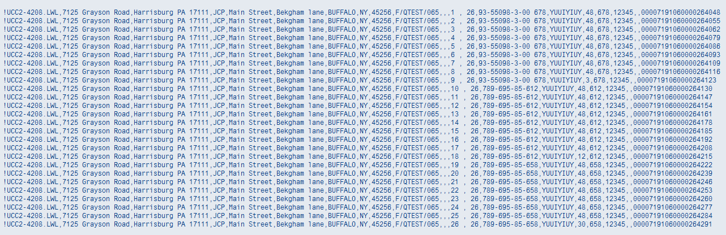

CHINA – 80009379 – L52

