Transport Request NEDK920743 results:

US – 80009357 – L76

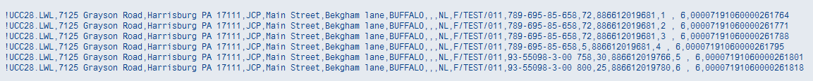

China – 80009358 – L76

