**Specification Document**



**Purpose**

The EMEA Region has difficulty seeing their top line Year to Date figures which looks at Royalties for both Shipped and Open Orders. This report will provide a view at four different levels which will enable NEC to deliver Royalty information which is a business requirement.

|  |  |
| --- | --- |
| **Project Title** | : EMEA BI Report – DC ROYALTIES |
| **Initial Specification** | : March 10, 2012 |
| **Created By** | : K Pitkin |
| **Created Date** | : 3/10/2012 |
| **Assigned to** | : Assigned to BMS |
| **QA by** | : |
| **Requested By** | : D Clare |
| **Integration Testing By** | : |
|  |  |

**Revision History:**

|  |  |  |
| --- | --- | --- |
| Revision Number | Date | Summary of Change |
|  |  |  |
|  |  |  |
|  |  |  |
|  |  |  |
|  |  |  |
|  |  |  |
|  |  |  |
|  |  |  |
|  |  |  |
|  |  |  |
|  |  |  |
|  |  |  |
|  |  |  |
|  |  |  |
|  |  |  |

**References (Document, URL, and Email etc):**

|  |  |  |
| --- | --- | --- |
| Version | Date | Name of the document |
| 1.0 | 10/3/2012 | DCBIEMEA – ROYALTIES REPORT.doc |
|  |  |  |
|  |  |  |
|  |  |  |
|  |  |  |
|  |  |  |
|  |  |  |
|  |  |  |
|  |  |  |

**Functional Requirement:**

1. To create or modify **one single** BI Report which displays order values / revenue for the following:
   * Royalties
   * Shipped Orders
   * Open Orders
2. The information needs to be displayed on a monthly basis, showing all calendar months for the current year.
3. The report also needs to display:
   * A running total of Royalties for Shipped Orders
   * A running total of Royalties for Open Orders
   * A running total of Shipped Orders at each level of the report
   * A running total of Open Orders at each level of the report
   * A Combined Total of Shipped Orders and Open Orders at each level of the report

**NB. The report does not need to show Volumes, only Revenue.**

1. The report needs to work at 4 levels:
   * Regional
   * License
   * Country
   * Sales Rep

This is loosely demonstrated by the attached file DCBIEMEA – ROYALTIES REPORT.doc

1. The report needs to be able to display the revenue figures in both USD, EURO’s and GBP

REGIONAL / LICENSE / COUNTRY / REP



Combined

Total

Shipped

Open

Royalties

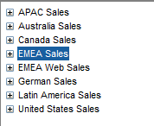

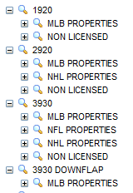

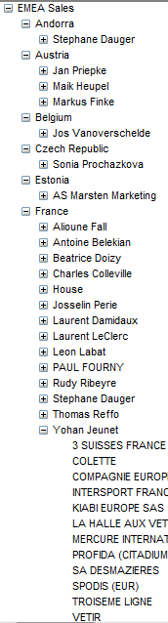

**Proposed - Solution Approach & Impact:**

**Solution Summary**

**Estimation:**

|  |  |  |  |
| --- | --- | --- | --- |
| Module | Item | Task Description | Hours |
|  |  |  |  |
|  |  |  |  |
|  |  |  |  |
|  |  |  |  |
|  |  |  |  |
|  |  |  |  |
|  |  |  |  |
|  |  | **Total Number of Hours** |  |

**Known Issues:**