**Specification Document**



**Purpose**

The EMEA Region has difficulty seeing their top line Year to Date figures which look at both Shipped and Open Orders. This report will provide a view at various levels which will enable better monitoring of the overall Sales Performance at a Regional, Country and Sales Rep perspective.

|  |  |
| --- | --- |
| **Project Title** | : EMEA BI Report - PG |
| **Initial Specification** | : March 6, 2012 |
| **Created By** | : K Pitkin |
| **Created Date** | : 3/6/2012 |
| **Assigned to** | : Assigned to BMS |
| **QA by** | : |
| **Requested By** | : P Gils |
| **Integration Testing By** | : |
|  |  |

**Revision History:**

|  |  |  |
| --- | --- | --- |
| Revision Number | Date | Summary of Change |
|  |  |  |
|  |  |  |
|  |  |  |
|  |  |  |
|  |  |  |
|  |  |  |
|  |  |  |
|  |  |  |
|  |  |  |
|  |  |  |
|  |  |  |
|  |  |  |
|  |  |  |
|  |  |  |
|  |  |  |

**References (Document, URL, and Email etc):**

|  |  |  |
| --- | --- | --- |
| Version | Date | Name of the document |
| 1.0 | 6/3/2012 | PGBIEMEA.doc |
|  |  |  |
|  |  |  |
|  |  |  |
|  |  |  |
|  |  |  |
|  |  |  |
|  |  |  |
|  |  |  |

**Functional Requirement:**

1. To create or modify **one single** BI Report which displays order values / revenue for the following:
   * Shipped Orders
   * Open Orders
2. The information needs to be displayed one a monthly basis, showing all calendar months for the current year.
3. The report also needs to display:
   * A running total of Shipped Orders at each level of the report
   * A running total of Open Orders at each level of the report
   * A Combined Total of Shipped Orders and Open Orders at each level of the report

**NB. The report does not need to show Volumes, only Revenue.**

1. The report needs to work at 4 levels:
   * Regional
   * Country
   * Sales Rep
   * Customer

This is loosely demonstrated by the attached file PGBIEMEA.doc

1. The report needs to be able to display the revenue figures in both USD and GBP

REGIONAL



Combined

Total

Shipped

Open

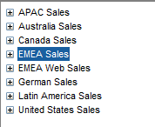

COUNTRY / REP / CUSTOMER



Combined

Total

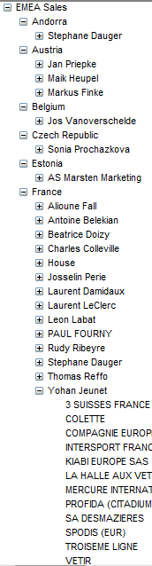

Shipped

Open

**Proposed - Solution Approach & Impact:**

**Solution Summary**

**Estimation:**

|  |  |  |  |
| --- | --- | --- | --- |
| Module | Item | Task Description | Hours |
|  |  |  |  |
|  |  |  |  |
|  |  |  |  |
|  |  |  |  |
|  |  |  |  |
|  |  |  |  |
|  |  |  |  |
|  |  | **Total Number of Hours** |  |

**Known Issues:**