Specification Document



Purpose
The EMEA Region has difficulty seeing their top line Year to Date Financial position across all countries in relation to Sales Performance. These figures are produced by the CFO and widely used by the Directors and the VP for the EMEA Region is used as a key performance indicator.
This particular report does not currently exist and is therefore a completely new report.

Project Title | : EMEA BI Report –WO2897.1200
Initial Specification | : March 23, 2012
Created By | : K Pitkin
Created Date | :3/23/2012
Assigned to | :Assigned to BMS
QA by | :
Requested By | :A Jones
Integration Testing By | :

Revision History:
Revision Number | Date | Summary of Change
1.0 | 23/3/12 | CFO 2012 Country Sales Report

References (Document, URL, and Emailetc):
Version | Date | Name of the document

Functional Requirement:
- To create a single BI Report which displays the following information:
  - The previous year’s actual revenue – 2011
  - The current years budgeted target – 2012– this would be hard coded in and supplied by the CFO at the start of the new financial year, or when changes are required.
  - The current years Shipped revenue figures - 2012
  - The current years Open order values – 2012
  - The current years Shipped and Open values combined – 2012
  - The percentage of the combined Shipped and Open values verses the current years budgeted target.

- The information needs to display:
  - All countries in the EMEA Region
  - All Retail locations to be provided for in the same format but not populated – see note below.
  - All Values to be shown in GBP

- The functionality of the report must allow the following:
  - To export in to Excel
  - Certain fields to be manually edited (Retail)– this is where the data cannot be pulled directly from any existing BI data sources. This capability would only be available to the CFO for EMEA.

An example report is shown below and has additional notes for guidance:
See Following page:
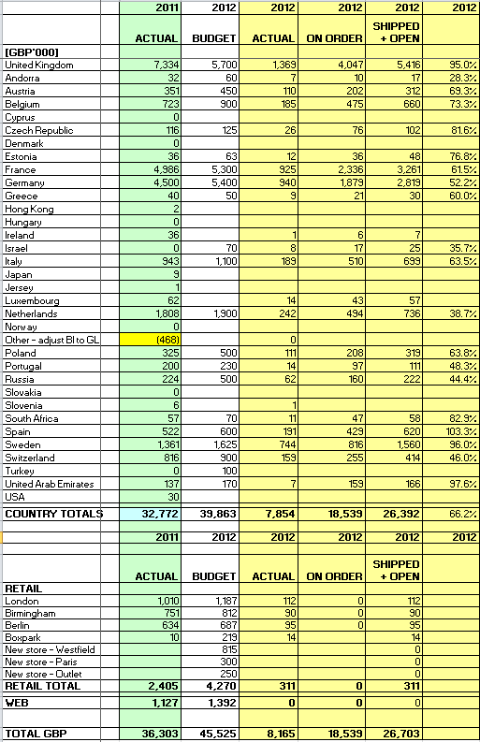
These fields need to be filled in manually once the report has run and exported to Excel, as there is no source from which to take it from.

Proposed - Solution Approach & Impact:
Solution Summary
Estimation:
Module | Item | Task Description | Hours
 |  | Total Number of Hours

Known Issues:

