|  |  |  |  |  |  |  |  |  |
| --- | --- | --- | --- | --- | --- | --- | --- | --- |
| **Seq** | **Scenario** | **ICO billing type** | **Should it has Stock value and quantity impact in COPA?** | **Cancellation billing type** | **Should cancellation has Stock value and quantity impact in COPA?** | **Sales Doc** | **Example in Q** | **Result** |
| 1 | Delivery based Intercompany invoice | IV | Yes | IVS | Yes | ZOR | 658892 > 90715139 (IV) > 90715409 (IVS) | Working |
| 2 | Non Delivery based intercompany invoice (3rd party drop ship) | IVA > IV | Yes | IVS | Yes | ZU3P | 658880 > 90715045 | Not working |
| 3 | Intercompany Debit memo | IVA | No | IVS | No | ZDR | 658293 > 70004789 > 90714845 (IVA) > 90715410 (IVS) | Working |
| 4 | ICO for return order | IG | Yes | IGS | Yes | ZRE | 60030823 > 90715404(IG) > 90715405 (IGS) | Working |
| 5 | ICO for Credit memo | IGA | No | IGS | No | ZCR | 60030824 > 90715407 (IGA) > 9075408 (IGS) | Working |
| 6 | Intercompany billing for DR ship scenario US-Miami | ZFX | Yes | ZS1 | Yes | ZOR | 659130 > 90715256 (ZFX) > 90715257 (ZS1) | Working |

Scenario 1 – both billing and cancelation should have COPA impact on Stock value and sales quantity:

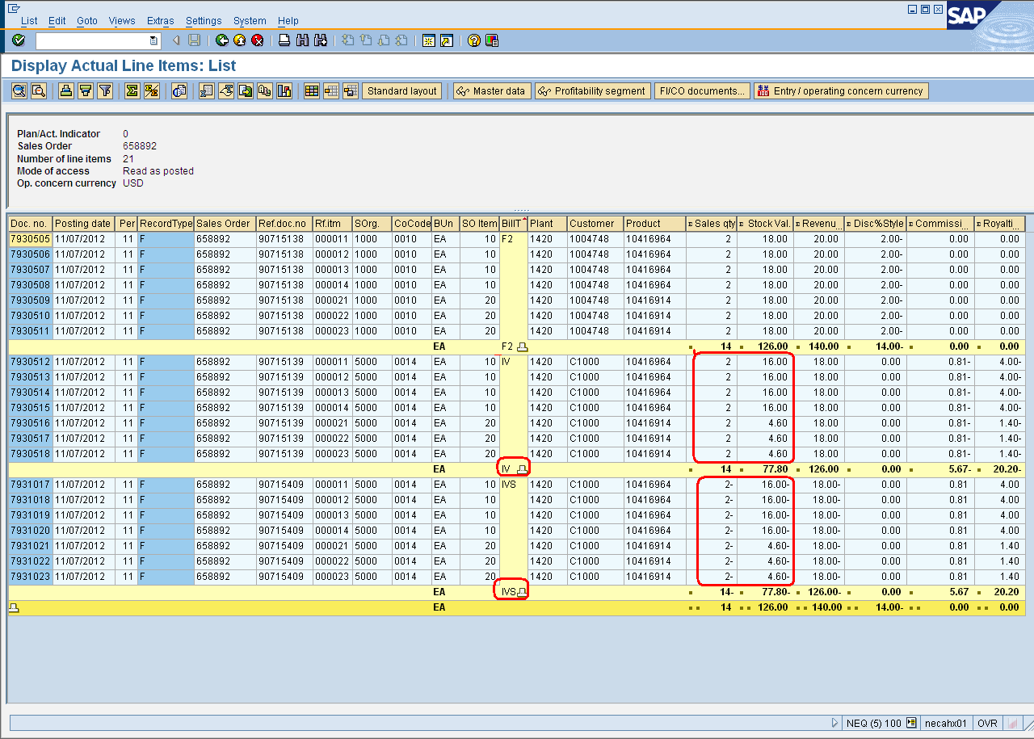

**Scenario 2 (Not working):both billing and cancelation should have COPA impact on Stock value and sales quantity, but although the cancelation in COPA looks good, the billing document itself does not show Stock value and sales quantity as it should.**

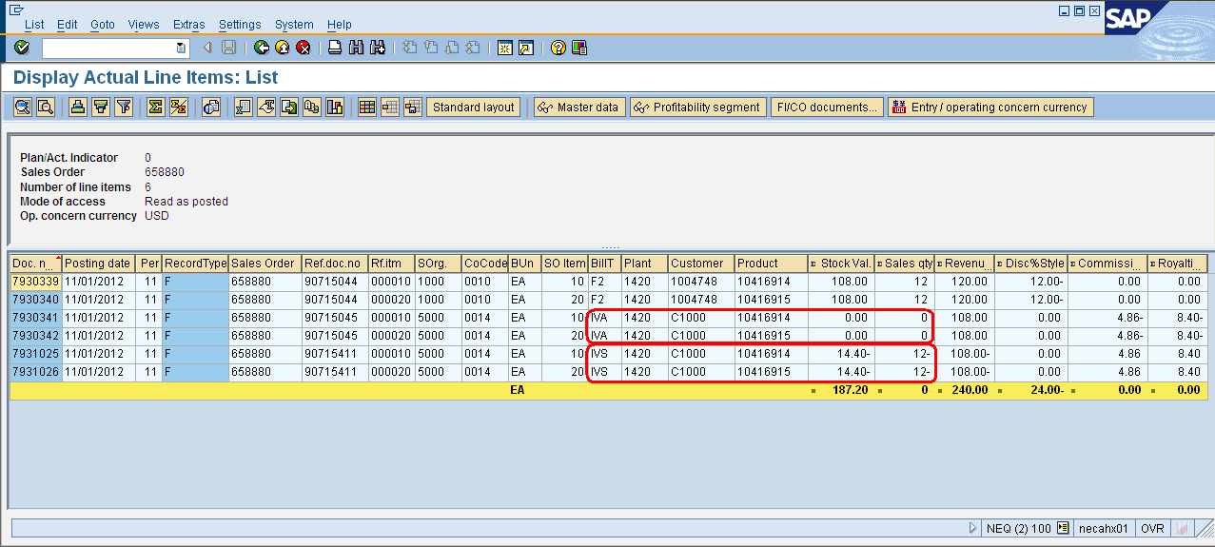

Scenario 3: neither billing nor cancelation should have COPA impact on Stock value and sales quantity.

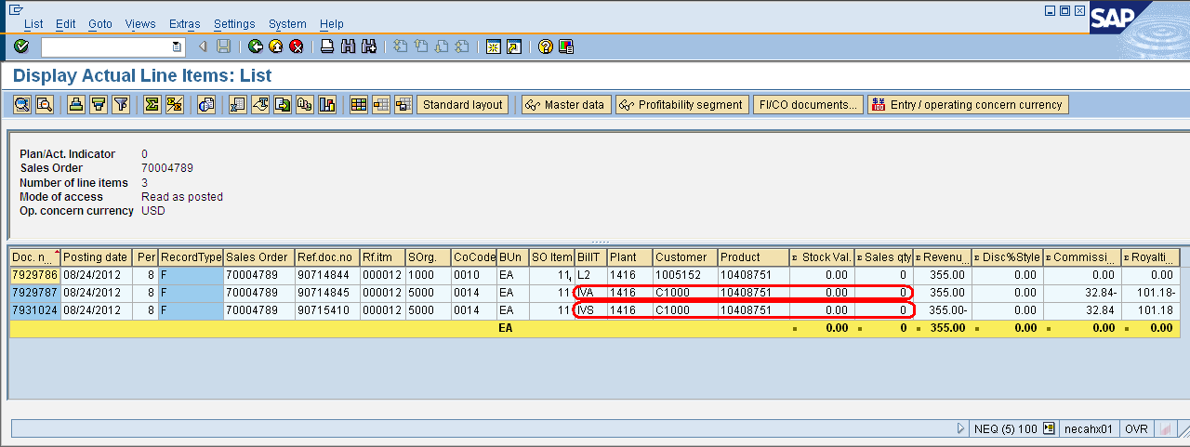

Scenario 4: both billing and cancelation should have COPA impact on Stock value and sales quantity

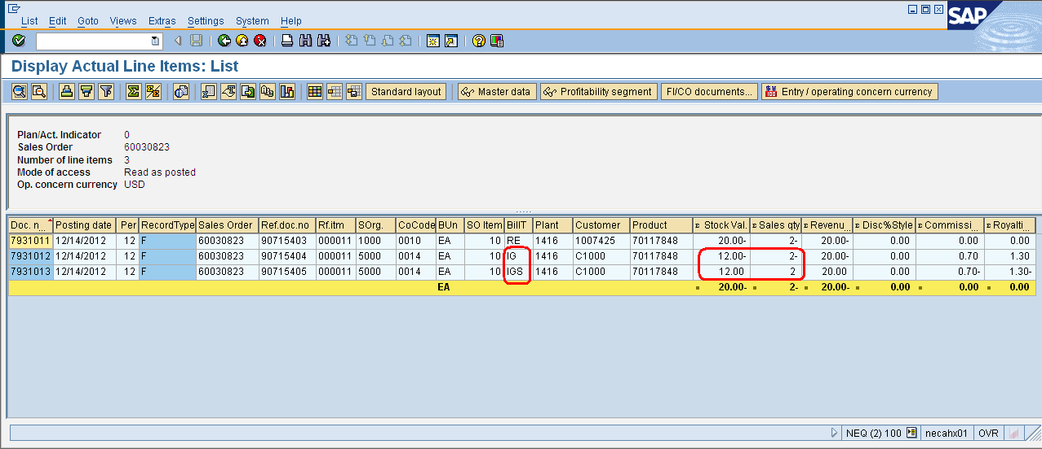

Scenario 5: neither billing nor cancelation should have COPA impact on Stock value and sales quantity.

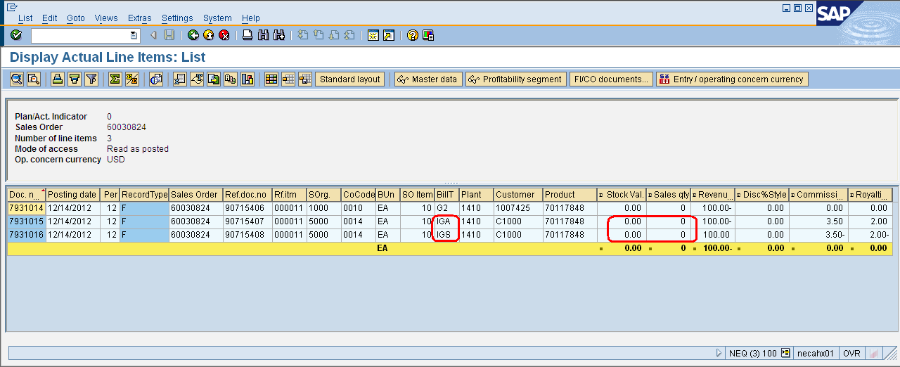

Scenario 6:both billing and cancelation should have COPA impact on Stock value and sales quantity

