1. **Example in Production – Issue that needs to be fixed:**

In Production, we currently have an issue where the ICO AP document generated by IDOC for Intercompany cancellations do not have Profit center. See below example:

Sales order 1207348, its intercompany cancelation document 91414303 has a follow on AP document 1700003742 (created by IDOC from output type RD04) does not have Profit center.

ICO Cancellation IVS:

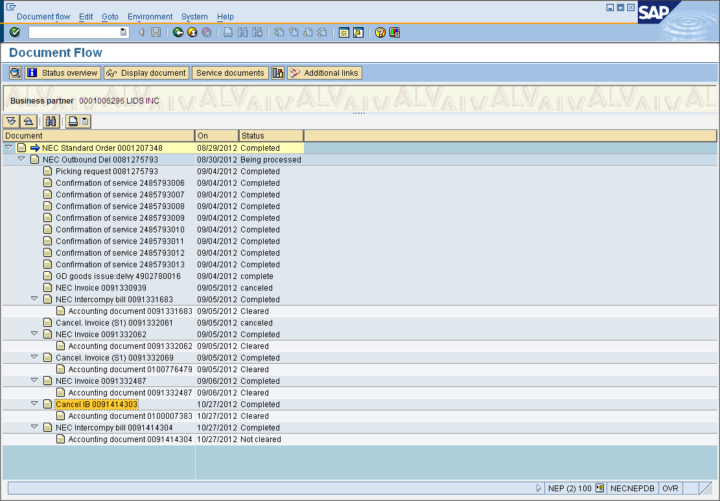

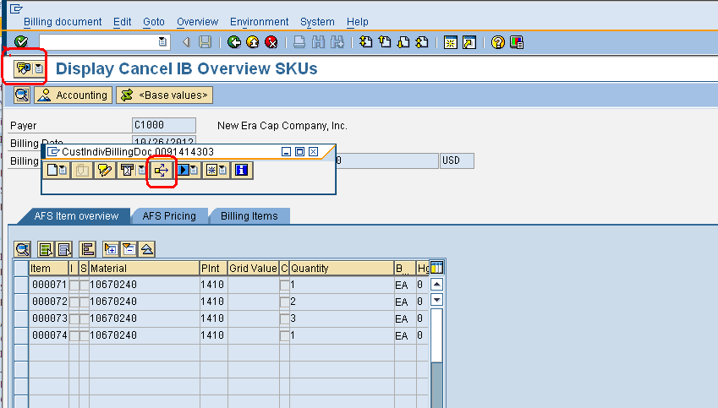

The ICO AP document was generated by the below IDOC.

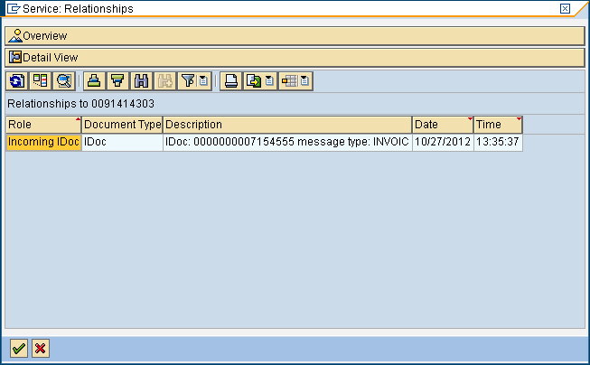

View the ICO AP document by going to the accounting document of IVS billing 91414303, click on environment > document environment > Relationship browser

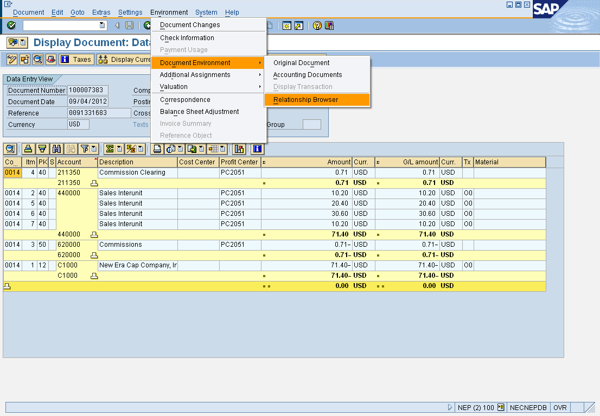

Double click on 1700003742

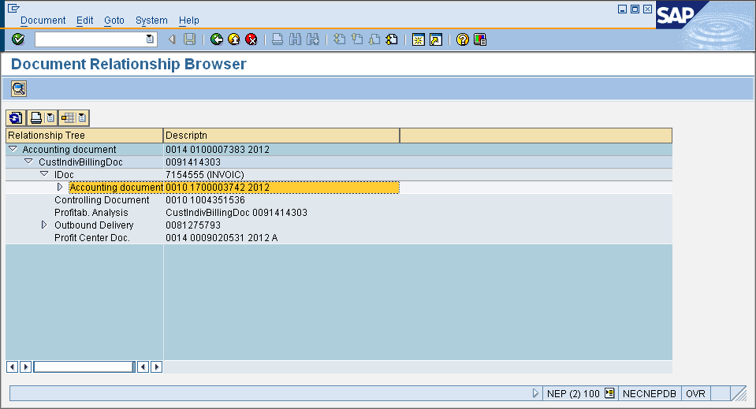

Profit center field is missing

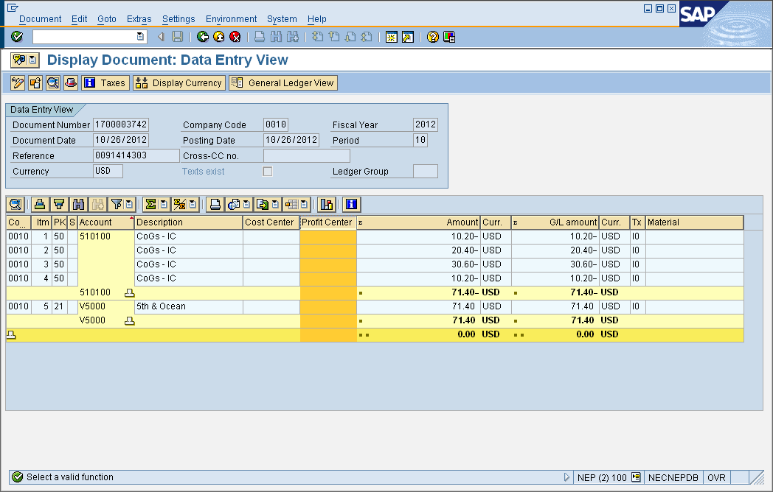

1. **Correct example in NEQ**

Sales order 658865, its ICO cancellation is 90715214. Follow the same step, you can see that the cancelation document has profit center

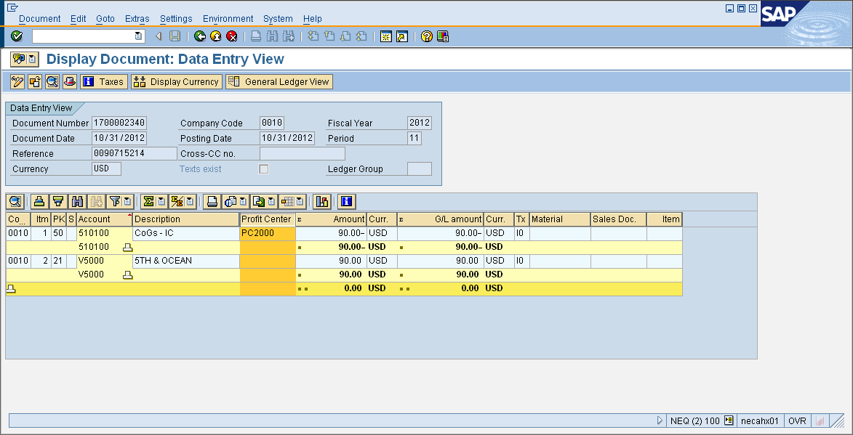

1. **Venu’s founding**

Venu analyzed the IDOCs for both scenarios, and found out that IDOC in Production is missing Qualifier 046 and 048are missing from the IDOC, the segment of the qualifier is under IDOC segment E1EDP01>E1EDP30. The segment 048 should be the place contains the correct profit center for the accounting document that is generated by the IDOC.

IDOC in P:

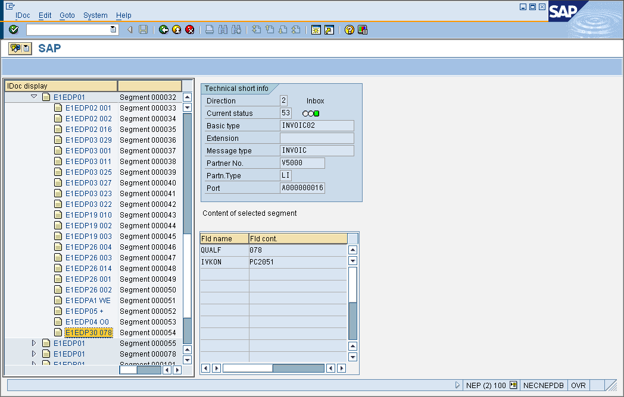

IDOC in Q:

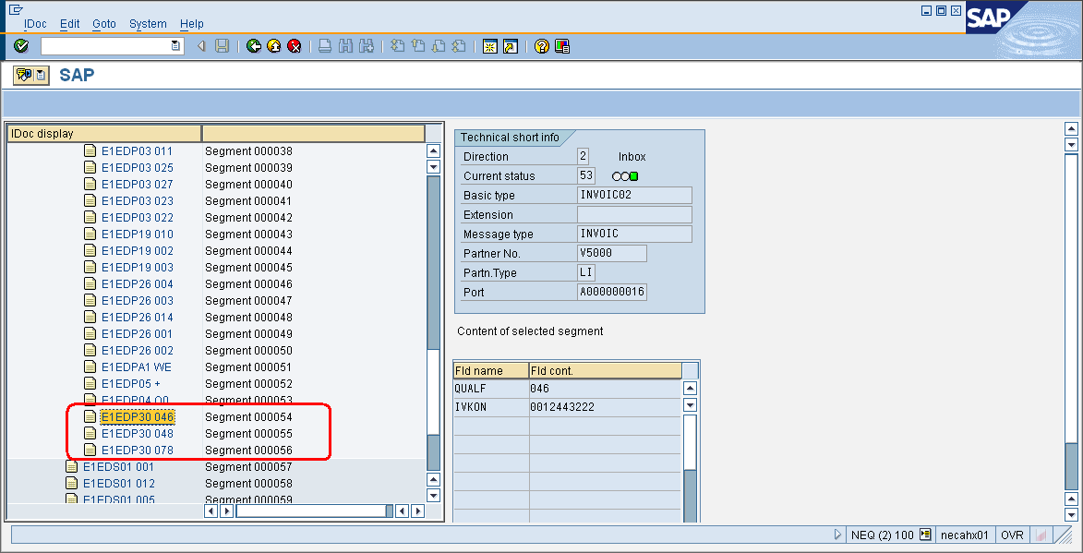

I checked the other correct ICO IDOCs for other billing types (IV, IG, IGA etc.), they all have qualifier 046, 048.

1. **Other fixes required:**

We need to fix above issue to ensure the IDOC document following the intercompany cancellations (IVS, ZS1 etc.) shows correct Profit center. One more thing we need to correct is that if the original intercompany document failed to post to accounting, the IDOC should not be triggered (or output type RD04 should not be triggered).

For example:

ICO Billing document 91214764 and its cancellation 91227182 both failed to post to accounting, but both documents generates IDOC (6237916 and 6298772), and those IDOCs generates accounting document 1900057903 and 1700003241. When ICO documents failed to post to accounting, output type RD04 should not be triggered.