**Recap:** 7945could not able to close Purchase Requisition.

**Symptom:** Invalid Purchase Requisition is Deleted/Closed; dependent requirements still remain in MRP (requirements driving down to 10530051 from mat id 10880749)

**Analysis:** A Purchase Requisition is showing up as demand with requirement type LB in /AFS/MD04 as shown below.

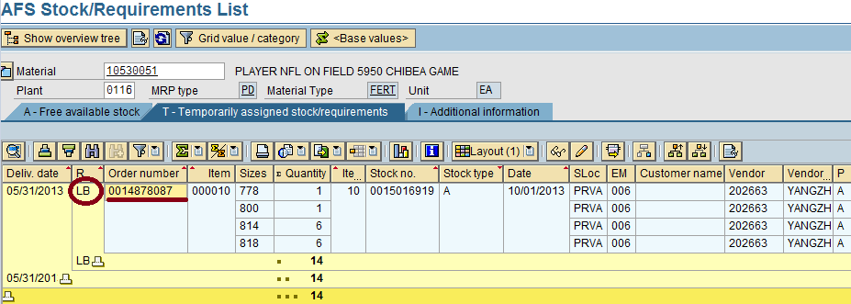

Purchase requisition is showing as demand for dependent requirements though:

1. Line item in the purchase requisition is Deleted/Closed.

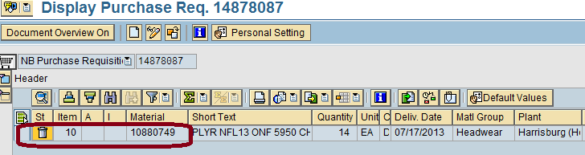

1. The Purchase Requisition is not seen as a proposal in /AFS/MD04 of the Independent requirement (Material : 10880749, it is not seen even deletion indicator is removed in Purchase Requisition line item)

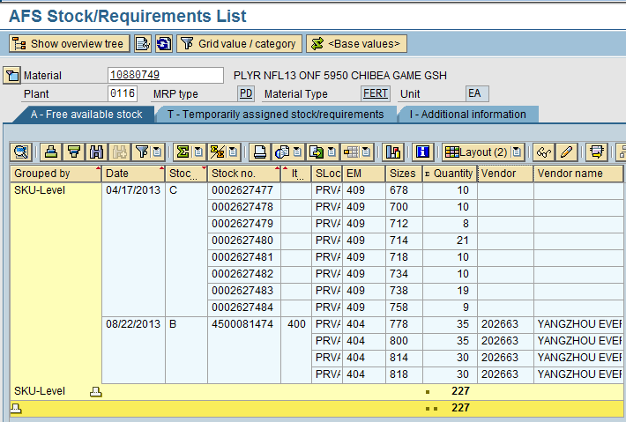

Other points which are observed:

* Item Category in the Independent Purchase Requisition (14878087) is empty which means that the Purchase requisition should not be a subcontracting one. But it is acting as Subcontracting Purchase Requisition as demand.

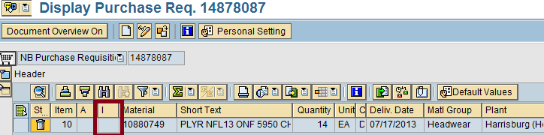

* A BOM was maintained for the material 1088749 which was deleted on 04/22/2013.
* Special Procurement key is changed on 04/22/2013 form 30(Subcontracting) to blank in the Material master.

Options that were tried to remove the Purchase Requisition:

* Set Deletion indicator in for the line item in the Purchase Requisition.
* Carried Stock rebalancing report, /AFS/SDRQ
* Carried Purchase Requisition Correction report, J_3AMBAC
* Carried Correction report for dependent requirements (Closed reqs) from Note 76753.