Contents

1. Requirement 1
2. Analysis 1
3. Solution and Recommendations 2

Requirement
MRP job running too long, review MRP job scheduled times and propose solution to MRP as separate task for all APAC plants.

Analysis
Observed that MRP Run is taking long time for Job NA_MM_MRP.
Below is the table with timings detailed for job NA_MM_MRP, To Analyze the issue we used MRP timings of different dates as shown in below screen shot.

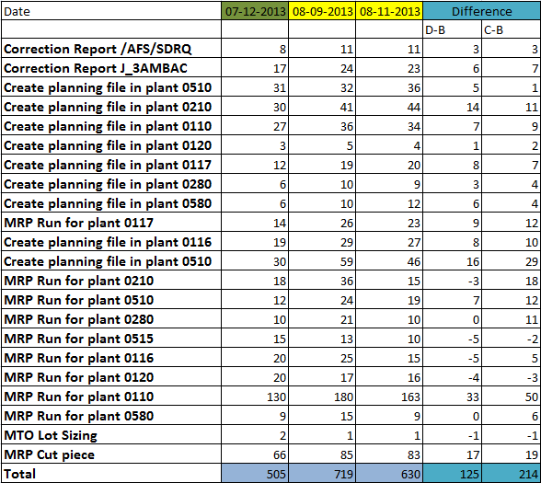

- MRP was good on 07-12-2013. This ran for 505 minutes.
- And it took some long time on 08-09-2013 & 08-11-2013.
- If we look at the difference “D-B” or “C-B” understand that all the steps in the job are taking bit long time which all together making extra 2 Hours (for D-B) and 3 ½ Hours (for C-B).
This is because of the fluctuation (increasing or decreasing) of requirements.
- Long time is because of the more requirements in net change Run.

Solution and Recommendations

To minimize the time for MRP job we can try doing this in the job NA_MM_MRP:

- Understand that step No. 16 in job NA_MM_MRP (MRP Run for plant 0515) is not required and we can delete this step.
- Planning file entry for plant 0510 is carried out twice (Step No. 3 and Step No. 12), we can delete any one of the job. (can be step No. 12)
- Observed that there is some buffer time maintained between the jobs:
- Job EMEA_MM_MRP starts at 17:00 and ends mostly by 18:30.
- Job NA_MM_APPAREL_MRP starts at 19:00 ends mostly by 20:20.
- Job NA_MM_MRP starts at 21:00.
If we can minimize this buffer time by maintaining logic: Job 2 must start after Job 1, Job 3 must start after Job 2 (independently).
- Step 1 /AFS/SDRQ is carried out for plants 0125 and 0130, Variant for step 1 is can be changed to maintain only for plant 0110.
- Step No. 22 in Job NA_MM_MRP (MRP Run for cut piece) is carried at Scope of planning “MRCP” level which includes plants 0110, 0125 & 0130. Scope of plan can also be changed to only one plant 0110, so that MRP run would carry out only for 0110. This would have a major impact in REGEN MRP, Job “NA_MM_MRP_REGEN “MRP Run is carried out for all the materials for plant 0125 and 0130.

Adding a new Job for APAC

- If we want to maintain a separate Job for “APAC” we can set this job after NA_MM_APPAREL_MRP i.e. sequence of MRP jobs would look like this :
- EMEA_MM_MRP
- NA_MM_APPAREL_MRP
- APAC_MM_MRP
- NA_MM_MRP
By maintaining the logic Job 2 starts as soon as Job 1 ends, Job 3 starts as soon as Job 2 ends, Job 4 starts as soon as job 3 ends
- APAC job includes MRP & planning file entry steps for plant 0510, 0580. For future Australia & New Zealand plants

