Intercompany AR posting berwwen Blue lable and 5th and Ocean
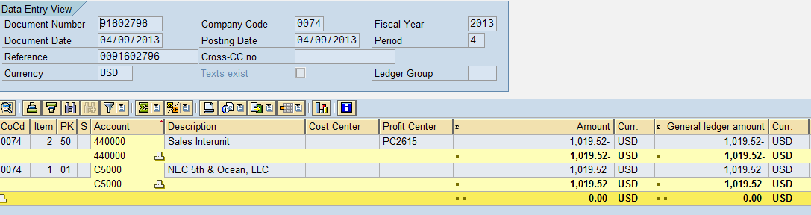

Inter Company Between 5th and Sales Org 1000
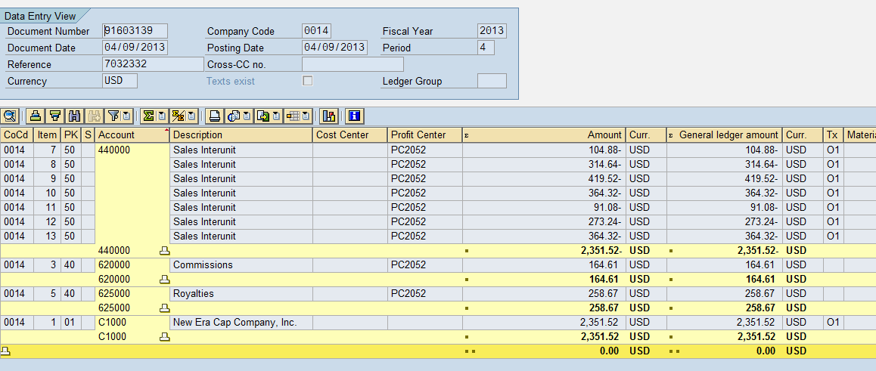
Customer postings for Sales Org 1000:
