**Availability check is considering Purchase Orders though it is been excluded in the scope of check irrespective of the procurement type.**

**Pre-requisites**

1. Availability check Z1 with check rule A has been configured for rush orders (document type – ZQR).

In the scope of check, Include safety stock is flagged under stock overview availability check is without RLT.

Purchase orders are not included in inward/outward movements.

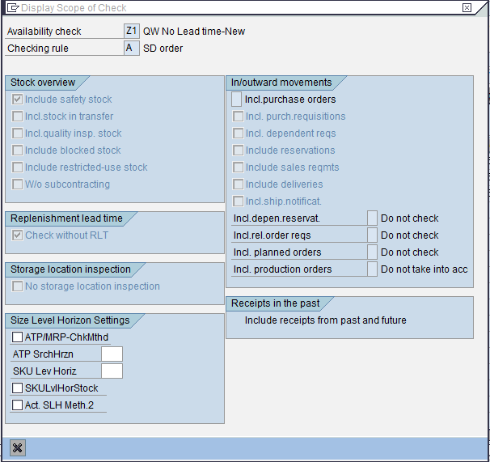

1. Materials used –
   1. 10017566 with Z1 availability check in MRP3 view with procurement type F in MRP2 view
   2. 10017580 with Z1 availability check in MRP3 view with procurement type X in MRP2 view
   3. 10017581 with Z1 availability check in MRP3 view with procurement type E in MRP2 view
2. Organisation and Master Data –
   1. Plant : 0116
   2. Sales area : 1000 / 10 / 00
   3. Sold to : 1000018
   4. Ship to : 1000018
   5. Vendor : 204242
   6. Purchase org : 0010
   7. Purchase grp : 001
   8. Company code : 0010

*Case – 1:* Z1 availability check with procurement type F

Step-1: Create PO for material 10017566 with quantity 10 EA for size 718 and delivery date 05/20/2014.

Step-2: Create SO with document type ZQR for item 10017566 for quantity 10 EA with requested delivery date 05/22/2014.

**Observation: ATP check confirms order quantity based on the PO stock though it is not configured in the scope of check.**

Example documents: PO – 4600006824

SO – 66905

*Case – 2:* Z1 availability check with procurement type X

Step-1: Create PO for material 10017580 with quantity 10 EA for size 718 and delivery date 05/20/2014.

Step-2: Create SO with document type ZQR for item 10017566 for quantity 10 EA with requested delivery date 05/22/2014.

Example documents: PO – 4600006825

SO – 66907

**Observation: ATP check confirms order quantity based on the PO stock though it is not configured in the scope of check.**

*Case – 3:* Z1 availability check with procurement type E

Step-1: Create PO for material 10017581 with quantity 10 EA for size 718 and delivery date 05/20/2014.

Step-2: Create SO with document type ZQR for item 10017566 for quantity 10 EA with requested delivery date 05/22/2014.

Example documents: PO – 4600006826

SO – 66909

**Questions**

1. Why is the ATP considering incoming PO’s though it is not included in the scope of check?
2. How to exclude PO’s from scope of check for items having different procurement types like External, In-house or Both?

*Case-1*

PO - 4600006923

Delv. - 6/20

Mat - 10017566

Qty - 10 EA

Size - 718

SO - 67050

Order rejected with J0 in create; changed to Z9 on save

*Case-2*

PO - 4600006924

Delv. - 6/20

Mat - 10017580

Qty - 10 EA

Size - 718

SO - 67051

Order rejected with J0 in create; changed to Z9 on save

*Case-3*

PO - 4600006925

Delv. - 6/20

Mat - 10017581

Qty - 10 EA

Size - 718

SO - 67052

Order rejected with J0 in create; changed to Z9 on save

*Case-4*

PO - 4600006926

Delv. - 6/20

Mat - 10017581

Qty - 10 EA

Size - 718

SO - 67053

*Case-5*

AVC - Z5 w/o RLT

Plant - 0116

Size - 714

SP - 1000149

PO - 4600006927

Delv. - 6/20

Mat - 10010212

Qty - 10 EA

Size - 714

SO - 67055

Delv. - 6/22

Order rejected with J0 in create; changed to Z9 on save

*Case-5*

AVC - Z4 with RLT

Plant - 0116

Size - 714

Mat - 10014291

SP - 1000149

PO - 4600006928

Delv. - 6/20

Mat - 10014291

Qty - 10 EA

Size - 714

SO - 67059

Delv. - 6/22

Order rejected with J0 in create; changed to Z9 on save

*Case-6 (MIGO)*

AVC - Z4 with RLT

Plant - 0116

Size - 734

Mat - 10010886

SP - 1000149

PO - 4600006931

MIGO - 5000004377

Delv. - 6/20; Posting – 6/10

Mat - 10010886

Size - 734

SO - 67061

Delv. - 80011242

Delv. - 6/10

*Case-7 (STK + PO)*

PO - 4600006932

STK - 40 EA (as on 6/10)

PO - 50 EA (delv. On 6/20)

Size - 734

SO - 67062 60 EA (delv. 6/30)

Delv. - 80011243

Excess qty 20 EA was rejected with Z9 and delivery created for 40 EA