Purpose: Document the process “Automate CFM to SNC”.

T Code: ZECC_SNC

Program Name: ZSNC_ECC_MASTERDATA

Requirement: To transfer Master Data like Material, Plant and Info Records.

## Design:

Create a program which shall facilitate to transfer the master data such as Material, Plant and Info Records.

The Program shall execute

1. CFM1 (RIMODGEN) which creates the Integration Model.
2. CFM2 (RIMODAC2) which shall activate the Integration Model.
3. CFM7 (RIMODEL) which shall delete the Integration Model.

### Prerequisites:

* Master data in ECC
* A flat file with the correct format which must be placed in a folder which is given in the program.
* One file shall be generated per one vendor.
* File name shall be started with “**SIM_Vendor” (SIM: SNC Integration Model) E.g. SIM_208766_1, SIM_208824_12.**
* **Naming Convention for Creation of Integration Model CFM1.**

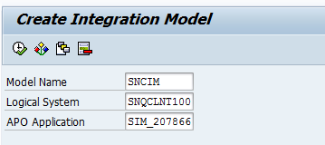

Model Name: **SNCIM** (This is hardcoded)

Logical System: Destination **SNQCLNT100** (Depending on the system we execute this program it would be SNPCLNT100 when executed in NEP)

APO Application: **SIM_207866** (this shall be starting 10 characters of the input file name)

This will facilitate a separate APO Application for each vendor.

This is currently hardcoded as the **IMPRG**.

*“Naming can be changed as per the convenience if required”*

* A folder in AL11 form where the files are read.
* A report which shall make a file and put in AL11 Folder (Crystal Report)

Split will be carried out by as per the number which is given in input. The program shall split the file and process.

### CFM Automatic Process:

T Code: ZECC_SNC

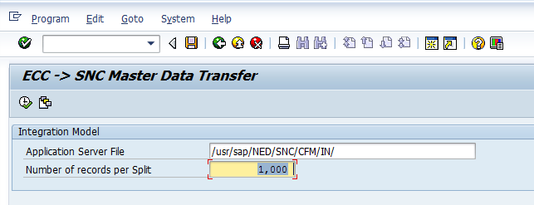

The program shall consider files with names starting with **“SIM”** in the folder mentioned in the above screenshot.

After the file is processed it shall be placed in the Archive folder

Currently the file path with the file name must be given as input.

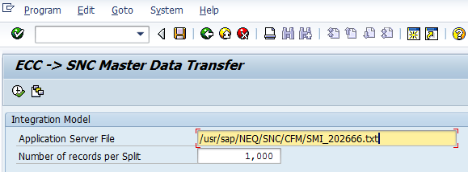

Current:

A Variant with the file name shall be saved and the program shall be executed. After the program is executed with the file, it (file in the directory which is saved in the variant) shall be overwritten with the new set of Master data list which shall be processed again.

Or

Whenever we execute a background job we need to give the file names dynamically.

Execute the program in background:

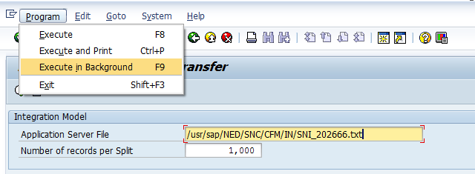

## Manual Process of CFM:

Create a Variant in CFM1, Input Material Numbers, Info Record and Plant.

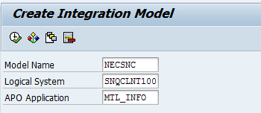

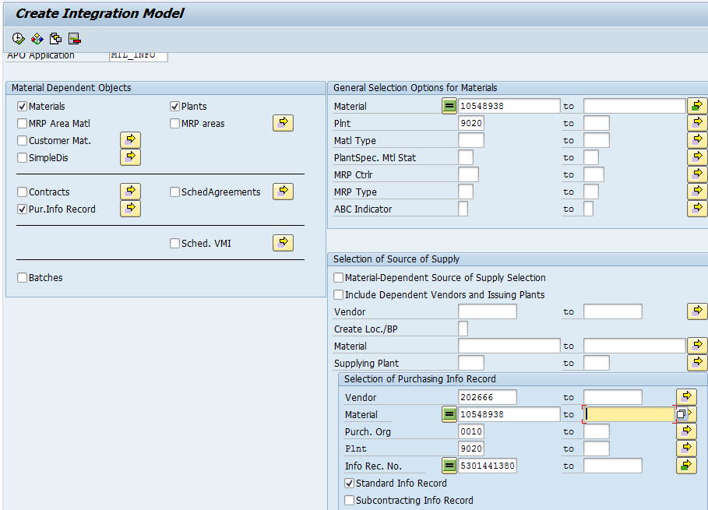

Save the variant.

With the same Variant execute CFM1

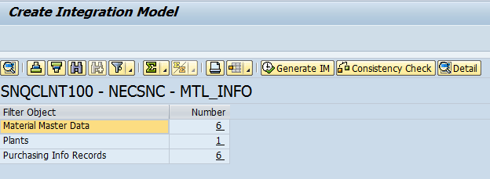

Hit Generate IM



This will create an Integration Model.

Go to CFM2:

Use same Model, Logical System and APO Application as inputs and execute:

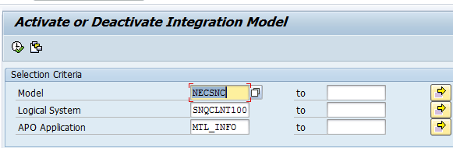

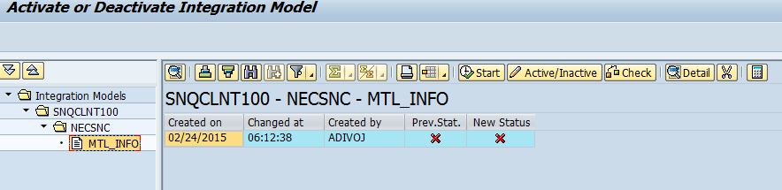

Select the IM and hit 

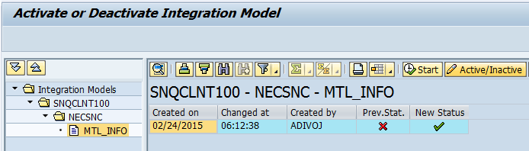

Then Hit Start.

Materials are processed and transferred to SNC.

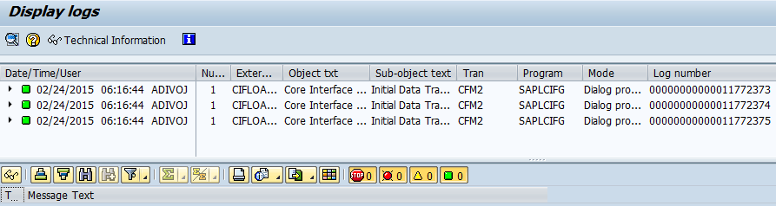

Notes:

* The variants are not saved for CFM1 to avoid huge number of Variants.
* Unaware of the type of errors usually seen when executed in NEP (need to be discussed with NE and if require need to add logic in the program)
* It is better to add a step to delete inactive integration models before this custom program when processed in NEP.

***The End***