**BIELSQ1:** Foreground Test:

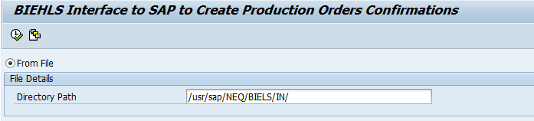

Result: Foreground Test1

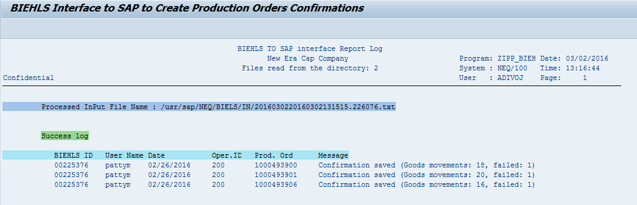

Result: Foreground Test2

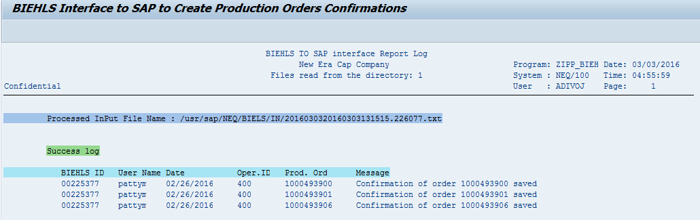

**BIELSQ2:** Foreground with no file in AL11 path:

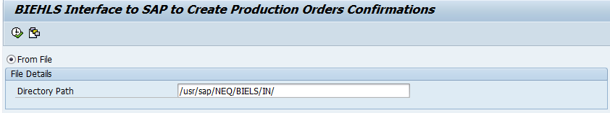

Result:

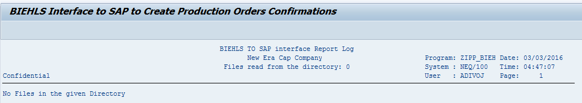

**BIELSQ3:** Background

Executed the program as background Job.

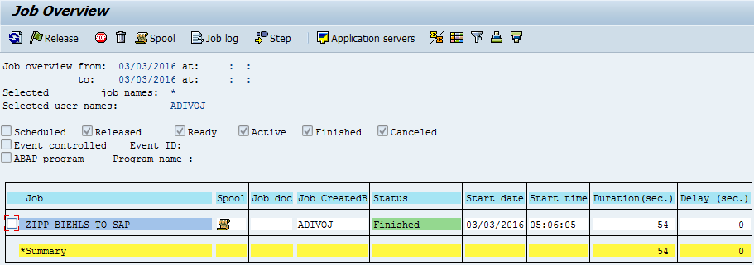

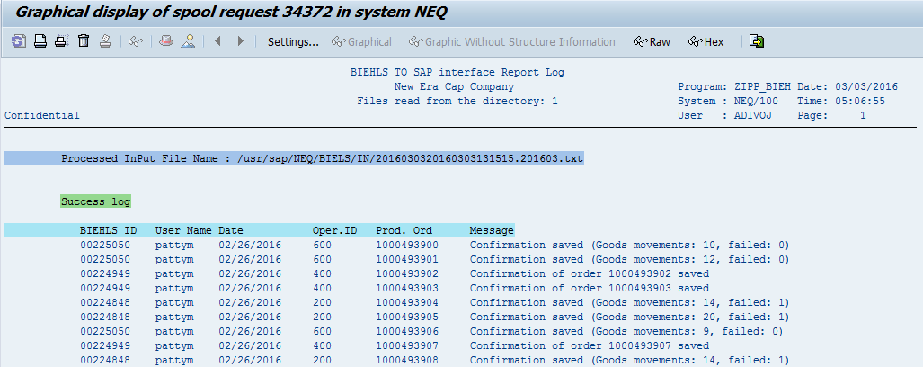

**BIELSQ4:** Background Job with no file in AL11 path:

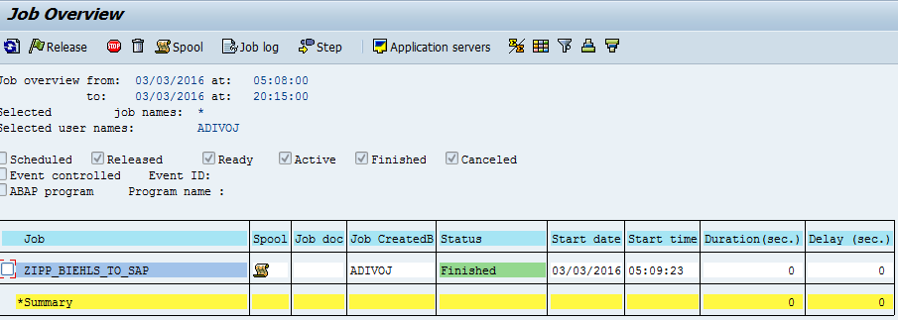

Spool:

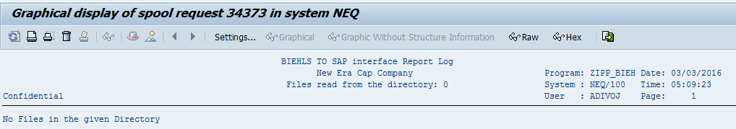

**BIELSQ5:** Background Job with some name in the input of the file.

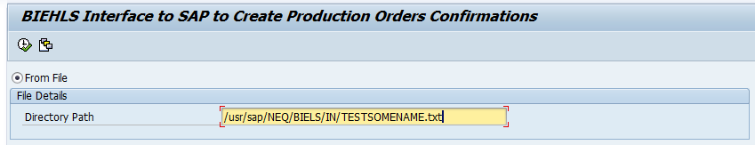

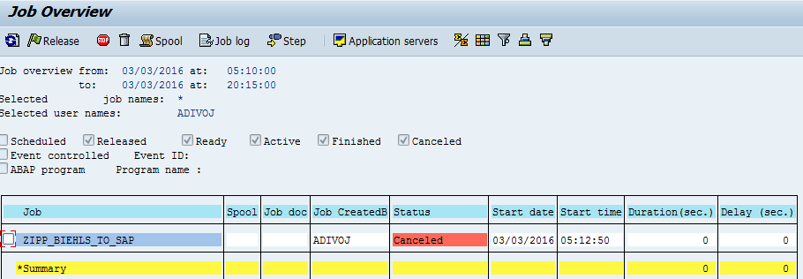

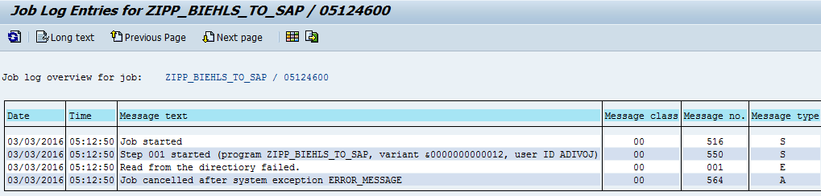

**BIELSQ6:** Wrong Directory path in the Input

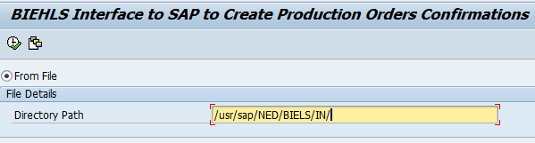

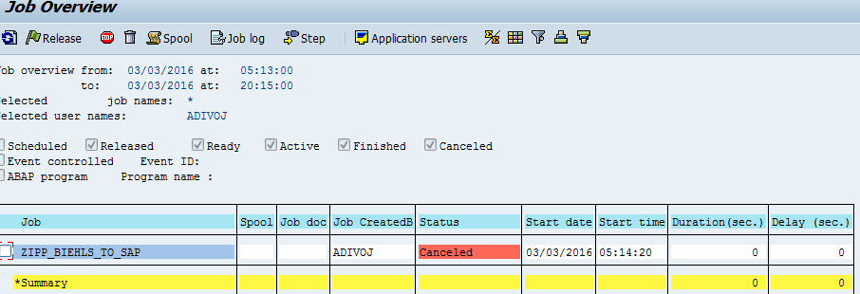

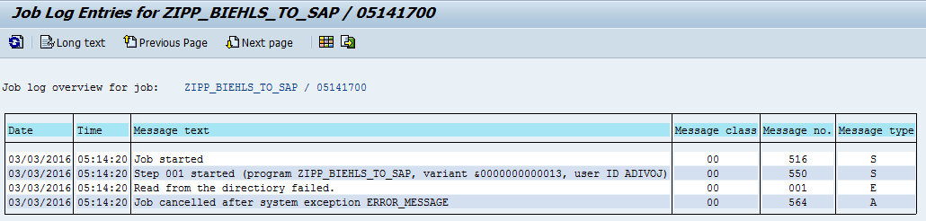

**BIELSQ7:** No Authorization to read the files from specified directory path, After the Transport is moved to QAS.

