**BIELS01:** Foreground Test:

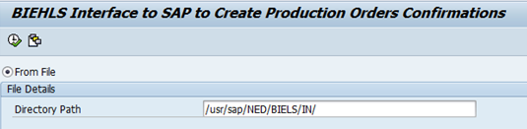

Result:

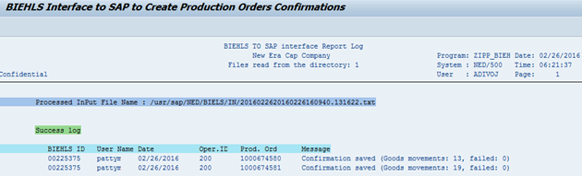

**BIELS 02:** Foreground with no file in AL11 path:



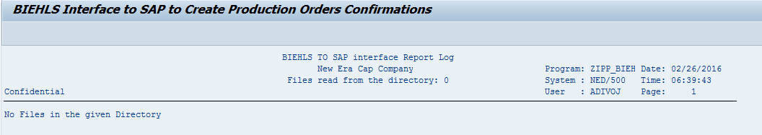

**BIELS03:** Background

Executed the program as background Job.

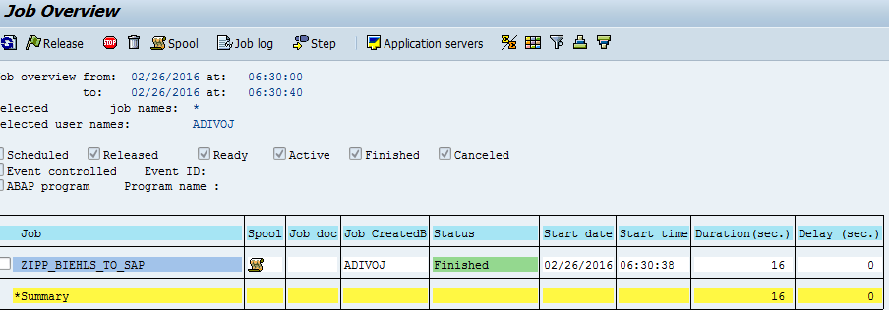

Spool:

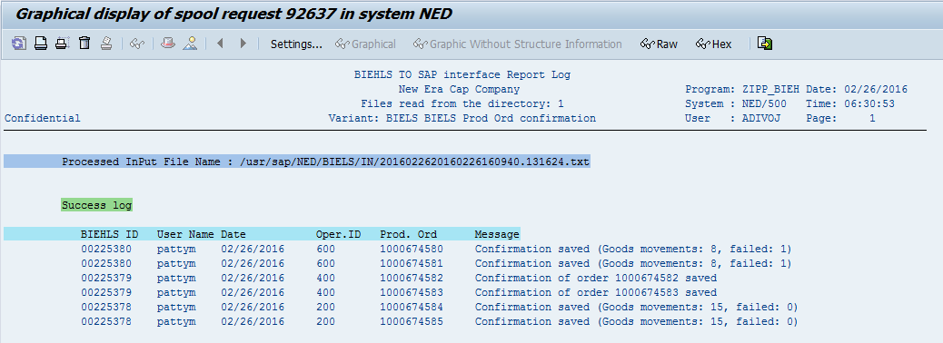

**BIELS 04:** Background Job with no file in AL11 path:

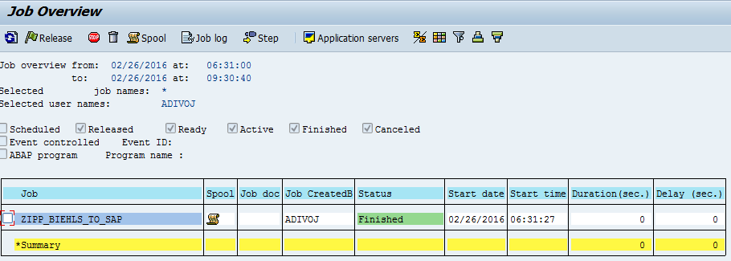

Spool:

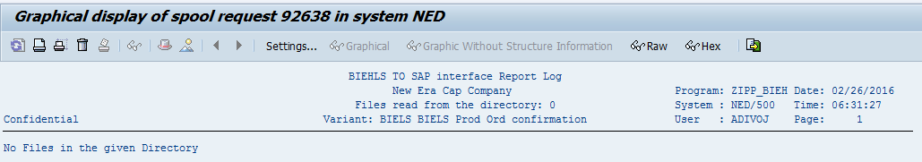

**BIELS 05:** Background Job with some name in the input of the file.

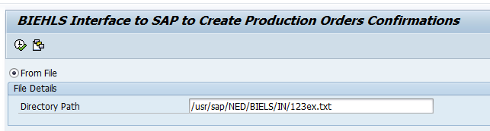

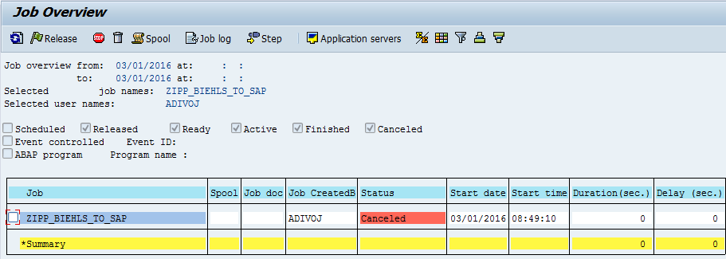

Job Log:

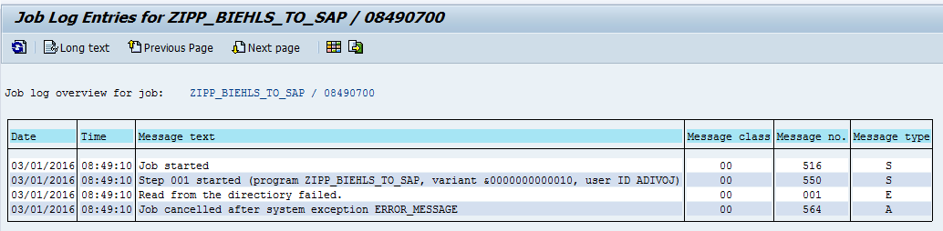

**BIELS06:** Wrong Directory path in the Input

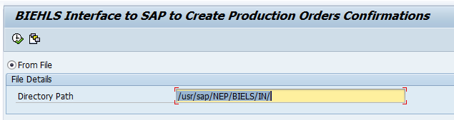

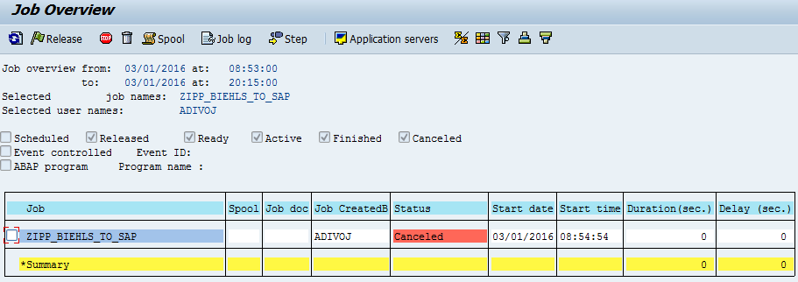

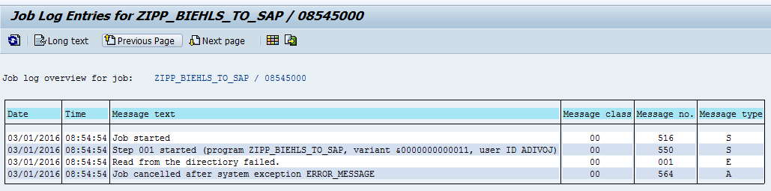

**BIELS07:** No Authorization to read the files from specified directory path.

We could not test this in NED500, but in NEQ600 we can test this once the TR is moved as I do not have authorization in NEQ600.

