**Billing plan Error in Sales order Display/change mode**

1. **Client – NEP100**
2. **Sales order – 3310114**
3. **Customer – 1005915**
4. **When the sales order is executed in VA02/ VA03, below error is displayed causing the exit of the transaction.**

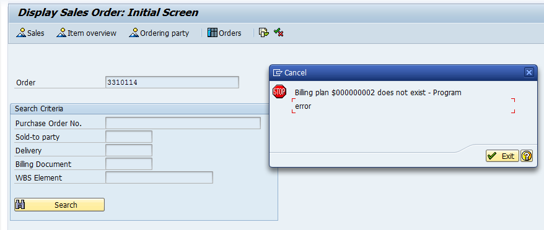

1. **No billing plan type is assigned in the sales order type or item category configuration.**

**Sales order type – ZOR**

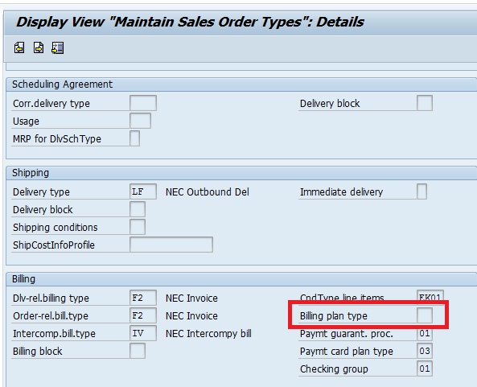

**Item category – TAN**

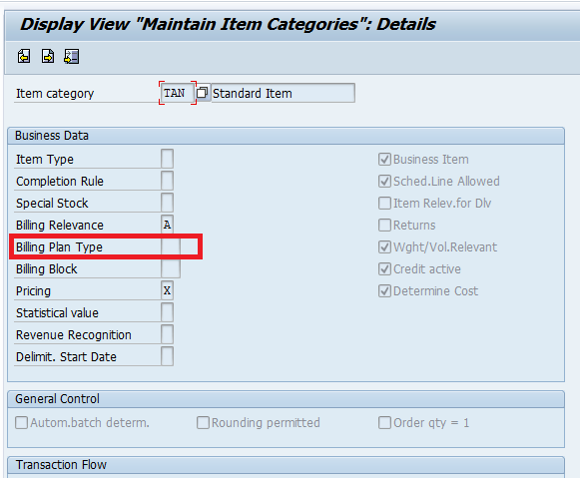

**Analysis:**

1. **The standard sales order program is debugged and found that the error is due to the invalid entry in VBAK – RPLNR field as below.**

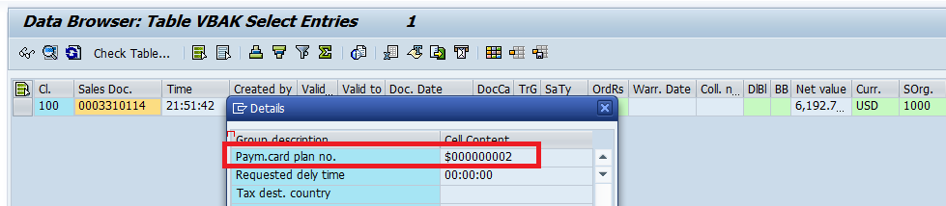

1. **No issue is found with the sales orders that are created before / after this specific sales order for the same customer.**

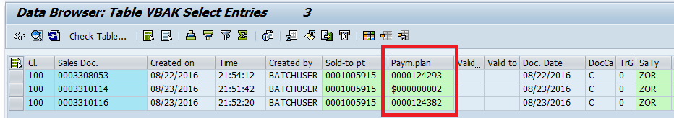

1. **While opening the SO in VA02/ VA03, the above error is obtained from the BILLING_SCHEDULE_READ Functional module.**