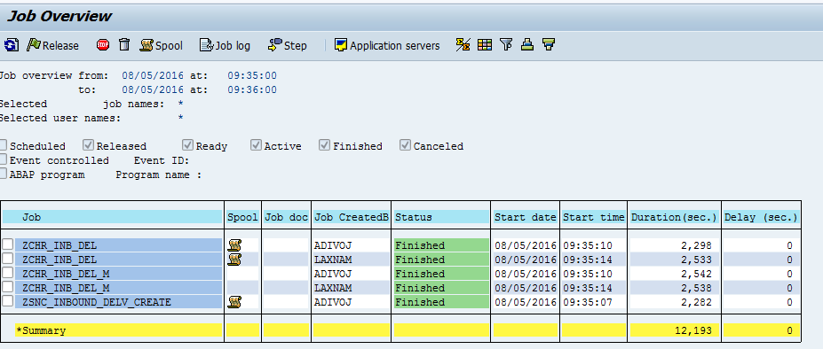

Job “ZCHR_INB_DEL” With user ADIVOJ is for Vendor 202290.

Job “ZCHR_INB_DEL” With user LAXNAM is for Vendor 202330.

ZSNC_INBOUND_DELV_CREATE is regular Inb Delivery Job.

Job “ZCHR_INB_DEL” With user Spool:

Vendor 202290: Only CHR Pos entered in the Job

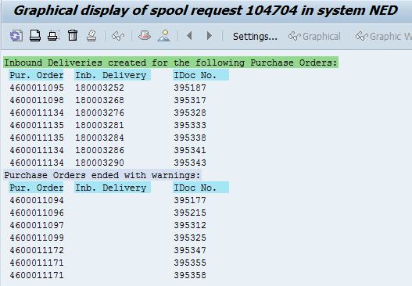

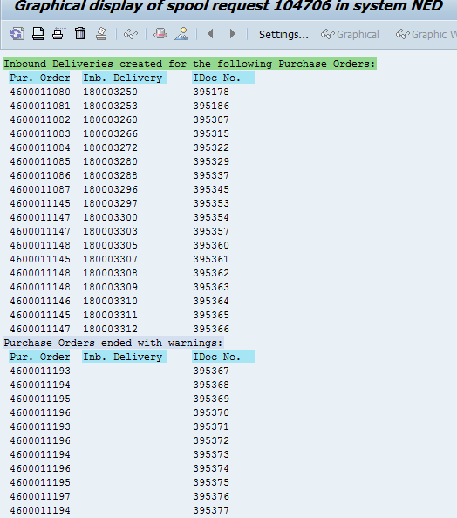

ZSNC_INBOUND_DELV_CREATE is regular Inb Delivery Job.

Z3NB Pos:

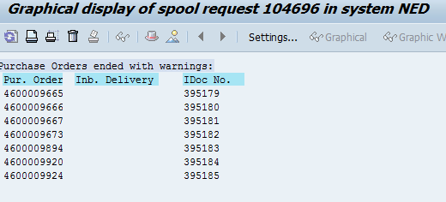

NB POS:

