**CM01** is the Capacity Evaluation and can be used for analysis of capacity.

**Prerequisites to run this transaction is**

Work Centre & Plant

Production Orders/ Planned orders.

Let us take a look at the CM01 transaction:

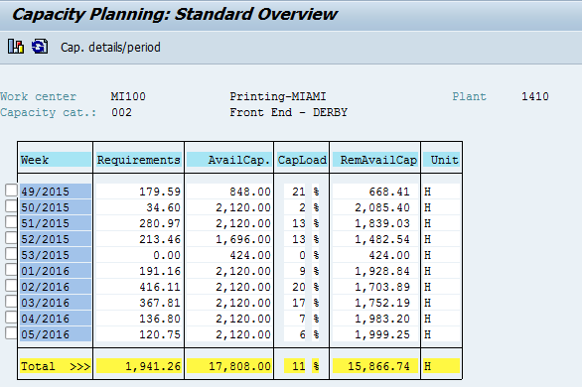

**How are Requirements determined in CM01?**

Let us take an example of week 50, which is showing 34.60 as the requirements

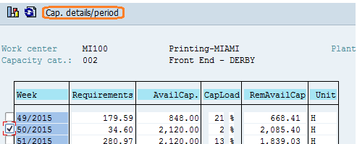

Select the week 50 and hit cap. Details/period which will show all the planned orders and production orders which are scheduled in that week.

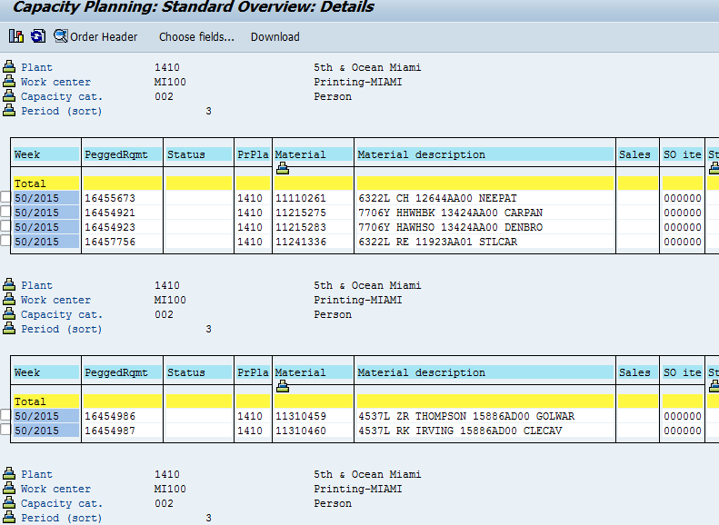

Here are the planned orders with materials and its quantities scheduled in week 50.

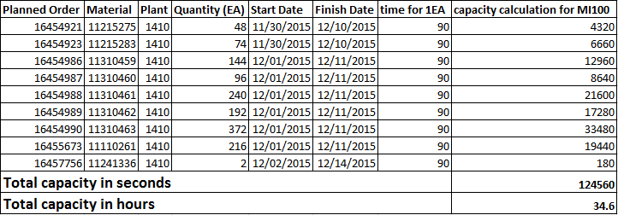

Let us calculate the requirements for planned order 16454921 form the above screenshot

Material ID: 11215275

Plant: 0116

Go to Transaction: CA03

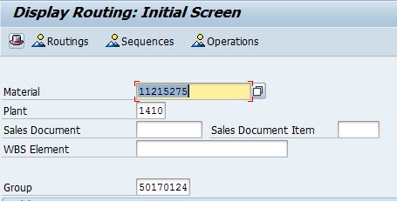

Hit Operations

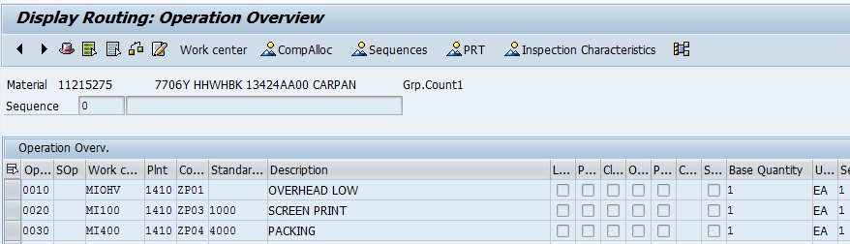

We see that operation 20 is carried out on the work center **MI100**, on which we are doing the capacity evaluation:

Double click on the Description of the operation to view the timings of the operation:

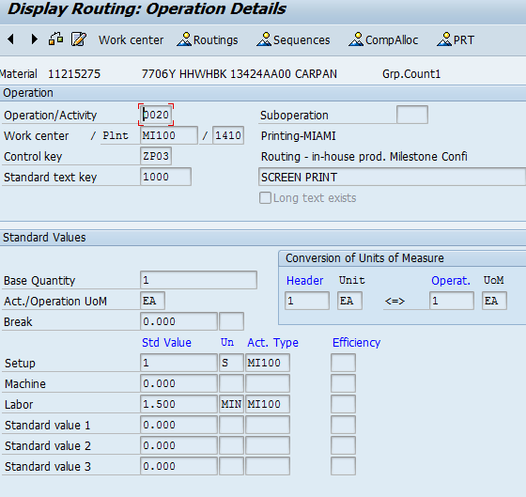

Looking at the above screen shot we see that to produce 1 EA of material 11215275 it takes 90 seconds.

As per the planned order 16454921 the quantity is 48 EA so time takes to produce 48 EA would be 4320 seconds.

**How available capacity is determined:**

For Eg: If we take a look at the Work Center MI100 for plant 1410 and for week 50 we see that the available capacity is 2120 Hours which is determined form the capacity transaction:

CR13 is the T code to view its capacity:

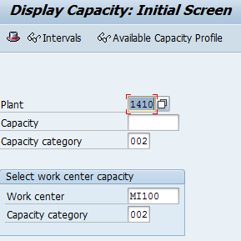

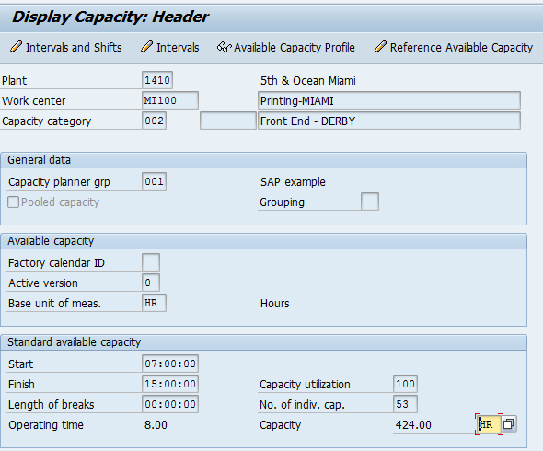

Here we see that the capacity for work center MI100 for one day is 424 Hours.

Week 50 is having 5 working days and the capacity is multiplied with 5 days hence the capacity of that work center for that week is 2120 hours.