COGI ERRORS

1000382318
Deficit of BA Unrestr. prev. 135 EA : 10683279 7410 STGE 0002164782.

Stock is available in SHIP S.Loc for blank size S and XL Change the Storage location and do the GR Reversal 102.

GR was done for the order 1000382318, on 07/13/2012.
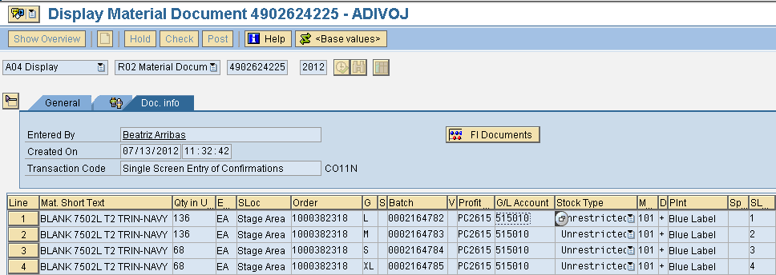

Delivery was done against to STO 6100006059 on 07/16/2012.

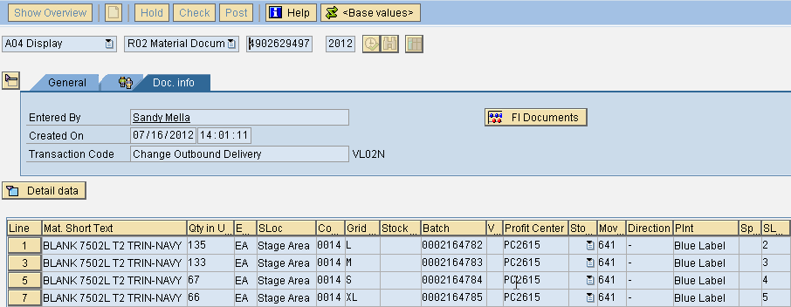

102 Reversal was shooting error on 08/20/2012, as the delivery was already done.
Hence 102 reversal to GR is not possible for the Blank Prd Ord 1000382318.

Stock is available in STGE S.Loc for Blank Size L and M, do reversal of GR.
1. Order 1000379771, Material 70121036.

Confirmation for this order was done two times by posting the stock in batches
L | 2177227 | 9 | 8
M | 2177228 | 6 | 5
S | 2177229 | 4 | 2
XL | 2177230 | 6 | 4

The Sales Order stock is again done transfer posting on 07/19/2012,
Sales Order 921030

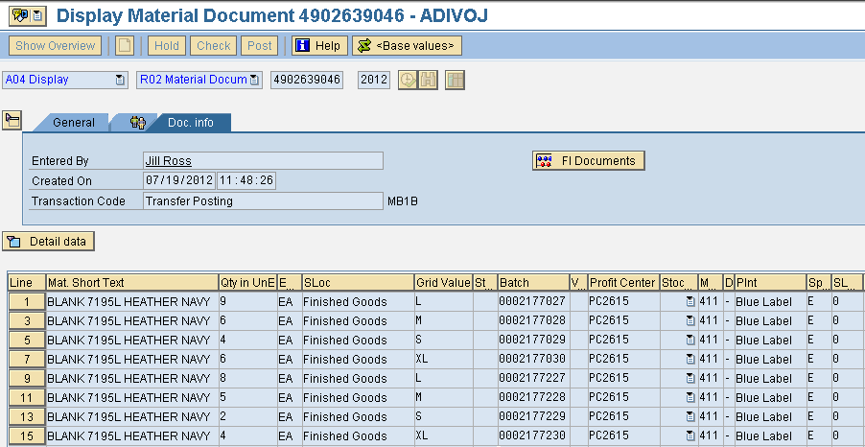
The stock is not available in that batch hence Error in doing the Reversal GR 102 for the Production oder.

Solution:

- Production Order 1000380298 Material 70121036

Confirmation was done for twice here are the details.
The stock is posted with the batch numbers.

L 2177032, 2177039
M 2177033, 2177040
S 2177034, 2177041
XL 2177035, 2177042

Transfer Posting is carried out for the stock posted batches shown in below screen shot.
Sales Order 921173
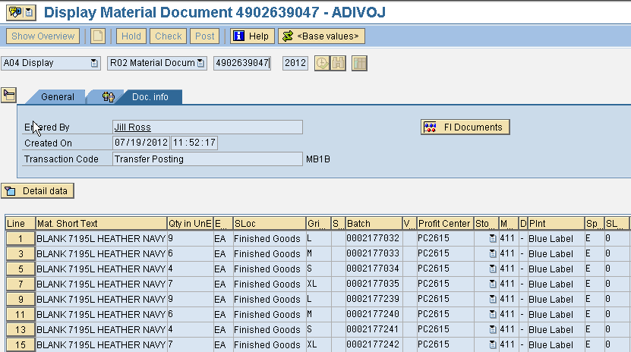
The stock is not available in that batch hence Error in doing the Reversal GR 102 for the Production oder on
07/18/2012
Solution:

- Order Number 1000379957 Material 70121036.

Confirmations for this order was done twice,
The stock is posted with the batch Numbers:

L 2177039, 2177231
M 2177040, 2177232
S 2177041, 2177233
XL 2177042, 2177234

Transfer Posting is carried out for the stock posted batches shown in below screen shot
Sales Order 921060
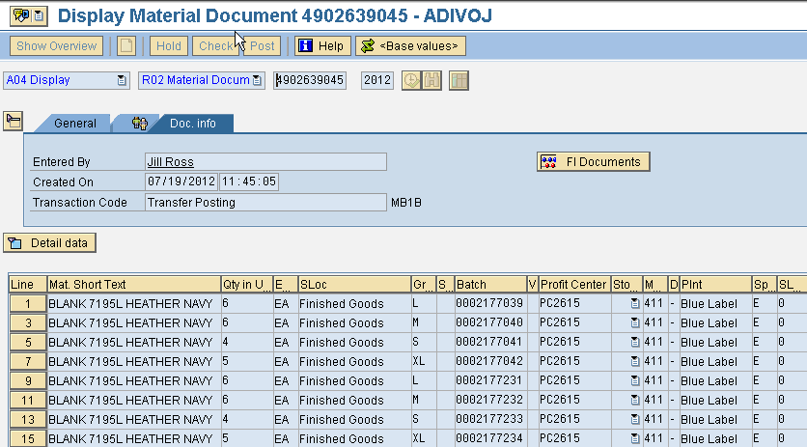

The stock is not available in that batch hence Error in doing the Reversal GR 102 for the Production oder on
07/18/2012

Solution:

- Order Number 1000379958 Material 70121036 .

The GR101 is done Twice for this Order
The Stock are posted in Batches
Transfer Posting is carried out for the stock posted batches shown in below screen shot
Sales Order : 921060
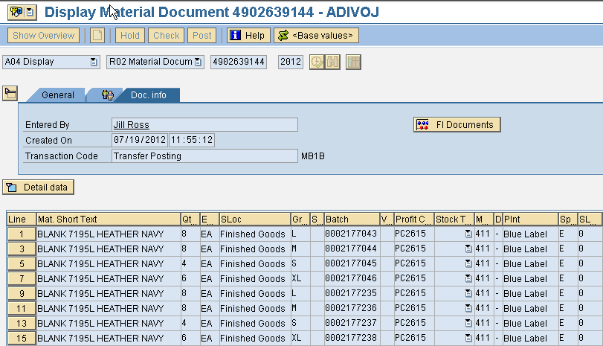
The stock is not available in that batch hence Error in doing the Reversal GR 102 for the Production oder on
07/18/2012
Solution:

Stock is not available in the batches for which GR reversal is carried out.
Change the Batch Number and go reversal GR.

- Order Number 1000379882 Material 70118805.

The GR for Confirmation is done Twice
The stock Posted With the Batch Numbers
Transfer Posting is carried out to the stock with the above Batch Numbers.
For the Sales Order 920996.
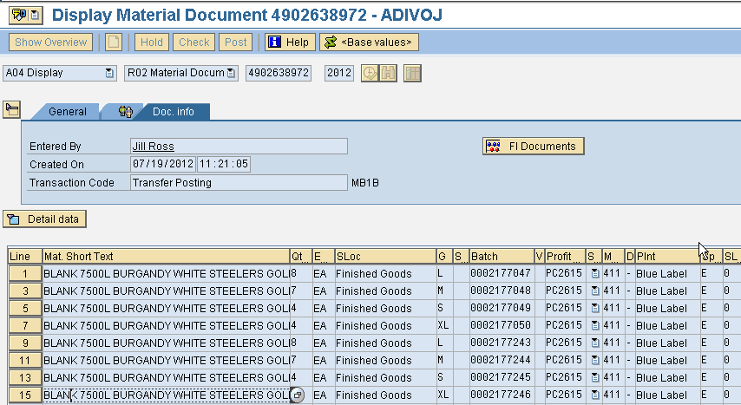
The stock is not available in that batch hence Error in doing the Reversal GR 102 for the Production oder on
07/18/2012
Solution:

- Order Number 1000380755 For Material 70119046,

The GR 101 is done Twice here are the details.
The Stock Posted to the Batches:
L 2178820, 2148848
M 2178821, 2148849
S 2178822, 2148850
XL 2178823, 2148851

Stock (Blanks) is consumed to the order 1000378081 (Pegged Req:70116270) with the reservation No 13453193.
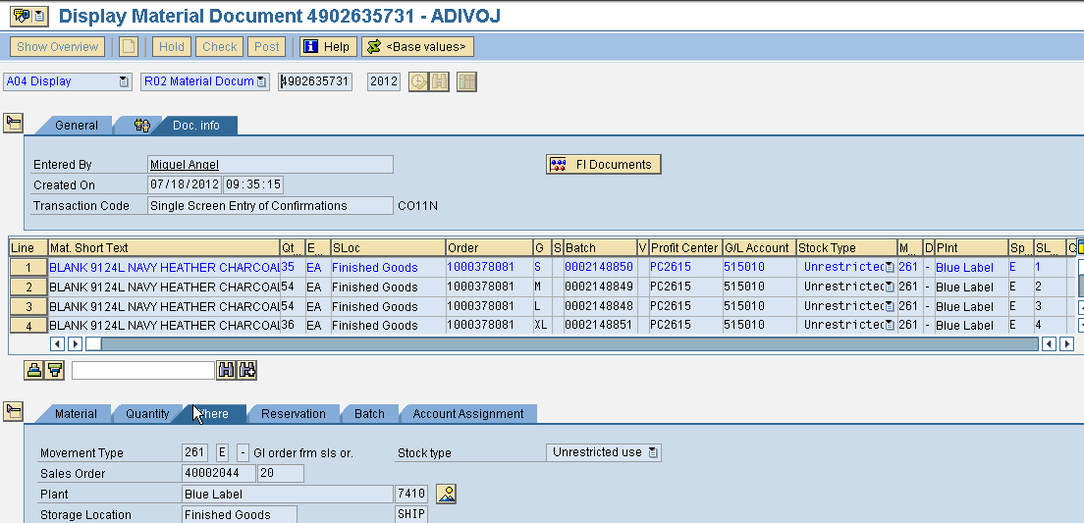
The stock is not available in that batch hence Error in doing the Reversal GR 102 for the Production oder on
07/18/2012
Solution:

- Order Number 1000379521, Material Number: 70121143, Solution can be implemented

GR 101 is done Twice to this order with some variances in the quantities for the Grid.
The Stock Posted with dates and Batches
SIZE | DATE POSTED | BATCH | QUANTITY
2XL | 06/30/12 | 2137638 | 73
2XL | 07/23/12 | 2191318 | 74
L | 06/30/12 | 2137639 | 95
L | 07/23/2012 | 2191319 | 95
M | 06/30/12 | 2137640 | 95
M | 07/23/2012 | 2191320 | 95
S | 06/30/12 | 2137641 | 97
S | 07/23/2012 | 2191321 | 97
XL | 06/30/12 | 2137642 | 96
XL | 07/23/2012 | 2191322 | 95

The Document Number Posted for GR for this order is

On 07/23/2012, the stock is consumed, i.e done GI 261 for Production Order No. 1000378302(pegged Requirment::70117065) , with the reservation 13461780. The above green coloured batch is consumed. Document shown below.

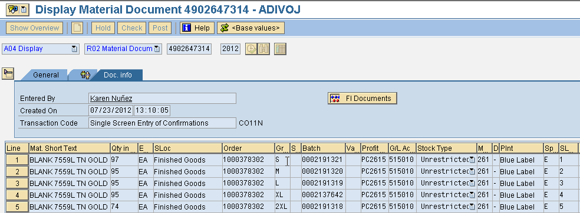
The reversal GR 102, was possible for the grid values L,M.S,2XL but not with XL because the stock was not available in the batch for which 102 was carried out

The reason for it is that stock is consumed by the reservation number 13461780. If the batch number at that time was 2191322.

Current Status: Stock is available in Batch No. 2191322. Quantity 95.

Solution: Change the Batch Number from 2137642 to 2191322 and do Reversal GR 102.

______________________________________________________________________________________

- For Production Order: 1000388891, Material: 70117402.

Stock is available for the batches.Reversal GR 102 can be carried out.

- For Produciton Order 1000401012, For Material 70118831

Stock is available listed in Batches below.

SIZE | DATE POSTED | BATCH | QTY |  |  | AVAILABLE STOCK
2XL | 07/23/12 | 2190975 | 1 | Transfer posting done from sales order stock to unrestricted stock, again from STGE to SHIP | Stock is available in SHIP | 1
2XL | 07/26/12 | 2202013 | 2 | -do- | Stock is delivered to 1410 on 08/22/2012 at 18:31:49 to STO 6100007155.
L | 07/23/12 | 2190976 | 4 | -do- | Stock is available in SHIP | 4
L | 07/26/12 | 2202014 | 4 | -do- | Stock is available in SHIP | 4
M | 07/23/12 | 2190977 | 5 | -do- | Stock is delivered to 1410 on 08/22/2012 at 18:31:49 to STO 6100007155.
M | 07/26/12 | 2202015 | 5 | -do- | Stock is delivered to 1410 on 08/22/2012 at 18:31:49 to STO 6100007155.
S | 07/23/12 | 2190978 | 3 | -do- | Stock is available in SHIP | 3
S | 07/26/12 | 2202016 | 3 | -do- | Stock is delivered to 1410 on 08/22/2012 at 18:31:49 to STO 6100007155.
XL | 07/23/12 | 2190979 | 3 | -do- | Stock is available in SHIP | 3
XL | 07/26/12 | 2202017 | 3 | -do- | Stock is delivered to 1410 on 08/22/2012 at 18:31:49 to STO 6100007155.

System is trying to do Reversal GR 102 from Following batches with quantities

0002190975 1 stock available is: 1, Change the Sloc from STGE TO SHIP and do GR Reversal 102
0002190976 4 stock available is: 4, Change the Sloc from STGE TO SHIP and do GR Reversal 102
0002190977 5 stock available is: 0,
0002190978 3 stock available is: 3, Change the Sloc from STGE TO SHIP and do GR Reversal 102
0002190979 3 stock available is: 3, Change the Sloc from STGE TO SHIP and do GR Reversal 102

- For Production Order 1000401010, Material: 70118831.

GR is done twice on 07/23/2012 at 11:45:15 : 4902647130
07/26/2012 at 13:32:20 : 4902656792

The Stock is Posted in the following Batches.
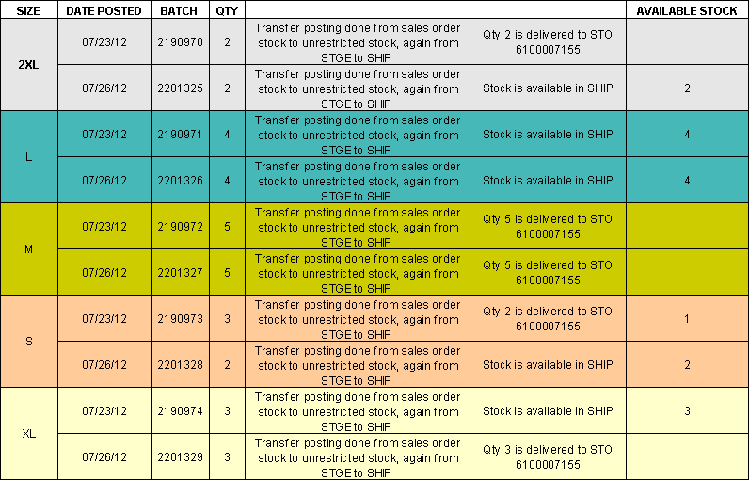
Sol:

- 2XL: Change the Batch No. 0002190970 to 0002201325, and S.loc from STGE to SHIP, and do Reversal GR.
- L : Change the Storage Location Form STGE to SHIP, and do the Reversal GR 102.
- M : Delivery for this Size is done Twice so the stock is not available for this Size, (wrong Delivery Posting done: Delivery not done atall for Size L: May be size mismatch.)
- S: Change the Quantity from 3 to 1, Change the S.Loc to SHIP, rest of the 2 quantities are available in another batch 2201328, GR can be done using the 2 Batches.
- XL : Change the S.Loc from STGE to SHIP and do the reversal GR 102.

- For Production Order: 1000400990, Material 70123418.

GR is done Twice 07//23/2012 at 17:39:19 : 4902647946
07/26/2012 at 13:32:52 : 4902656794

The Stock is Posted in following batches.
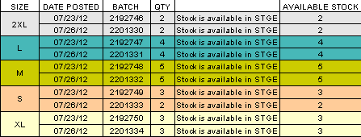
The Stock is available for all the batches.

Sol: Stock is Existing in all the Batches. Do Reversal GR 102.

.
- For Production Order: 1000392526, Material: 70118764.

GR is Done Twice 07/17/2012 : 4902632657
07/26/2012 : 4902665437

The Stock is Posted in Following Batches.

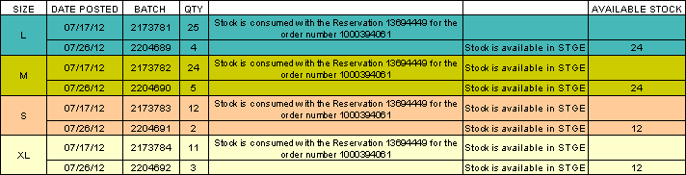
Sol:

- L : Change the Batch number from 0002173781 to 0002204689.
- M: Change the Batch number from 0002173782 to 0002204690.
- S: Change the Batch number from 0002173783 to 0002204691
- XL: Change the Batch number from 0002173784 to 000204692.

- For Production Order No. 1000411015, Material 70117322.

GR is done once to this order on 08/01/2012 : 4902676211
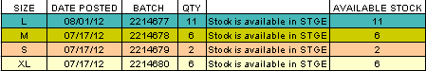
Sol: Stock is available in the batches for doing GR Reversal 102.

- For Production Order No. 1000420078, Material: 0002247239

GR is done once.
Sol : Stock is available Reversal GR 102, can be done.

