ZFOC sales process (TAB order) Configuration
1.Create a new item category as below.
Menu path – SPRO -> IMG -> Sales and Distribution-> Sales -> Sales document item -> Define Item categories.
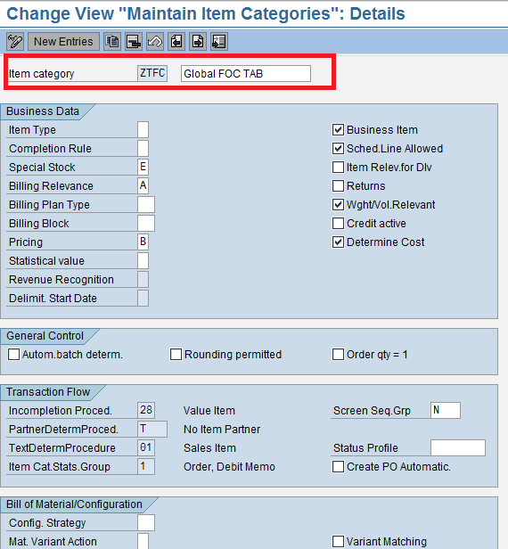

2.Item category determination for sales document type with NORM,BANC,BANS item category group as below.
Menu path – SPRO -> IMG -> Sales and Distribution-> Sales -> Sales document item -> Assign Item categories.

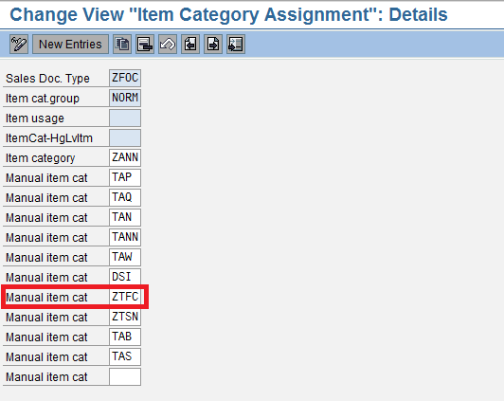

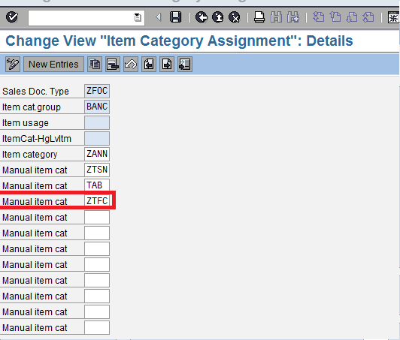

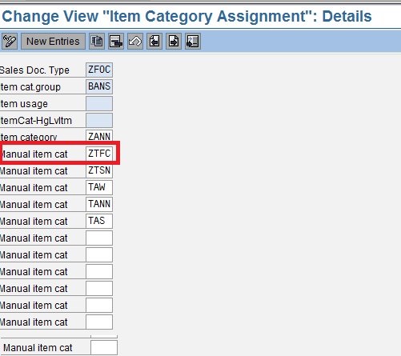
3.Create new account assignment category as below.
Menu path – SPRO -> IMG -> MM -> Purchasing -> Account Assignment -> maintain account assignment categories.

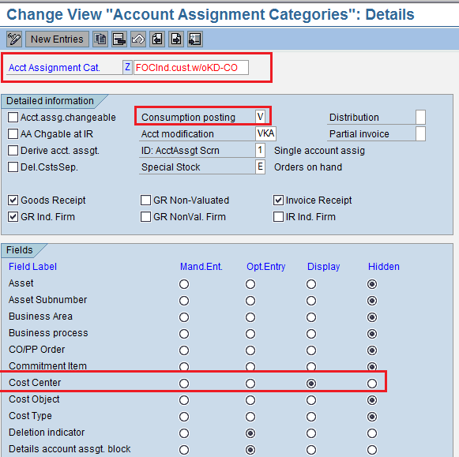

4.Assign account assignment to item categories as below.
Menu path – SPRO -> IMG -> MM -> Purchasing -> Account Assignment -> Define combination of item categories/Account assignment categories.
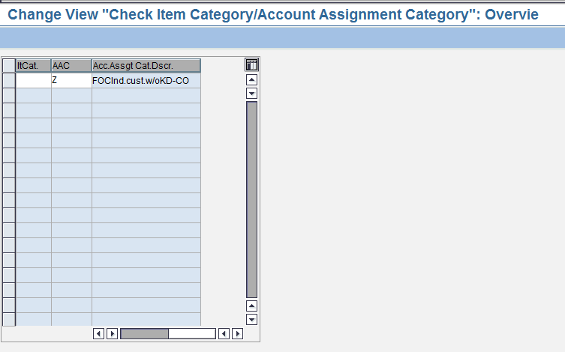
5. Create new Schedule line category as below.
Menu path – SPRO -> IMG -> Sales and Distribution-> Sales -> Schedule lines -> Define Schedule line categories.
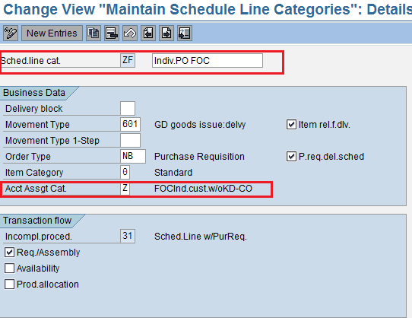

6. Assign Schedule line category for the item category ZTFC as below.
Menu path – SPRO -> IMG -> Sales and Distribution-> Sales -> Schedule lines -> Assign Schedule line categories.
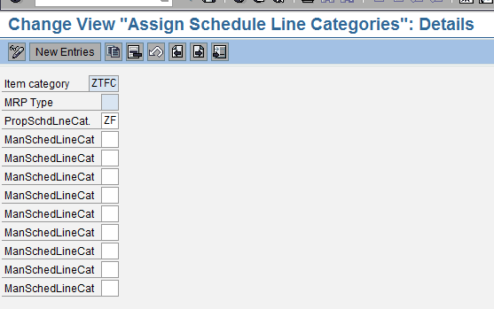
7. Create new requirement class with acc assignment ‘Z’ as below.
Menu path – SPRO -> IMG -> Sales and Distribution-> Basic functions -> Availability check and TOR -> TOR -> Define Requirment classes.
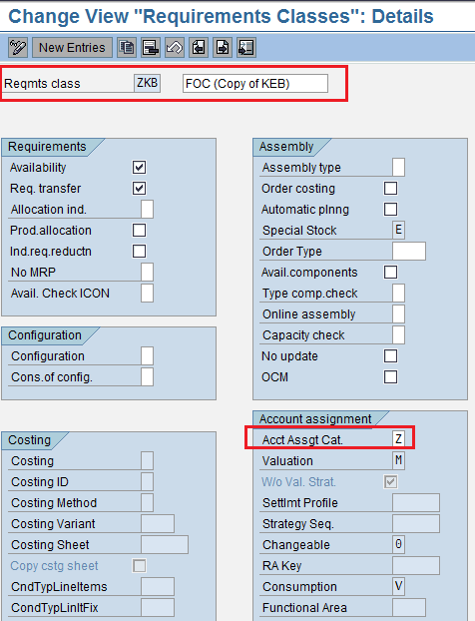

8. Assign new requirement type to the requirement class as below.
Menu path – SPRO -> IMG -> Sales and Distribution-> Basic functions -> Availability check and TOR -> TOR -> Define requirement types.

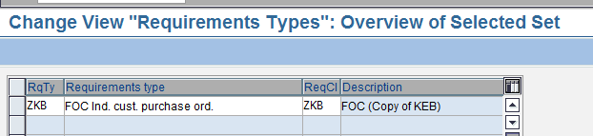

9. Assign requirement type to the item category ZTFC as below.
Menu path – SPRO -> IMG -> Sales and Distribution-> Basic functions -> Availability check and TOR -> TOR -> Determination of requirment types using transaction.

