1. REQUIREMENT:
To understand the current costing process and to provide a solution to update the actual standard price in the Material Master based on the last PO price from the most recent Purchase Order for that material.
2. SUMMARY:

The cost estimate with quantity structure is a tool for planning non-order-related costs and establishing the prices for the materials. It calculates the cost of goods manufactured and cost of goods sold for each product unit. We can use the results of the standard cost estimate for material valuation for standard prices.

We do Cost Estimate by using CK40N Transaction code. CK40N considers primary vendors condition record (J3AP) to estimate the cost of the material if the material is supplied by different vendors with different prices.
- CK40N uses priority of strategy sequence to calculate the price.
- Strategy sequence is supplied by costing variants.
- NEC uses costing variants as NEC1, NEC2, NEC3, PPC4.
- Mostly used Costing Variant is NEC2.

Below Document explains about the Cost estimate by the user exit and calculation of the condition types in the user exit and final calculation and it's dependencies.

Provided the solution to the requirement of updating the last PO price in the material master that existed in the system.

NEC Costing Variant Strategies:
NEC2 Strategy Sequence for Glabal Material:
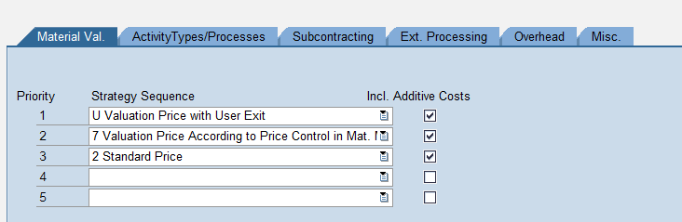
NEC3 Strategy Sequence for Domestic Material:
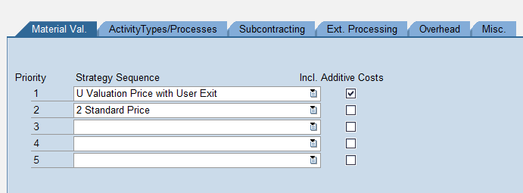

NEC2 are assigned with the cost components (N10).NEC3's cost component is (N13).Actively used costing variants are NEC2 for global Items and NEC3 for domestic Items. NEC1 and PPC4 are not in use now.
In production NEC2 and NEC3 contains the following records NEC2: 10,291,338. NEC3: 43,309

NEC's most used costing variant is NEC2 with 10M records in PRD. Below is the pricing strategy sequence for NEC2.
- U Valuation Price with User Exit will trigger only if J3AP values are maintained. J3AP price can be carried out from condition record or purchase Info record. If the condition type is maintained it considers the value from Condition record. If condition record is not maintained it considers the value from the purchase info record.
- 7 Valuation price according to the price control in material master will trigger only if the J3AP values are not maintained and standard or/and moving average values are maintained in the material master.
- Standard Price: This step will never trigger as it will stop at step 2 as the step 2 is always valid.

If none of the above steps are valid CK40N troughs error.

There are multiple places we maintain the standard cost of the material.
1. Standard Cost of the material in the material Master (MM03)
2. Standard Purchase Price (J3AP) from Condition record (ME11)
3. The Price in info record cost (MEK1)
4. Actual PO Price (ME21N).

1. Standard Cost of the material in the material (MM03)
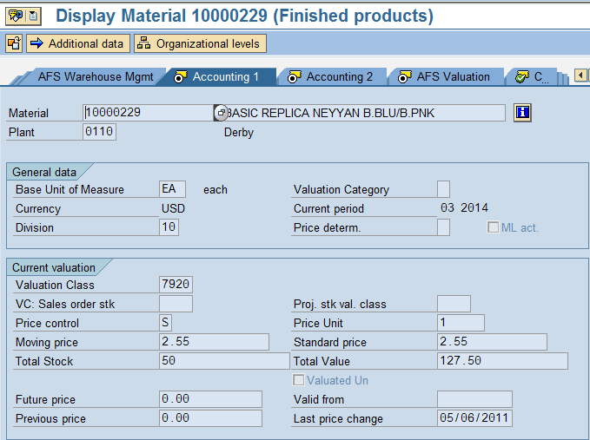
2. Standard Purchase Price (J3AP) from Condition record (ME11)
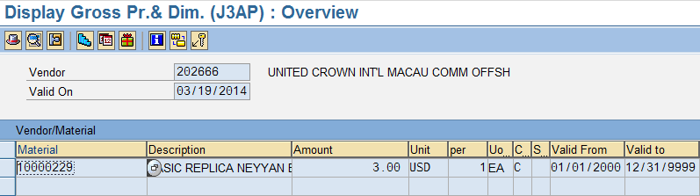

4. The Price in info record (MEK1)
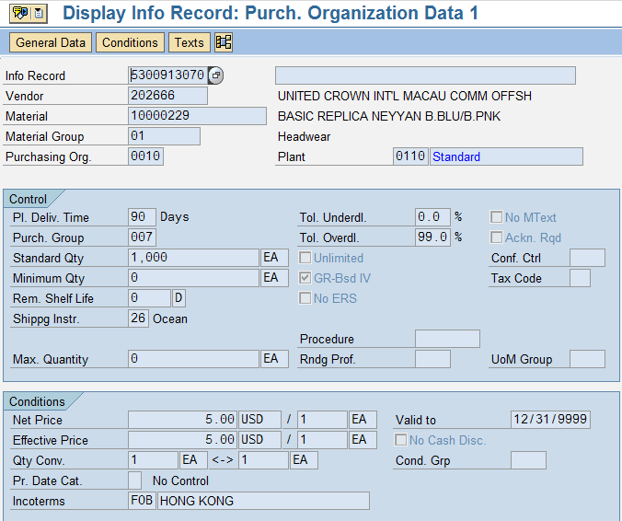
5. Actual Price(Entered) in the PO (ME21N) .
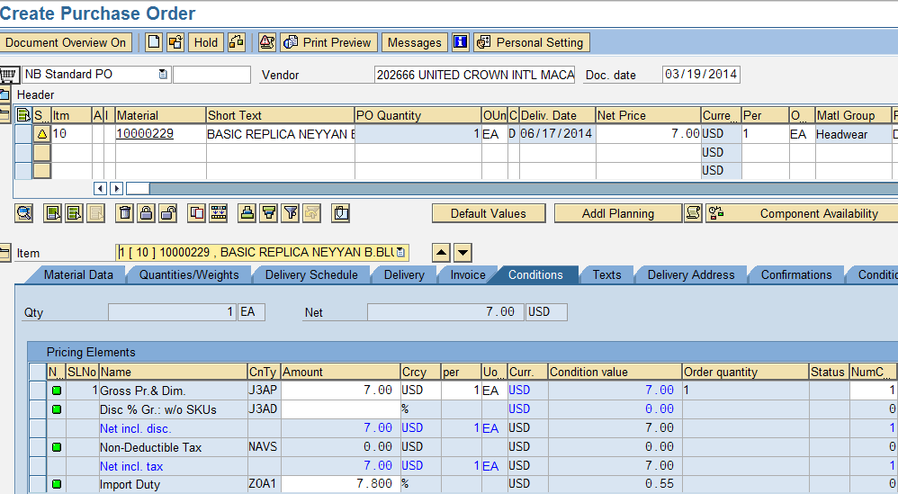
User Exit in CK40N calculates the material price with the below priority:
1. Standard Purchase Price (J3AP) from Condition record (ME11) 3.00 USD
2. The Price in info record cost(J3AP) (MEK1). 5.00 USD
3. Standard Cost of the material in the material (MM03) 2.55 USD
But it does not get any value from the PO as below price
Actual PO Price (ME21N). 7.00 USD

If we assume, we maintained the condition record for the Primary vendor 202666 then the Price of J3AP is 3.00 USD. We will consider J3AP= 3.00 in the below example to show how the user exit is calculating the condition types and then the standard cost of the material.

User exit is ZXCKAU08 considers the condition types J3AP, ZJ3S, ZOS0, ZOA1, ZGE0, ZPOH while calculating material cost.

J3AP Gross Pr.& Dim.
ZJ3S Item Size Schg
ZOS0 Import Frt Air/Ocean
ZOA1 Import Duty
ZGE0 Distribution OH
ZPOH Procurement Overhead

During cost roll up, SAP will calculate the new standard material cost based on the condition record price 3.0, in addition, also taking additional freight , duty , and Procurement overhead, into consideration.

Condition | Table | Vendor | Material | Value | Calculation
J3AP | A965 | 202666 |  | 3.00
ZJ3S | A982 | 202666 |  | 0
ZOS0 | A968 |  |  | 0.25
ZOA1 | A967 |  |  | 0.23
ZGE0 | A977 |  |  | 0.05
ZPOH | A978 |  |  | 0.05
  3.58 | USD
Calculation of the condition type values based on the criteria in the table, it is not a fixed value that user exit captures country of the plant that exists.
We can see the CK40N values as below as 3.58USD as a result of user exit calc.

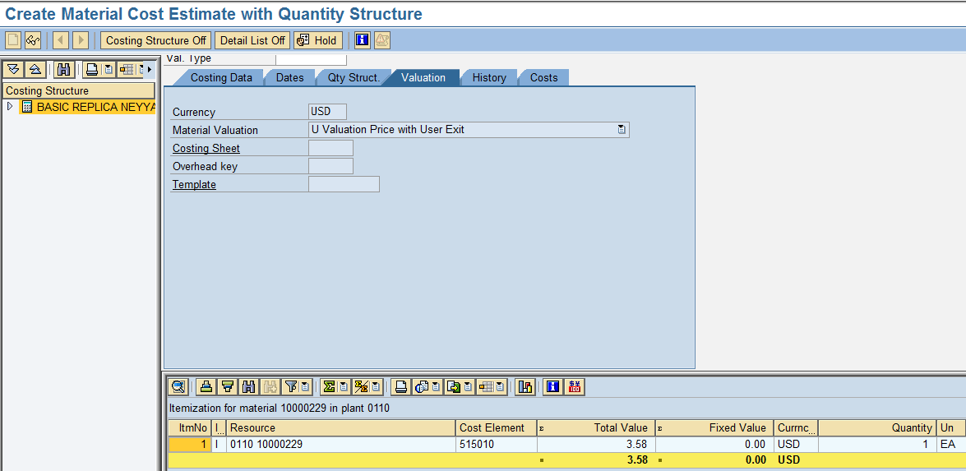

Primary Vendor determination Process:
1. The system searches first for a quota arrangement.
2. If no quota arrangement or permitted vendor can be found, the system
searches for a source list for the material.
3. If no such vendor can be found, the system checks to see whether you have
defined in Customizing that a regular vendor can be set.
4. If even searching the source list proves fruitless and you have defined in
Customizing that a regular vendor can be set, the system then searches for a
vendor in every available info record.
5. If there is no regular vendor or if you have specified in customizing that the
regular vendor indicator in the info record is ignored, the system uses the
vendor having the lowest net price of all the info records to calculate the price.

Note: If we select more than one Vendor in the source list system selects the cheapest price of the Vendor.
In NEC we maintain Source List as below (ME01):

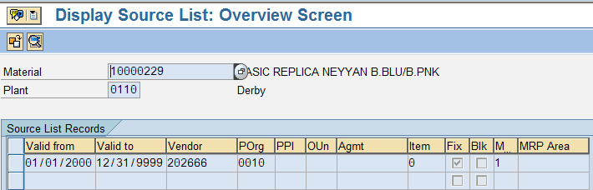

VENDOR INFO RECORD:
Material 10000229 is supplied by 3 vendors 200002,202666,204246 at different prices. Cost Estimate program considers only the Vendor 202666 as a primary vendor as we maintained the source list.

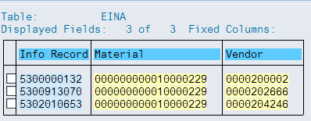

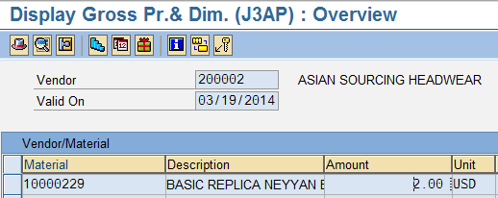

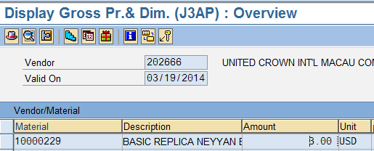

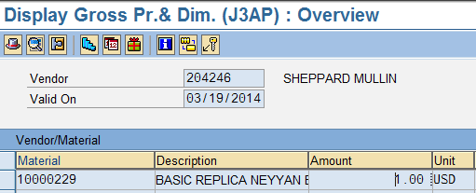

REQUIREMENT:

Normally Costing run captures J3AP from the condition record or purchase info record. But Requirement is to have the standard cost estimate from the Last changed price (J3AP)from the PO.

Screen1, Screen 2 shows the purchase order price and CK40N Values before we change the price in the PO. Screen 1 and screen2 shows the same values.

Screen 3, Screen 4 shows the purchase order price and CK40N price after changing the price in PO. Screen 3 Screen 4 the values are different.

Note: Not all the conditions in the PO are same as user exit conditions.

Screen 1:
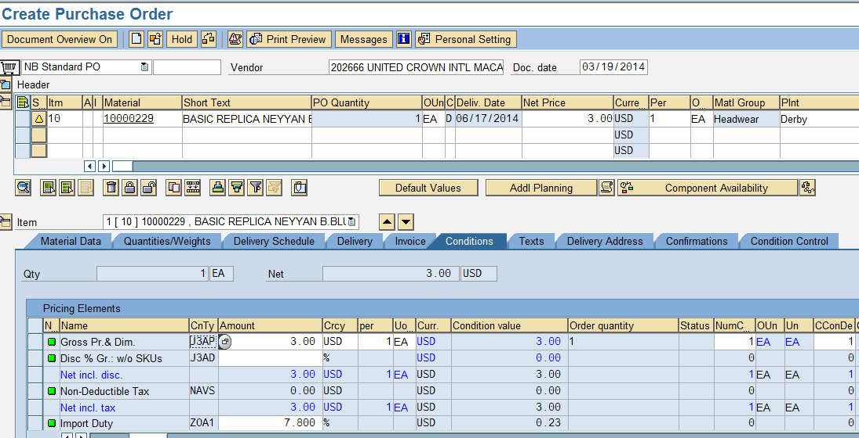

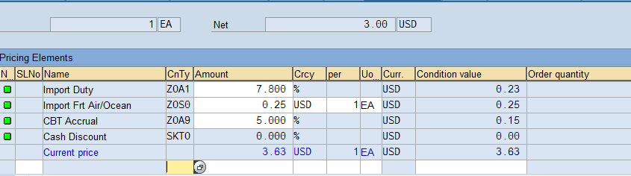
3.63-0.15(Z0A9)+.0.5(ZGE0) = 3.58

Screen 2
CK40N
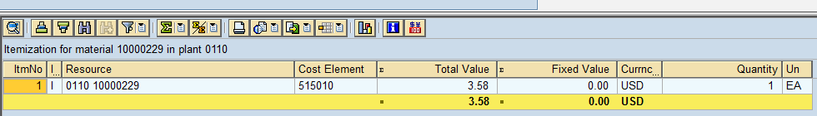

If we change the price in PO, J3AP value changes but costing does not take the J3AP values that are changed by PO.
Screen 3:
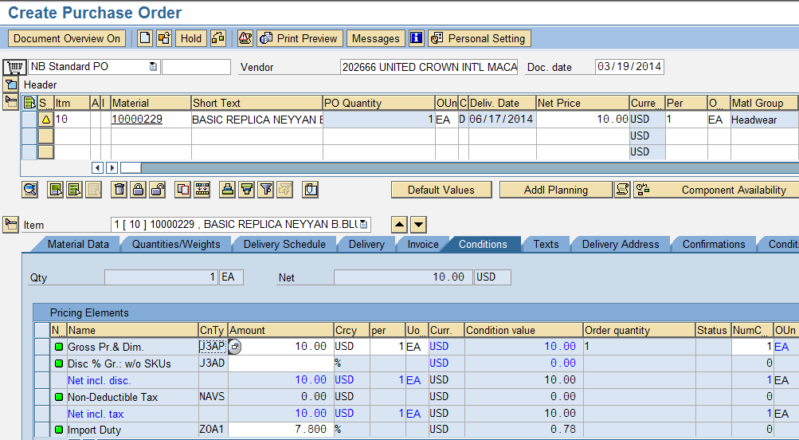
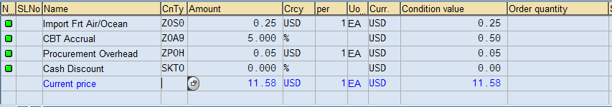
Screen 4:
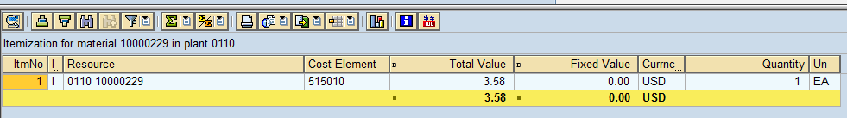

SOLUTION 1:

Update the purchase Order price in the purchase Info record and then use the purchase info record for the material valuation strategy sequence in costing variant.

Below screen shows the settings to update the purchase Order price in the purchase Info record.
Material Management → Purchase Order → Environment Data → Define Default Values for Buyers
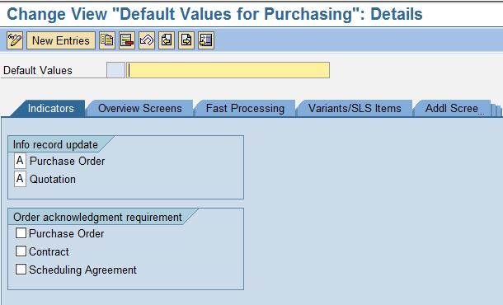

Update the Last Purchase Order Price: Enter the price 10$ manually in purchase order, Make sure to set info update check mark on the purchase order is set. It assumed to update the purchase order Info record. Once it updates the price then that price can be captured in costing Variant. For that costing variant material strategy should be defined as Purchase Order Info record price.

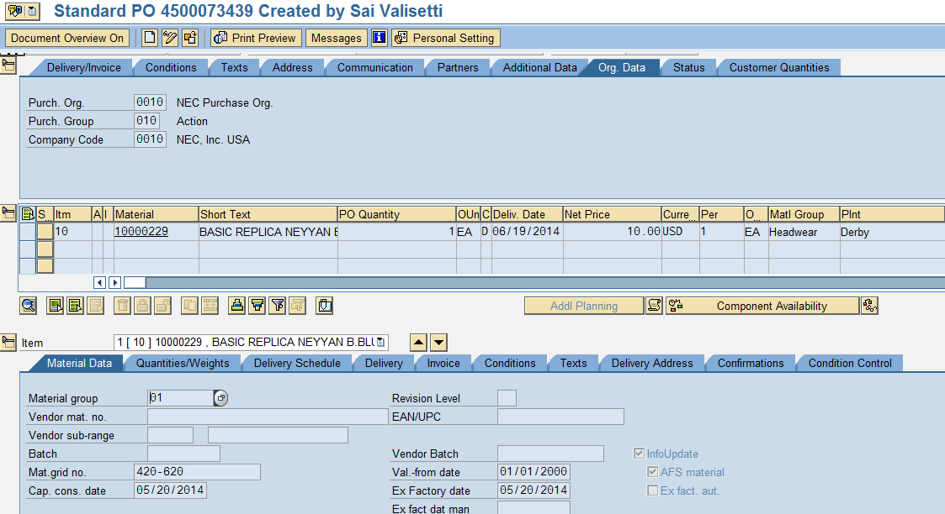

Costing variant to use the purchase Info record as the material valuation price.
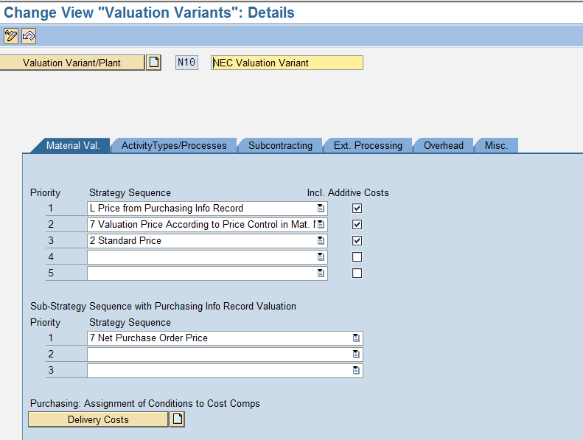
SOLUTION 2:
Develop a program to update the plan price 1 in costing tab of material master with the last purchase price. Define the valuation variant with the strategy as price from plan price 1. When we run the cost estimate the cost will be calculated with the last purchase price.

Note: We need to run the update last purchase price program (Zprogram) first and then the cost estimate.
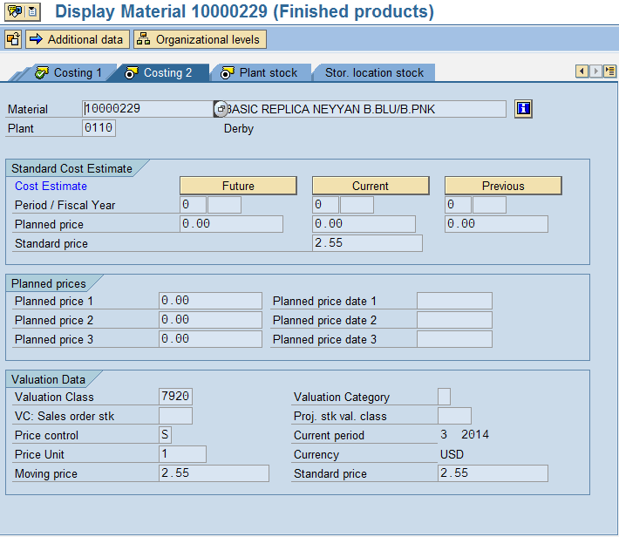

SOLUTION 3:
Costing run considers the value of the condition record of the primary vendor.
But the request is to have the value from the Latest value in the purchase order. Purchase order price is not determined by the primary vendor.
Need to know if the cost estimate by primary vendor or any vendor that supplied the material listed in the last PO created.
If it is a primary vendor's the latest purchase price value update in material master by changing the USER EXIT or creating a new user exit and assigning that to new Costing variant NEC4?.

