**Purpose:** This document is to show Sales order Rescheduling considers the delivery date form the Inbound Delivery.

**Process Steps:** Here are the process steps which were done.

Created a sales order 1338618

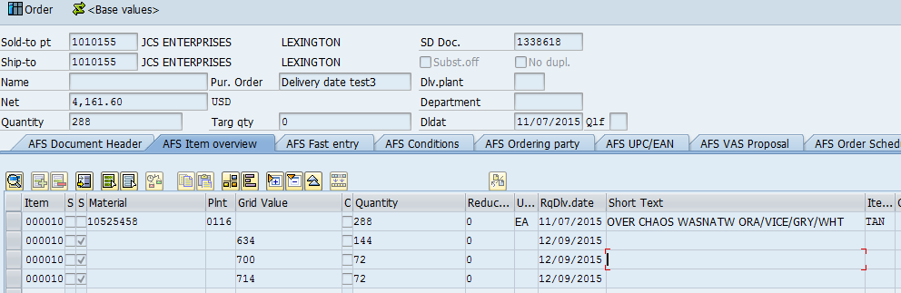

/AFS/MD04 Screen:

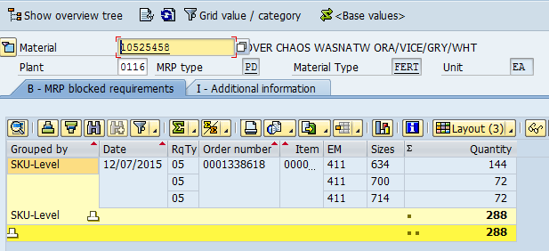

Ran MRP on this Material:

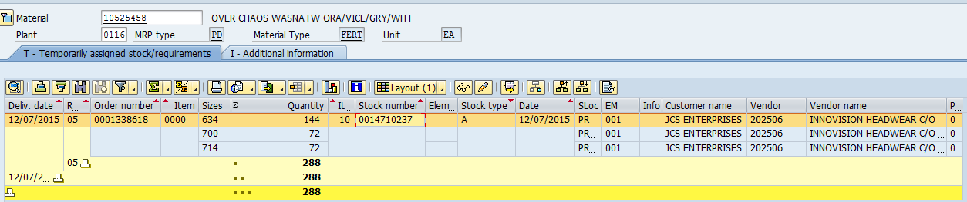

Converting PR to PO

Here we see that the availability date is shown as 12/07/2015

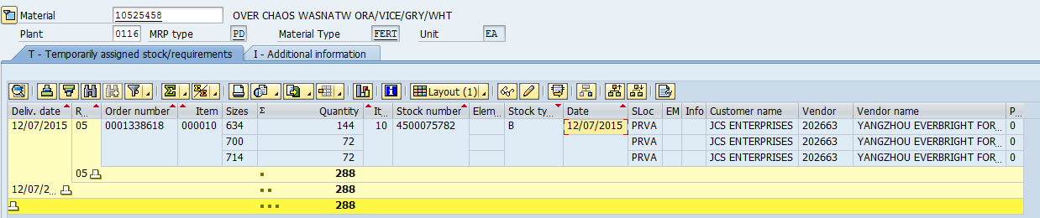

Here is the PO:

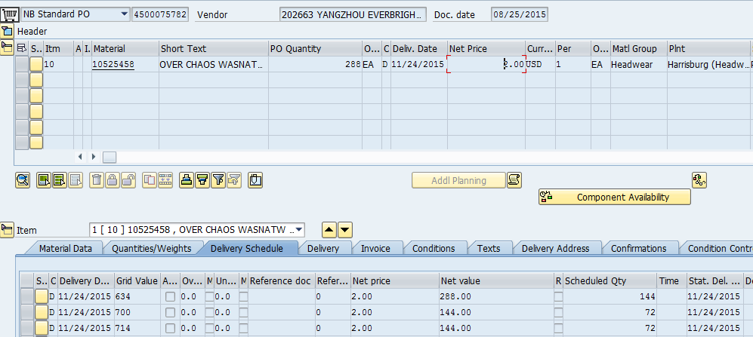

The PO is sent to SNC and is published. ZE and ZB are updated and Inb Delivery is created.

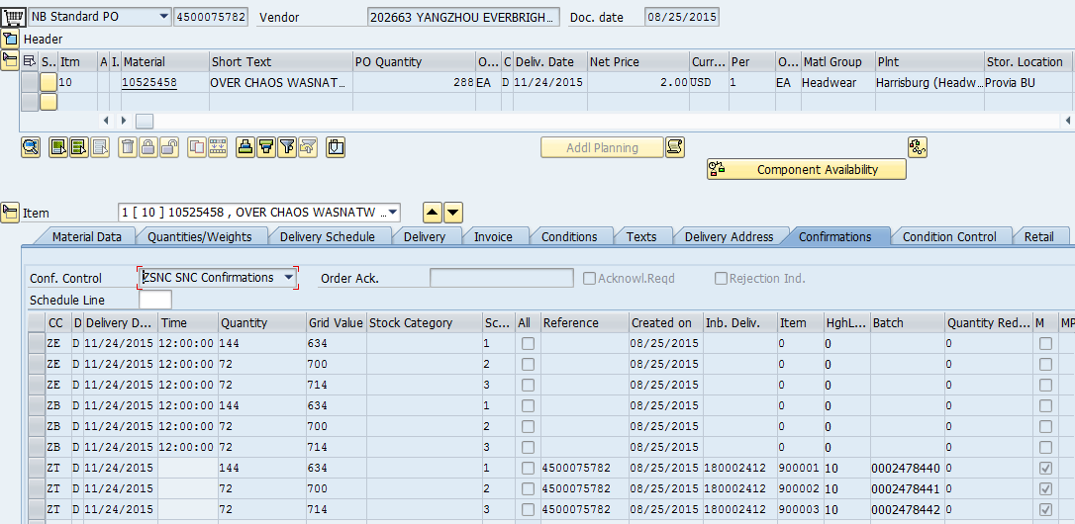

When we see the availability date in MD04 as 12/07/2014 as delivery date + GR Processing time

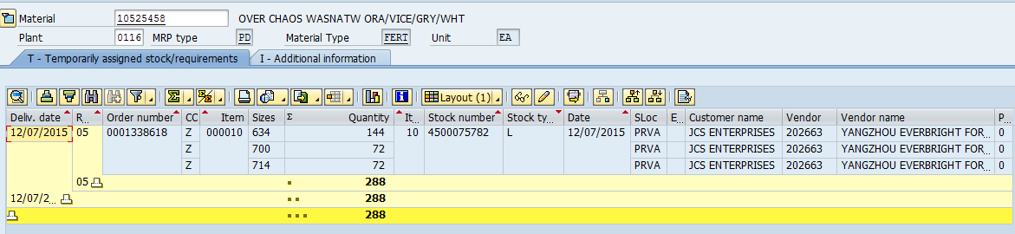

Changing the delivery date in Inbound Delivery: 180002412 to 10/26/2015

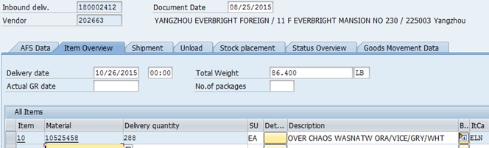

When we check /AFS/MD04 the availability date is changed to 11/04/2015.

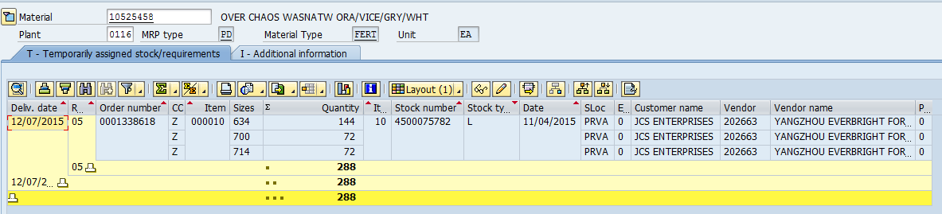

Before Running Rescheduling Program sales order is as shown below

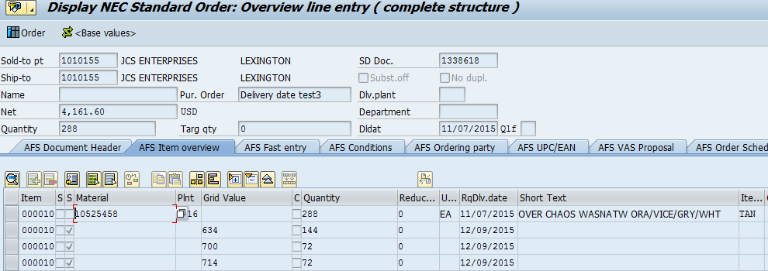

Run Rescheduling Program /n/AFS/V_V2:

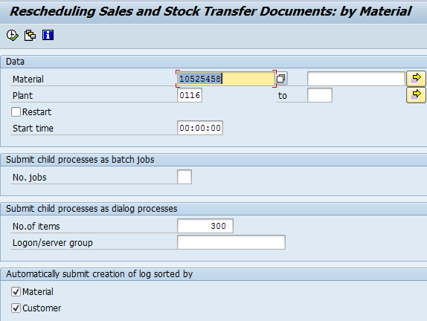

Log of Rescheduling Program:

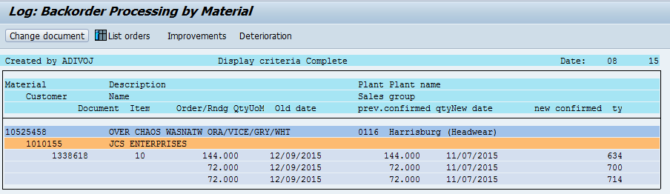

After the Rescheduling program is Ran sales order is as shown below:

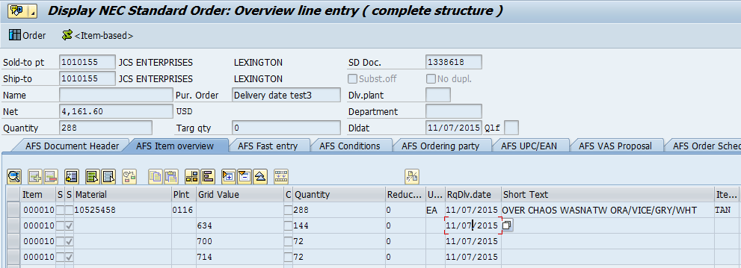

In the above sales order we see that the delivery date is being changed to 11/07/2015.

When we look at the MD04 Screen:

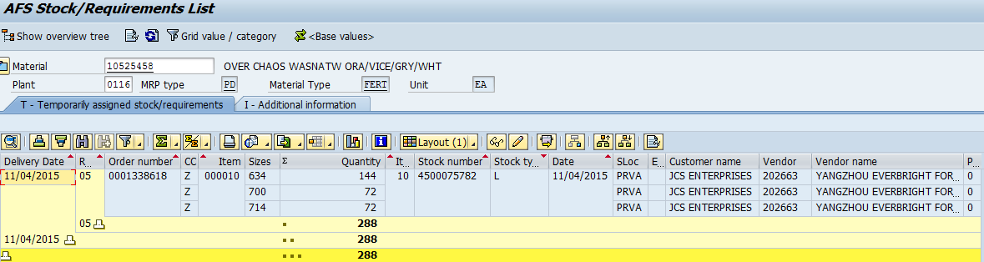

Changed the delivery date of the Inbound Delivery to 01/15/2016.

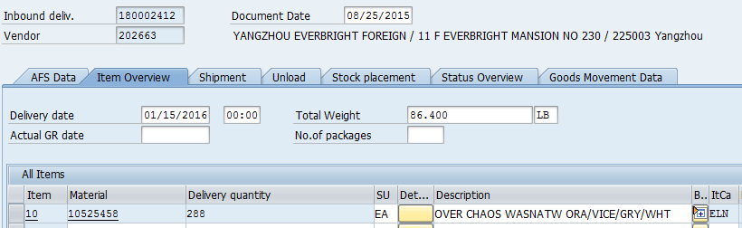

The same is shown on the confirmations screen in the PO.

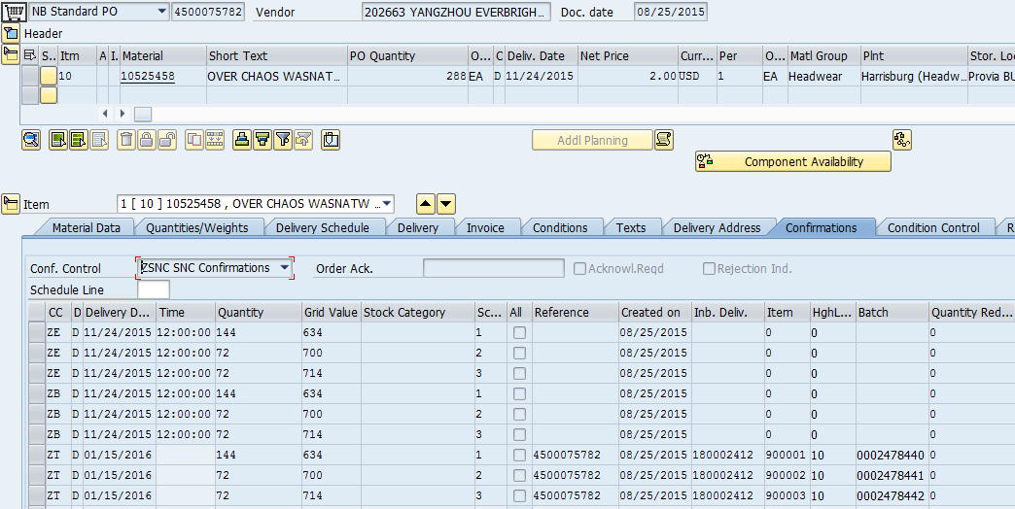

When we see that in MD04:

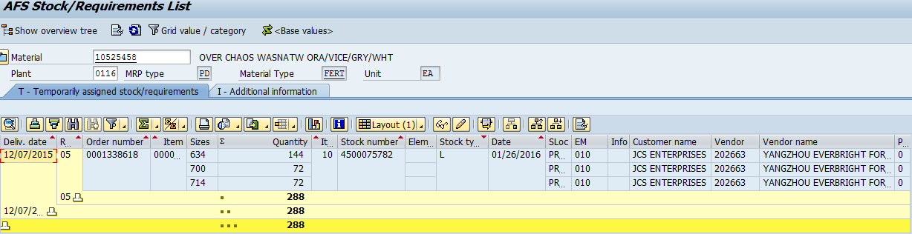

In the above screen it is showing that the date is 01/26/2016.

But when we do rescheduling the date in the sales order is changed to 12/09/2015 as shown below because it is the maximum planned delivery time + GR time which is maintained in the material master.

Any date which is given out of that availability date range will not be considered and the availability date will be considered and it will be placed in the sales order

