**Business Requirements**

User would like to see the ACTUALs as currently they do not have visibility of BY Materials, Landed Cost, Cost paid to the vendors, Duty, Freight, and the overall cost to bring the product in, neither they can see what is the INVOICE and if it is an INVOICE, how much quantity delivered.

The landed cost is the sum of amount paid to vendors, Duty, Freight, and Over Heads, where all these values currently coming from PO Cube which is at Schedule line level and are incorrect. The new PO design would help users get correct and detailed information to make better decisions.

**Functional Design:**

Currently the PO Cube data is being pulled on Schedule line level where as the CONDITION records are maintained on ITEM level, and PO Cube is at the Grid Level. PO Cube does not have separate CONDITION DSO or Info Cubes. In this situation we cannot integrate ITEM LEVEL source with SCHEDULE LEVEL source.

When we switch the ITEM source into BW for all the values, the condition record assigned to ITEMs in SAP ECC, gets copied to all grid levels of BW system. This is causing PO values in SAP BW Info Cube, 4 times and duplicates in the output.

The information Business users’ need can only come from Item Level. To fetch the requested data, customized solution will be done at Item Level. This way, in addition to Item Level information with all the price data, users will also be getting data on what is delivered (GR) and the Invoice value (IR) for that PO.

**Example of Issue:**

Consider the below example of PO 4400077894 in NEP where ORDERED VALUE = 71.10, RECEIVED VALUE = 71.10 & DELIVERY COST = 21.17

**PO Transaction (ME23N) – ECC:**

For item 10 & 20, the RECEIVED VALUE is 71.10 & DELIVERY COST is 21.17 as shown below.

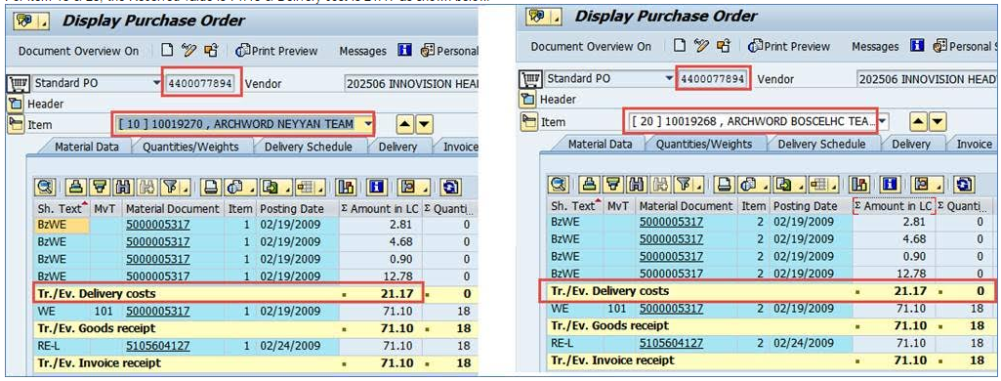

**BW Info CUBE:**

When the same PO gets extracted into BW, DELIVERY COST of 21.17 is adding up to the RECEIVED PO VALUE (71.10) resulting in 92.27 as shown. As DELIVERY COST gets included into the PO RECEIVED VALUE; the OPEN VALUES are showing up as negative (-ve).

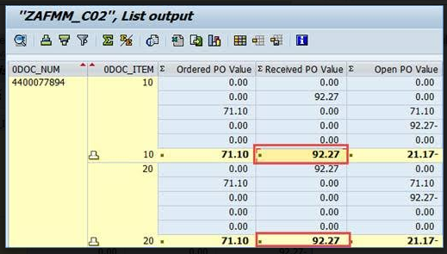

This is why negative “Open PO Values” being shown in the report.

**Technical Overview:**

Complete customized PO Cube will be built at ITEM LEVEL in BW system. This is give users access to detailed information of BY Materials, Costs, Duties, Freight, Invoice Receipt and information like Quantity Delivered. All this information will help users for detail analysis.

**Condition Tables:**

* **KONV** - Sales order related conditions.
* **KONP** - Values for the condition records.

**Purchasing Document Table:**

* **EKPO**- Purchasing Document Item Level

**Condition Types for Purchase Orders:**

**Price Relevant:**

J3AP - AFS Standard Sales Price

J3AX – Gross Price and Dimension

ZJ3P – Item Scale Scheduling

**Overheads Relevant:**

ZOA1 - Duty

ZOS0 - Freight

ZPOH - Procurement Overhead

ZGE0 - Distribution Overhead

CBT - Does not considered for costs

TAX - There is no Tax

**PO CUBE DATA FLOW DIAGRAM**

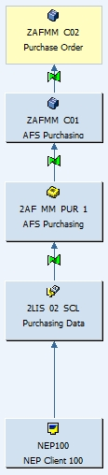

**PO Info Cube “ZAFMM_C02” Structure:**

|  |  |
| --- | --- |
| ZAFMM_C02 | Purchase Order Infocube |
| Characteristics | |
| 0COMPL_DEL | Delivery Completed Indicator |
| 0AF_COLL | AFS Collection |
| 0AF_SEAN | AFS Season |
| ZACAS_CAT | Account Assignment Category |
| 0DOC_ITEM | BW: Document Item Number |
| 0DOC_NUM | BW: Document Number |
| 0COMP_CODE | Company code |
| 0DISTR_CHAN | Distribution Channel |
| 0DIVISION | Division |
| 0DOC_DATE | Document Date |
| ZEXFACDAT | Ex.Factory Date(Manual) |
| ZEXFACMON | Ex.Factory Period/Year |
| 0INCOTERMS | Incoterms part 1 |
| ZLSDTRECD | Last Date Received |
| ZLSTMTRCD | Last Received Period/Year |
| 0MATERIAL | Material |
| 0MAT_SALES | Material (Sales) |
| 0CREATEDBY | Name of person who created the object |
| 0SCL_DELDAT | Planned delivery date of document schedule line |
| 0PLANT | Plant |
| 0ORD_TYPE | Purchasing Document Type |
| 0PUR_GROUP | Purchasing Group |
| 0SALESORG | Sales Organization |
| 0DOC_NUMBER | Sales document |
| 0S_ORD_ITEM | Sales document item |
| ZSHIP_INS | Shipping Instructions |
| 0VENDOR | Vendor |
| Time Characteristics | |
| 0CALDAY | Calendar day |
| 0CALYEAR | Calendar year |
| 0CALWEEK | Calendar year / week |
| 0CALMONTH | Calendar year/month |
| 0FISCYEAR | Fiscal year |
| 0FISCPER | Fiscal year / period |
| 0FISCVARNT | Fiscal year variant |
| Unit Charcteristics | |
| 0BASE_UOM | Base Unit of Measure |
| 0DOC_CURRCY | Document currency |
| 0LOC_CURRCY | Local currency |
| Navigational Attributes | |
| 0MATERIAL__0DIVISION | Division |
| 0MATERIAL__0IND_SECTOR | Industry |
| 0MATERIAL__0MATL_GROUP | Material Group |
| 0MATERIAL__Z_LICENSE | License |
| 0MATERIAL__Z_LOGO | Logo |
| 0MATERIAL__Z_SBU | SBU |
| 0MATERIAL__Z_SILH | Silhouette |
| 0MATERIAL__Z_SPORT | Sport |
| 0MATERIAL__Z_TEAM | Team |
| 0MAT_SALES__0AF_COLL | AFS Collection |
| 0MAT_SALES__0AF_SEAN | AFS Season |
| 0MAT_SALES__0MATL_GRP_5 | Material group 5 |
| 0SALESORG__ZREGION | Region |
| 0SALESORG__ZSUBREG | Sub Region |
| Key Figures | |
| 0AF_NETW | AFS Net Value in Document Currency |
| ZSTOGRCEA | Good's Received Qty in Eaches - STO |
| ZSTOGRCQT | Goods Received Qty - STO |
| 0NETPRICE | Net price |
| ZOPNPOQTY | Open PO Quantity |
| ZOPNPOQEA | Open PO Quantity in EA |
| ZOPNPOVAL | Open PO Value |
| ZORDPOQTY | Ordered PO Quantity |
| ZORDPOQEA | Ordered PO Quantity in EA |
| ZORDPOVAL | Ordered PO Value |
| ZGRCDQTY | Received PO Quantity |
| ZGRCDQTEA | Received PO Quantity in EA |
| ZGRDPOVAL | Received PO Value |
| ZSTOORDEA | STO Ordered Qty in Eaches |
| ZSTOORDQT | STO Ordered Quantity |