**Business Requirement**

The EMEA POS system will provide information in certain format and a customized program should be developed to read this information and create journal entries in SAP automatically (Number 3 in below process). The journal entries are created to capture Retail Revenue, Cost of Goods Sold, Inventory movement that is related to sales, accounts receivables as well as the inventory movements that are not related to retail sales.

**Process Flow Diagram (SD Delivery and Billing)**

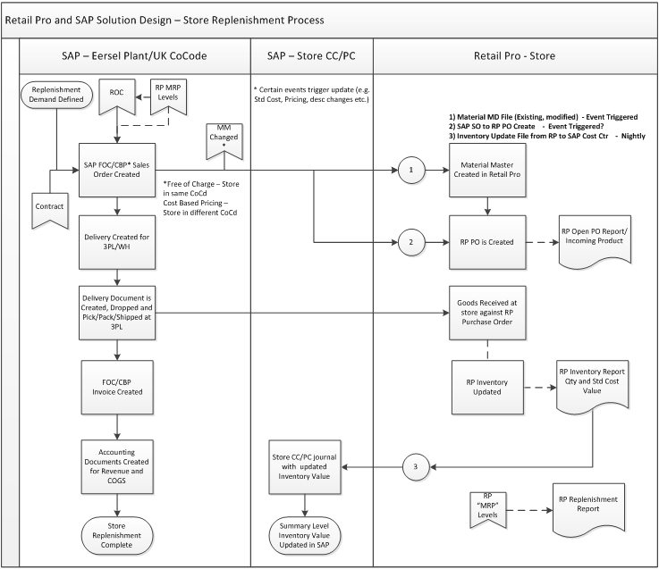

**Assumptions**

In order for this process to work, the following assumptions have been made:

1. The information for the FICO journal entries is available in EMEA POS

**Proposed Solution**

A customize SAP program is needed in order to obtain the necessary information from the upload files and create journal entries in SAP. Two similar upload files will be available, one contains sales related information, and the other contains inventory activities that are not related to sales.

1. **Retail Sales**

*1.1 File that contains Retail Sales information*

This file should include all information that is needed for SAP journal entry creation for retail sales. SAP journal entry will record revenue, accounts receivables, Value Added Tax, Sales related inventory and cost of goods sold. The file will be sent via excel format (it could be other format based on the feedback from development team) and the layout would be like below:

|  |  |  |  |  |  |  |  |  |
| --- | --- | --- | --- | --- | --- | --- | --- | --- |
| POS Transaction Category | Store Location | Posting Date | Currency | Net sales (excluding tax) | VAT | Total AR | Inventory change | COGS |
| Sales | TBD:UK001 | 04/21/2014 | GBP | 100 | 20 | 120 | -39 | 39 |
| Sales | TBD:GE001 | 04/21/2014 | EUR | 200 | 34 | 234 | -78 | -78 |

*1.2 Customized table that contains Inventory activities which are related to Retail Sales*



*Program that generates Journal entry ()*

A customized program is needed to create the journal entry. The program should call transaction FB50 to create one journal entry per store for the given period’s Retails Sales. Each journal entry will have different cost center and profit center assignment based on the store ID. Document type should be SA, and the Reference field should show the store ID.

1. If the Retail Pro transaction total amount for Total AR is positive number (more sales than return), below transaction should be created automatically:

Dr: Accounts Receivable (GL account is different based on the Store ID, posting key 40)

Cost of Goods Sold (New 5* GL – TBD - posting key 40)

Cr: Revenue (GL account 460000, posting key 50)

VAT (GL account 221020, posting key 50)

Inventory (New 13* GL – TBD - posting key 50)

1. If the Retail Pro transaction total amount for Total AR is negative number (more return than sales), below transaction should be created automatically:

Dr: Revenue (GL account 460000, posting key 40)

VAT (GL account 221020, posting key 40)

Inventory (New 13* GL – TBD - posting key 40)

Cr: Accounts Receivable (GL account is different based on the Store ID, posting key 50)

Cost of Goods Sold (New 5* GL – TBD - posting key 50)

1. **Inventory valuation**

*2.1 File that contains Inventory activities which are not related to Retail Sales*

This file should include all information that is needed for SAP journal entry creation for non-sales related inventory activities. SAP journal entry will record inventory value change accordingly. The file will be sent via excel format (it could be other format based on the feedback from development team) and the layout would be like below:

|  |  |  |  |  |  |
| --- | --- | --- | --- | --- | --- |
| POS Transaction Category | Store Location | Posting Date | Currency | Inventory value | Movement type |
| Inventory | TBD:UK001 | 04/21/2014 | GBP | -100 | 01 |  |  |  |
| Inventory | TBD:UK001 | 04/21/2014 | GBP | 1000 | 02 |
| Inventory | TBD:UK001 | 04/21/2014 | GBP | -30 | 03 |
| Inventory | TBD:UK001 | 04/21/2014 | GBP | -5 | 04 |
| Inventory | TBD:UK001 | 04/21/2014 | GBP | -5 | 05 |
| Inventory | TBD:UK002 | 04/21/2014 | GBP | -100 | 01 |
| Inventory | TBD:UK002 | 04/21/2014 | GBP | 1000 | 02 |  |  |  |
| Inventory | TBD:UK002 | 04/21/2014 | GBP | -300 | 03 |
| Inventory | TBD:UK002 | 04/21/2014 | GBP | -50 | 04 |
| Inventory | TBD:UK002 | 04/21/2014 | GBP | -50 | 05 |
|  |  |  |  |  |  |

There are 5 movement types:

01. Store Sales/Return (NOTE!! If the movement type is 01, no journal entry is needed)

02. Goods Receipt from New Era Plant

03. Goods Return to New Era Plant

04. Sample

05. Cycle Count Adjustment

* 1. *Customized table that contains Inventory activities which* ***are not related*** *to Retail Sales*



*Program that generates Journal entry*

A customized program is needed to create the journal entry. The program should call transaction FB50 to create one journal entry per store per inventory movement category. There will be 5 categories for Inventory related transactions. They are listed as below. Each category requires journal entry to be posted to different document type, cost center, trading partner and offset account based on the store ID and category. A customized mapping table maybe needed to achieve this goal.

01. Store Sales/Return (NOTE!! If the movement type is 01, no journal entry is needed)

02. Goods Receipt from New Era Plant

03. Goods Return to New Era Plant

04. Sample

05. Cycle Count Adjustment

If the Retail Pro transaction total amount for Inventory is positive number, below transaction should be created automatically:

Dr: Inventory (New 13* GL – TBD - posting key 40)

Cr: Offset account (See above for the actual GL account ID for each category, posting key can be 50, 17 etc. based on the document type)

If the Retail Pro transaction total amount for Inventory is negative number, below transaction should be created automatically:

Dr: Offset account (See above for the actual GL account ID for each category, posting key can be 40, 07 etc. based on the document type)

Cr: Inventory (New 13* GL – TBD - posting key 50)

**Potential Issues / Questions**

N/A