Credit/Debit COPA impact for Headwear MTO process
Configuration: According to below configuration, only billing type G2 should show 0 Sales quantity and Stock value in COPA. Tcode KE4W
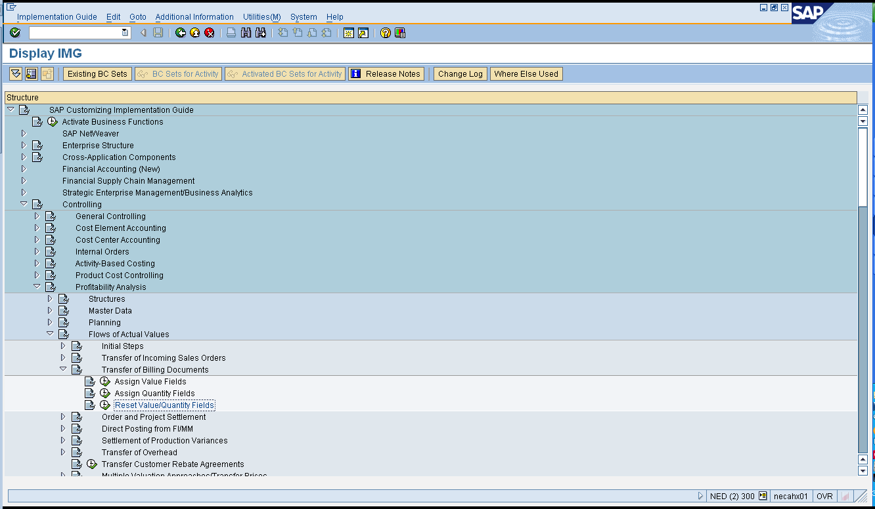
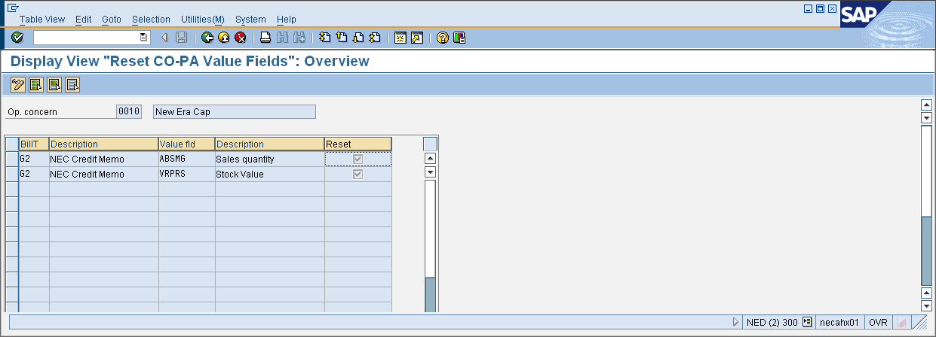
This only works for credit memos that are not for MTO products (non-valuated stock scenario). If the product is stock, this configuration works fine.

Stock scenario:
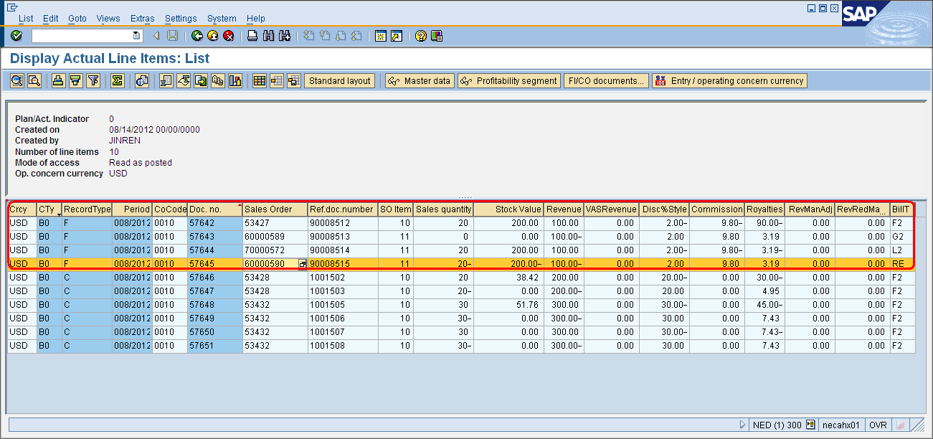

MTO scenario:
In MTO scenario, COPA posting shows credit, debit and return as billing type “F2”. This is because SAP does not settle the credit, debit or return for MTO orders. All of the follow on documents, regardless debit, credit or return, are settled as the original sales order. And because the system consider ZCR, ZDR and ZRE related to MTO as F2, therefore the configuration above does not seem to work.
Note, although this configuration cannot make the sales quantity and stock value zero for MTO credit/debits, using this configuration does not cause any problem. Because the manual month end adjustment that Baiwa performs does not zero out the quantity or stock value neither, due to the fact that billings for credit and debit are shown as “F2”.
- Create MTO sales order 53432
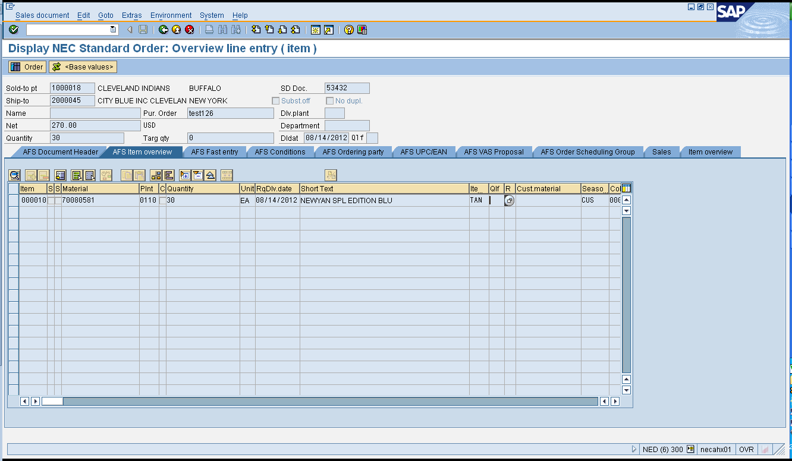

- Production order 1000008856 is released. Tcode /N/AFS/MD02
- In CO11N, confirm production order
- In J3AT run the Arun.
- In VL01N, create delivery 8007593
- Create billing 9008520
- Settle the production order and sales order with KO88 and KKAK, VA88. Then run KE24 and see the result as below:
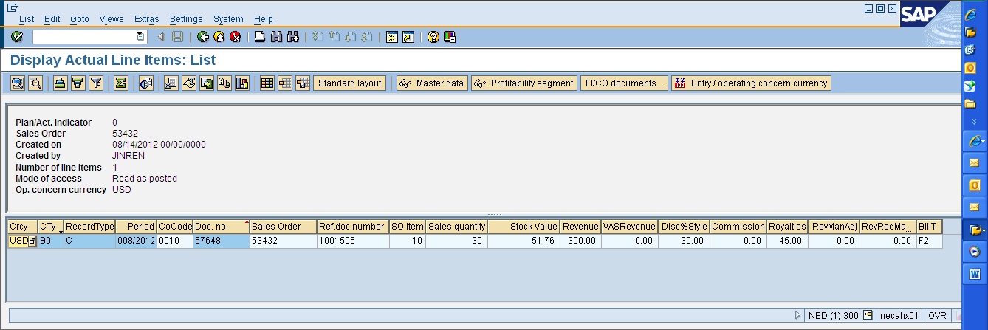

- Create ZCR 6000593 for billing 9008520. Credit billing is 9008521
Then run KKAK and VA88 to settle the sales order again.
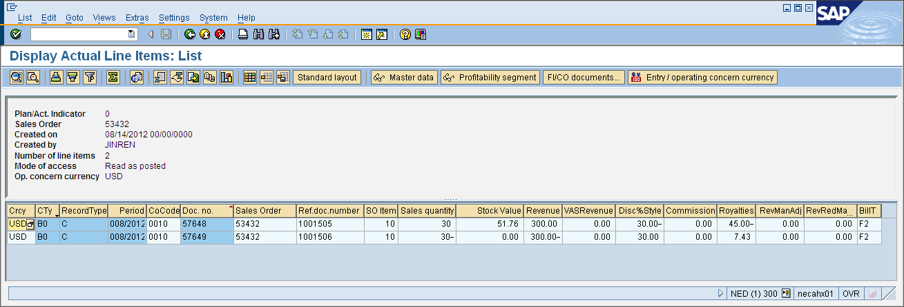

- Create ZDR 70000574, follow on invoice 9008522.
Then run KKAK and VA88 to settle the sales order again:
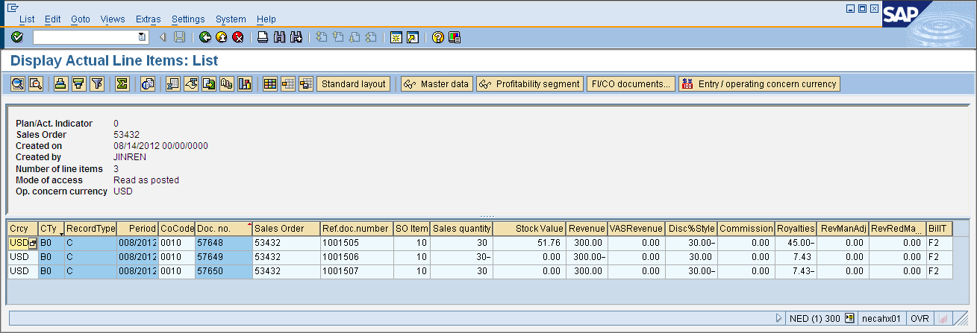

- Create ZRE 6000594, follow on invoice 9008523.
Then run KKAK and VA88 to settle the sales order again:
