Payments using F-26
Problem:
Credit control area for company code is defaulting from the company code(00300 Instead of the customer master credit control area(0050).
Customer: 1003757
Bank account 114080
Document type DZ
Cutrrency: USD, EUR, GBP
F-26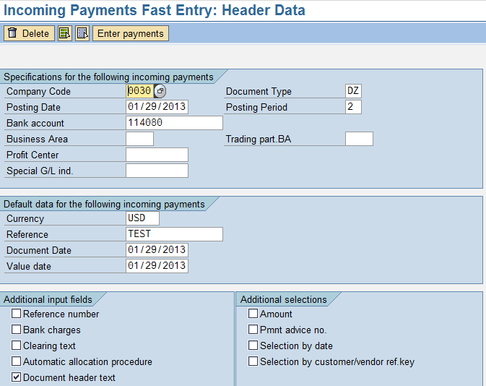

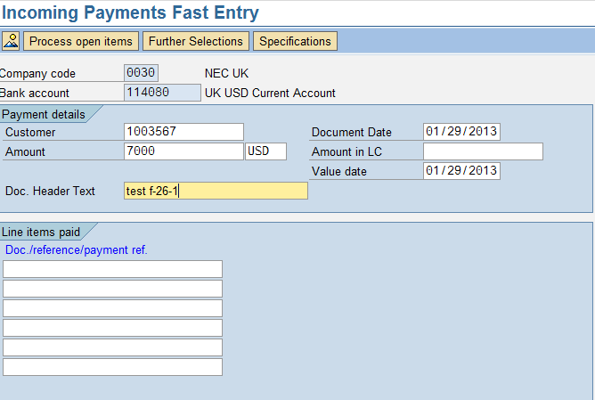
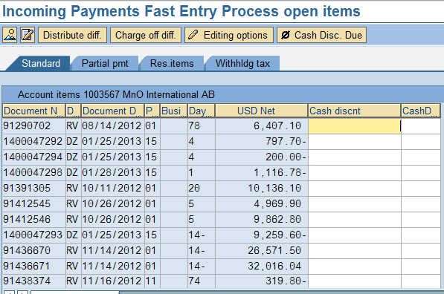
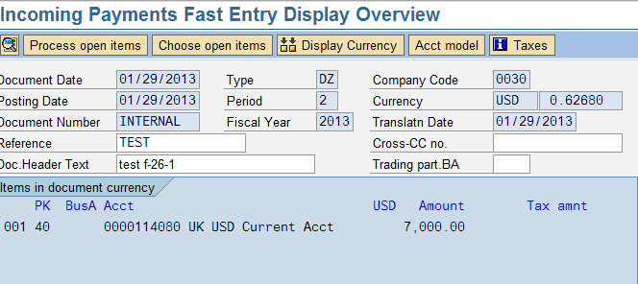

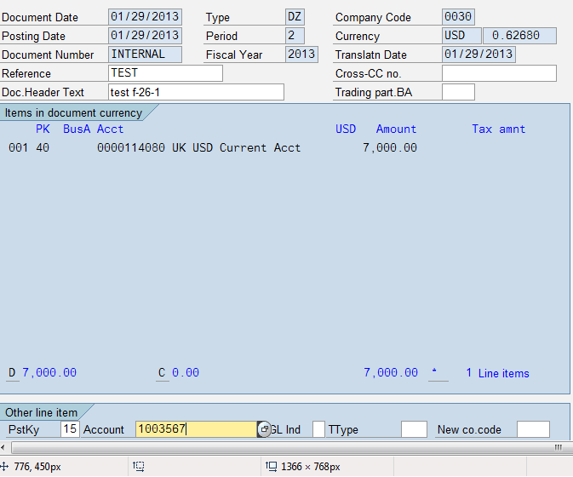
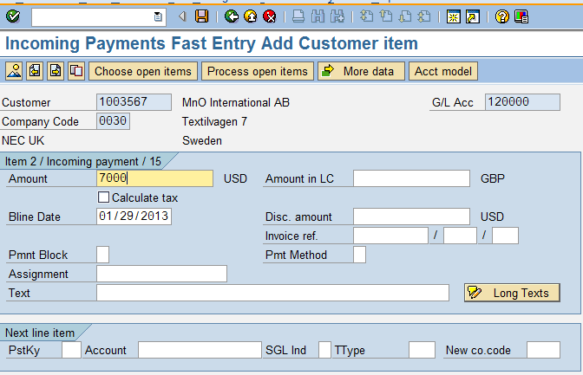

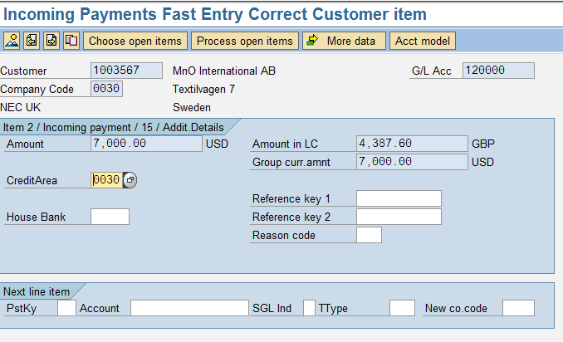

Document Posted with correct credit controlling area after changing from 0030 to 0050 is 1400047299.
