1. Issue:

When we create the materials using FERT Generator an error is being issued.

2. When creating materials using FERT Generator

T Code /AFS/FGEN

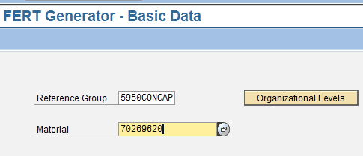

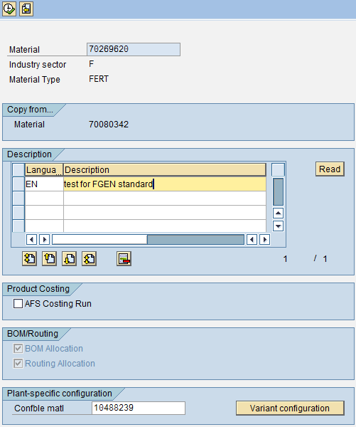

After configuring the variant below is the error:

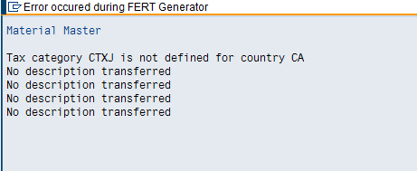

3. Tax code:

Looks like Tax code is maintained
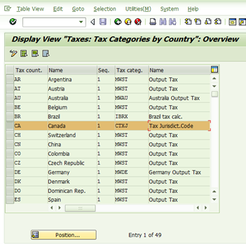

When a material is been created manually using the transaction code MM01 the tax code CTXJ is being triggered and material is created without any error.

