**Functional Specification**



|  |  |
| --- | --- |
| **Object Name** | : FI112 |
| **ReCAP Number** | : 7195 |
| **Functionality** | : Income Statement with Last Year Budget by Region |
| **Functional Area** | : Finance |
| **Created By** | : Joan Profetta and Jingsha Brennan |
| **Created Date** | : 5/20/2013 |

**Revision History:**

|  |  |  |
| --- | --- | --- |
| Revision Number | Date | Summary of Change |
| 1.0 | May 20, 2013 | Initial Revision |
| 1.1 | May 23, 2013 | Version 1.1 |
| 1.2 | May 29, 2013 | Version 1.2 GL Hierachy added |
|  |  |  |
|  |  |  |
|  |  |  |
|  |  |  |
|  |  |  |
|  |  |  |
|  |  |  |

**Related Documents (Document, URL, Email, etc.):**

|  |  |  |  |
| --- | --- | --- | --- |
| Document Name | Date | Author | Description |
|  |  |  |  |
|  |  |  |  |
|  |  |  |  |
|  |  |  |  |
|  |  |  |  |
|  |  |  |  |
|  |  |  |  |
|  |  |  |  |
|  |  |  |  |
|  |  |  |  |

**Business Requirement:**

FI 112 is an existing BI report that shows the Income Statement by Region and consists of the comparison of This Year Actual vs. Budge and This Year Actual vs. Last Year Actual. The current process of generating FI112 involves steps that utilize a screen scrape tool called Monarch. The objective of this functional specification is to not use Monarch and to streamline the creation of the FI112 report.

**Functional Specification:**

**Overview:**

FI112 is an Income Statement Report grouped by Region and includes two portions. The top half of the report should show Income Statement with comparison of This Year Actual vs. Budget. The bottom half of the report should show the Income Statement with comparison of This Year Actual vs. Last Year Actual. All currency is in USD.

**Source:**

FI112 should be sourced from BW; this includes the Company code, GL account, GL description, GL account hierarchy and amount. The only manipulation within Crystal should be for Positive/Negative signs, some calculated fields, and the grouping by region. Please refer to the current FI112 report for formatting.

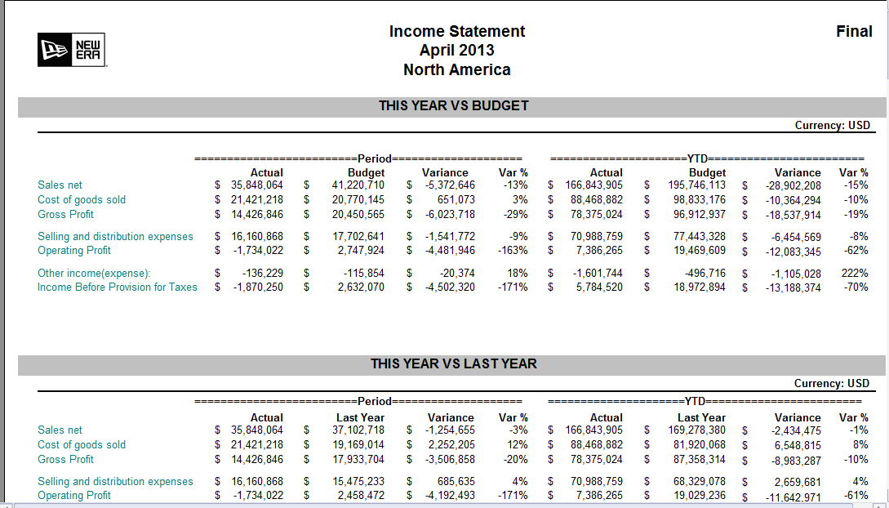



**Grouping of company codes into Regions:**

Company codes '0010','0011','0014','0020','0021','0100','0074' falls under ‘North America’.

Company codes ‘0030’,'0040','0042' fall under ‘EMEA’.

Company code ‘0060’ is ‘Japan’.

Company codes '0026','0028','0050','0055','0058' fall under ‘Emerging’.

All others fall under ‘New Era LLCs’

**Parameters:**

Period Range (starts and end)

Watermark (Preliminary Final)

Fiscal Year (ex. 2013)

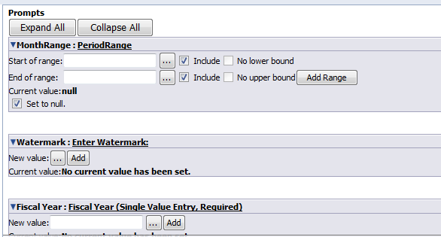

**Drill Down:**

**Fields on the left of the report can be drilled down to the company codes within the reports region.**

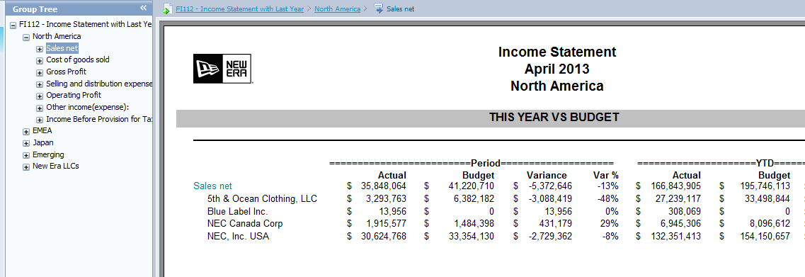 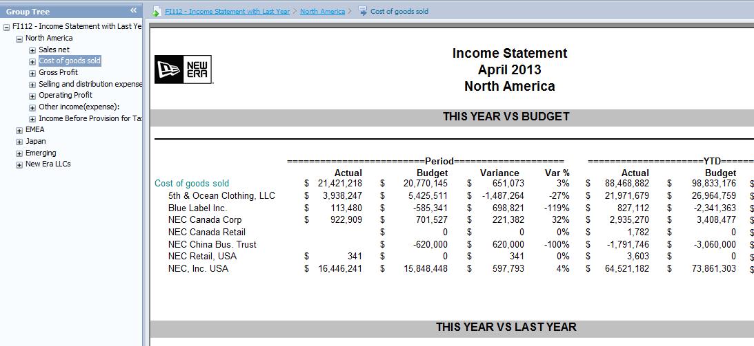

**Positive/Negative sign:**

Because SAP stores Credit balances as Negative and Debit balances as positive, for the purpose of reporting, formatting for each of the reports items need to be taken into consideration:

* Sales Net: SAP credit balance should appear on the report as positive value, SAP debit amount should appear as negative value
* Cost of goods sold: SAP credit balance should appear on the report as negative value, SAP debit amount should appear as positive value
* Selling and Distribution expense: SAP credit balance should appear on the report as negative value, SAP debit amount should appear as positive value
* Other income(expense): credit balance should appear on the report as positive value, SAP debit amount should appear as negative value

**Top Portion of the Report:**

**Calculated fields:**

* Gross Profit = Sales Net – Cost of goods sold
* Operating Profit = Gross Profit – Selling and distribution expenses
* Income Before Provision for Taxes = Operating Profit + Other income (expense)
* Variance (This year vs. Budget): = Actual – Budget
* Variance % (This year vs. Budget): = (Variance/Budget)*100%

**Top Portion of the Report:**

**Calculated fields:**

* Gross Profit = Sales Net – Cost of goods sold
* Operating Profit = Gross Profit – Selling and distribution expenses
* Income Before Provision for Taxes = Operating Profit + Other income (expense)
* Variance (This year vs. Budget): = Actual – Budget
* Variance % (This year vs. Budget): = (Variance/Budget)*100%
* Variance (This year vs. Last Year): = Actual – Last Year
* Variance % (This year vs. Last Year): = (Variance/Last Year)*100%

**GL Hierachy**

GL hierarchy can be found in ECC Tcode OB58

Financial Statement Version 0010, the portion under “Profit&Loss Statement”.

Only below items should be included in FI reports:

* Sales Net
* Cost of Goods Sold
* Selling and distribution expenses
* Other Income(expense)

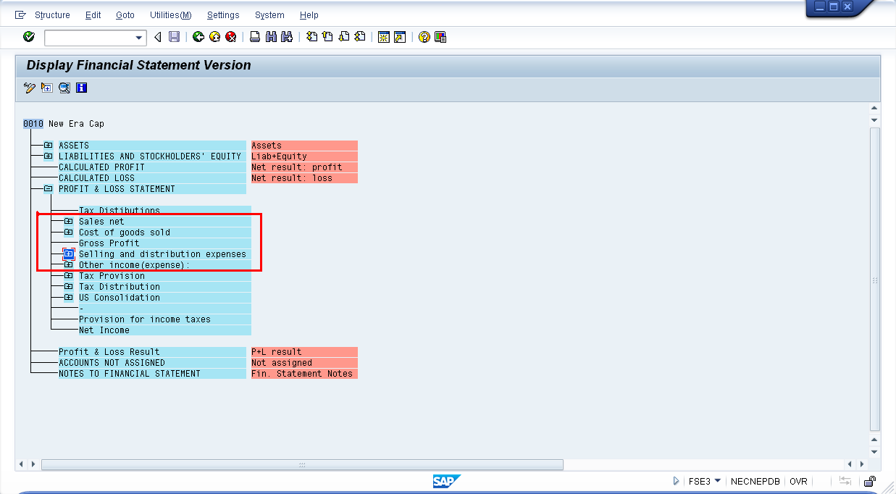

**Assumptions:**

**Known Issues:**

Existing FI210 and FI213 are similar to FI110 and FI113, and they contain company codes for the purpose of grouping by region. The company code needs to be manually added to the two reports. The manual process of adding company code and the use of Monarch need to be eliminated,

**Technical Specification:**

|  |  |  |
| --- | --- | --- |
| Object | Type | Description |
|  |  |  |
|  |  |  |

**Transports:**

|  |  |  |
| --- | --- | --- |
| Transport | Developer | Description |
|  |  |  |

**Test Scenarios:**

|  |  |  |  |  |  |  |
| --- | --- | --- | --- | --- | --- | --- |
| No. | Test Scenario | Expected Results | Actual Results | Tester | Date | P/F |
| 1 |  |  |  |  |  |  |

**Panaya Scripts:**

|  |  |  |
| --- | --- | --- |
| Panaya Script | Tester | Description |
|  |  |  |
|  |  |  |
|  |  |  |

**TDMS Requirements:**

Is a new TDMS client required? **No.**

**uPerform / RWD:**

Are uPerforms required? **Yes and it should be created in English.**