**Monthly FICO Adjustment Process**

1. Getting source data

Enter T-code KE24 in SAP

Enter “0010” on Operating concern and choose “costing-based” as Type of Profit Analysis.

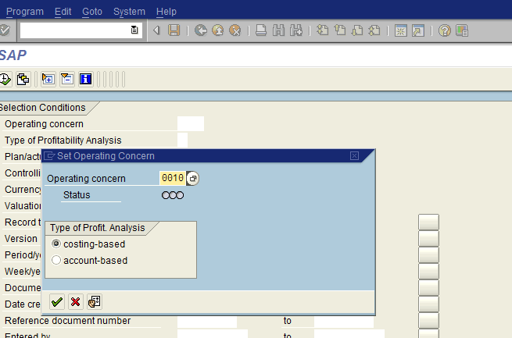

Enter period

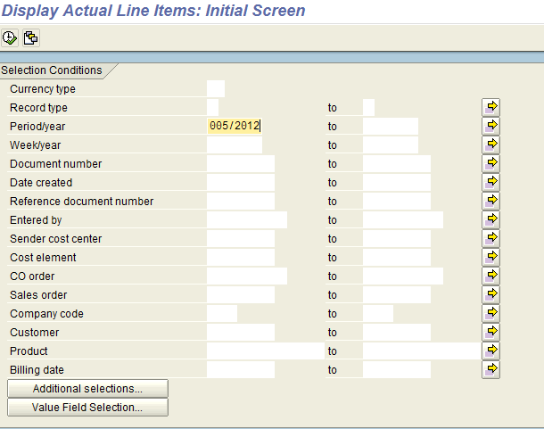

Choose “Billing Type” in “Additional selections”

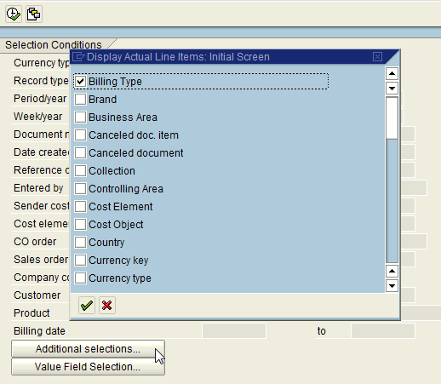

Choose both G2 and L2 as Billing Type

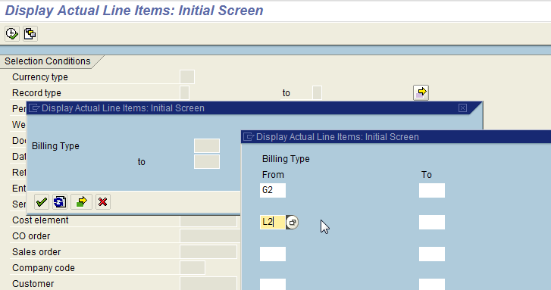

Select upload format after data returns

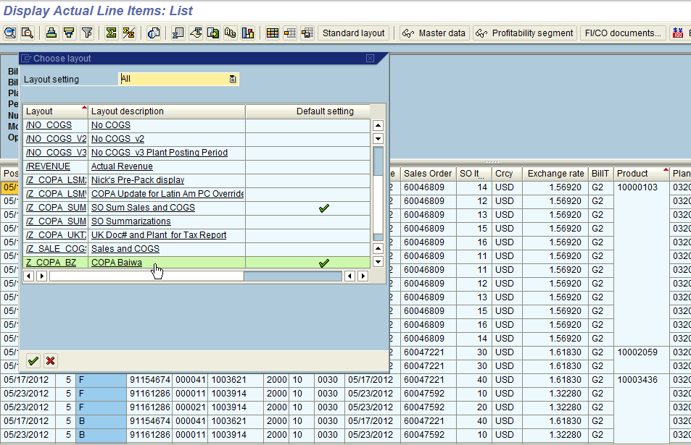

Choose “Entry/operating concern currency”

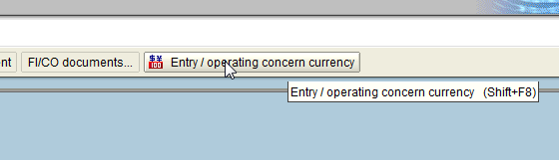

Then export as excel

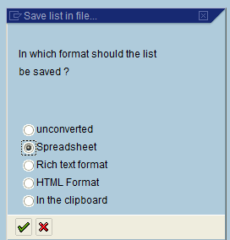

1. Formatting/updating source data

Clean up the data and remove extra spaces

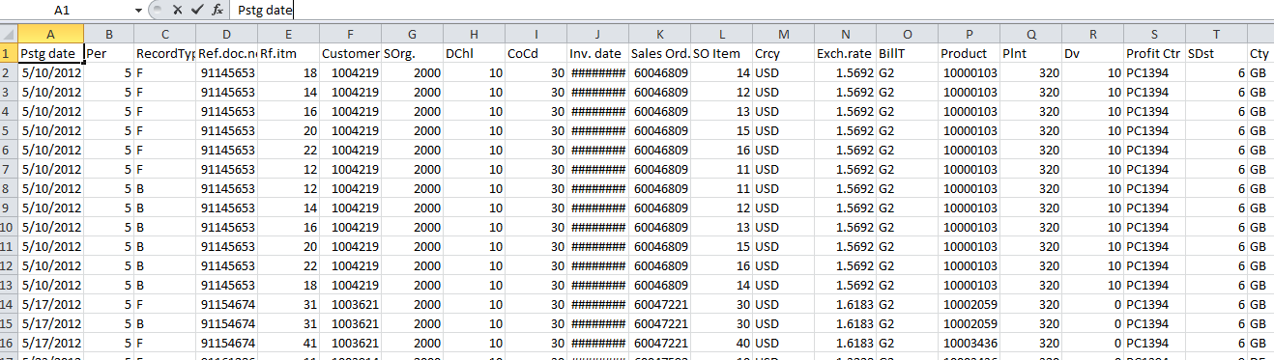

Change Record Type to “B”

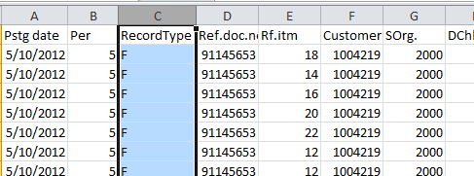

Make sure Region values all exist in T-code KES1

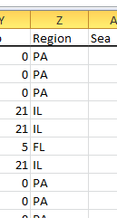 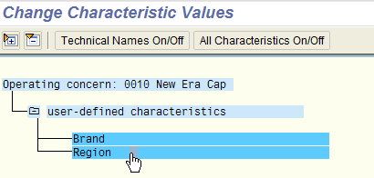

If not, find the customer and region code and add it in KES1.

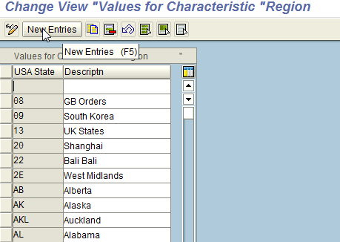

Remove columns Revenue, Disc Style, Commission and Royalties.

Multiply “-1” to “Stock Value” and “Sales Qty”.

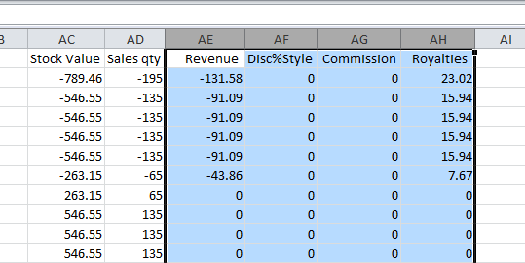

Copy format from old file, change stuff like period 5 to 005, plant 320 to 0320, etc.

Then save it as text file, tab delimited.

1. Upload

Then upload through LSMW program:

