FS15: Loading the G/L accounts with Range:
Here are we are trying to load the G/L accounts of the Range 20000 to 29999 from company code 0014 to 0074.
We Need to Enter the Range that we want to copy from one company code to the other.
We can load using the batch job. Or we can load in to the file and then can load it.

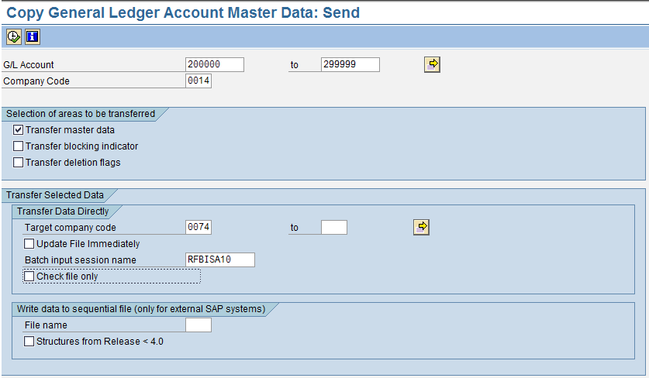
After executing the above selection it creates a batch Job.

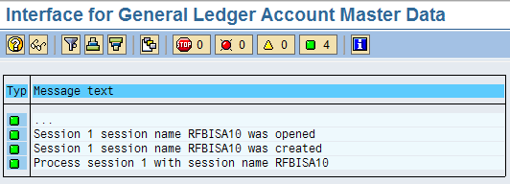
In SM 35 run the batch job in the back ground.
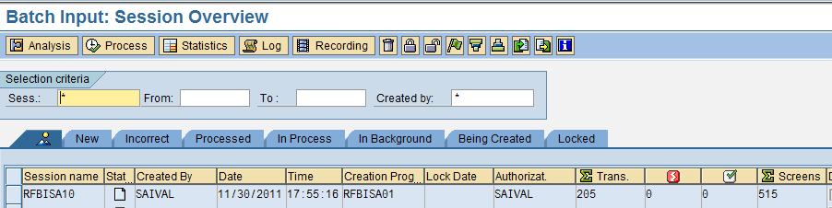
You can Check all the accounts that si acreate for the company code 0074
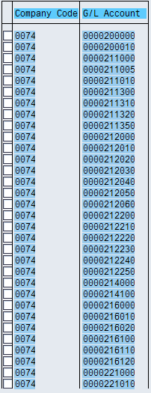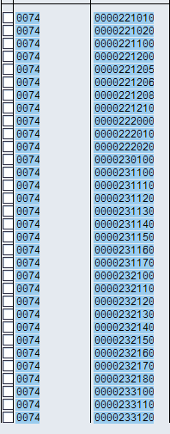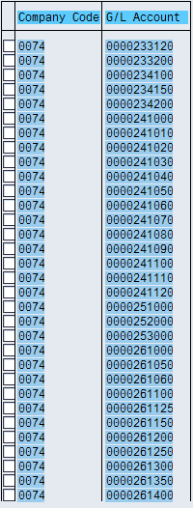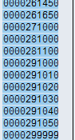

I have done postings with the account that I created.
