**Business Requirement:**

For all Canadian provinces other than Quebec (QC), the invoice form is legally required to display the cumulative tax percentage charged per item. The existing form only displays the federal tax percentage, and it is displayed only at the bottom of the form, not for each item.

**Functional Specification:**

A new column (GST/HST %) should be added to the Canadian invoice form.

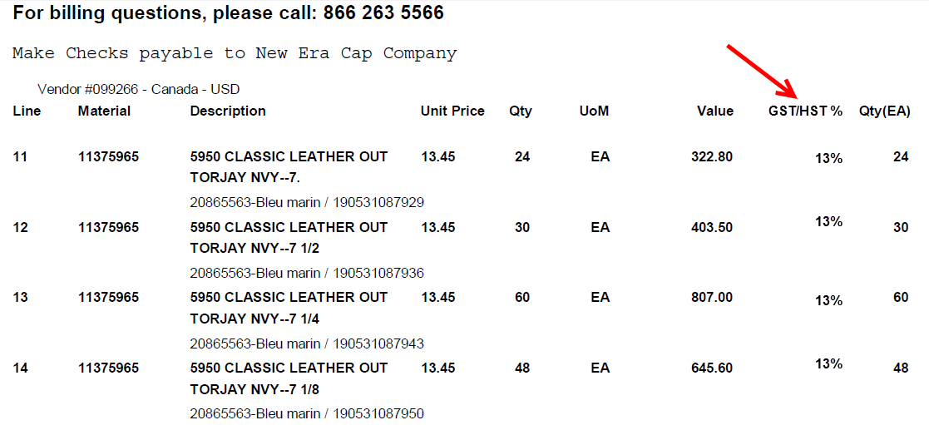

For each item, the combined GST (Goods & Services Tax – condition type JRC1) and HST (Harmonized Sales Tax – condition type JRC2) should be displayed. In some cases, one of these condition types may be missing or have a value of 0. This is expected for some provinces, and the form should display the percentage it finds.

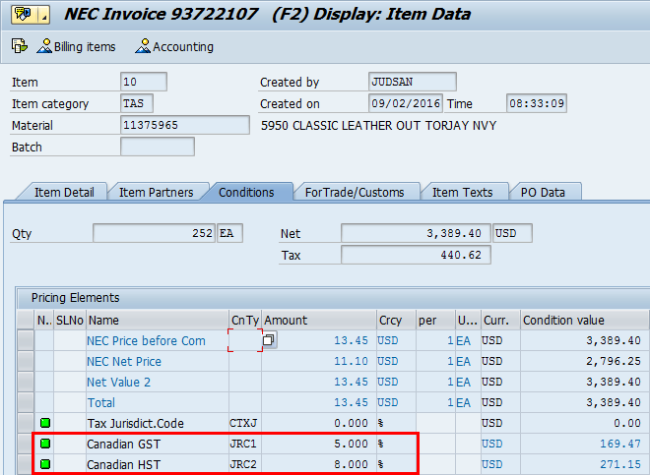

Also, at the bottom of the existing invoice form, we display the SAP tax code, along with the description. This should be modified to only display the tax code (no longer the description).



**Assumptions:**

Master data for Canadian tax will be maintained accurately.

**Known Issues:**

None.

**Technical Specification:**

| Technical Object | Type | Description |
| --- | --- | --- |
|  |  |  |
|  |  |  |

**Source Control:**

| Change Object | Application | Developer | Description |
| --- | --- | --- | --- |
|  |  |  |  |
|  |  |  |  |

**TDMS Requirements:**

Is a new TDMS client required? No

**Test Scenarios:**

| No. | Test Scenario | Expected Results | Actual Results | Application / Environment | Tester | Creation  Date | P/F | Panaya |
| --- | --- | --- | --- | --- | --- | --- | --- | --- |
| 1 | Test Alberta (AB) | GST/HST: 5% |  | NECNEQ-600 | Daniel Brennan |  |  | No |
| 2 | Test British Columbia (BC) | GST/HST: 5% |  | NECNEQ-600 | Daniel Brennan |  |  | No |
| 3 | Test Manitoba (MB) | GST/HST: 5% |  | NECNEQ-600 | Daniel Brennan |  |  | No |
| 4 | Test New Brunswick (NB) | GST/HST: 15% |  | NECNEQ-600 | Daniel Brennan |  |  | No |
| 5 | Test Newfoundland & Labr. (NL) | GST/HST: 15% |  | NECNEQ-600 | Daniel Brennan |  |  | No |
| 6 | Test Nova Scotia (NS) | GST/HST: 15% |  | NECNEQ-600 | Daniel Brennan |  |  | No |
| 7 | Test Northwest Terr. (NT) | GST/HST: 5% |  | NECNEQ-600 | Daniel Brennan |  |  | No |
| 8 | Test Nunavut (NU) | GST/HST: 5% |  | NECNEQ-600 | Daniel Brennan |  |  | No |
| 9 | Test Ontario (ON) | GST/HST: 13% |  | NECNEQ-600 | Daniel Brennan |  |  | No |
| 10 | Test Prince Edward Island (PE) | GST/HST: 15% |  | NECNEQ-600 | Daniel Brennan |  |  | No |
| 11 | Test Saskatchewan (SK) | GST/HST: 5% |  | NECNEQ-600 | Daniel Brennan |  |  | No |
| 12 | Test Yukon Territory (YT) | GST/HST: 5% |  | NECNEQ-600 | Daniel Brennan |  |  | No |

**Panaya Scripts:**

| No. | Panaya Script | Test No. | Tester | Description |
| --- | --- | --- | --- | --- |
|  |  |  |  |  |
|  |  |  |  |  |
|  |  |  |  |  |

**uPerform / Camtasia:**

| No. | uPerform Script | Creation Date | Language | Description |
| --- | --- | --- | --- | --- |
|  |  |  |  |  |
|  |  |  |  |  |
|  |  |  |  |  |