Business Requirement:
SAP provides a standard program to ensure changes within the supply chain are accurately reflected on sales orders. Unfortunately, this program is inefficient, and runs for multiple days when executed wide-open against our plants. As such, we will optimize the process by only executing rescheduling against specific materials. The list of materials to be rescheduled per plant should be driven based on changes to the purchase order (either a change in date or quantity).

It is also important to note that SAP will not reschedule any sales order that is on credit hold, or has a delivery date outside the total replenishment lead-time of the material. To ensure orders in these scenarios are eventually rescheduled, we will need to reschedule those materials each week until these scenarios are cleared.

Functional Specification:
Description:
To meet the business requirement above, two changes will be made:

- At the time changes are saved to a purchase order (ME22N), a user-exit should evaluate whether any changes have been made to either the delivery date or quantity on the items. If any item has either of these updates, the material and plant should be written to TVARVC.

- A new program should be written which will execute following the completion of rescheduling. Each material within TVARVC should be evaluated for two criteria: (a) does this material exist on any open-orders that are currently on credit-hold, or (b) does this material exist on any open-orders that have a delivery date outside of total replenishment lead-time. If either of these are true, the material should be left in TVARVC so that it is executed during the next rescheduling run. If neither of these are true, the material should be removed from TVARVC.

To ensure the program runs efficiently, if an instance of the criteria above is found, the material should be left in TVARVC, and the next material should be evaluated. There is no value in continuing to evaluate other open-orders once a hit has been found.

Process Flow:
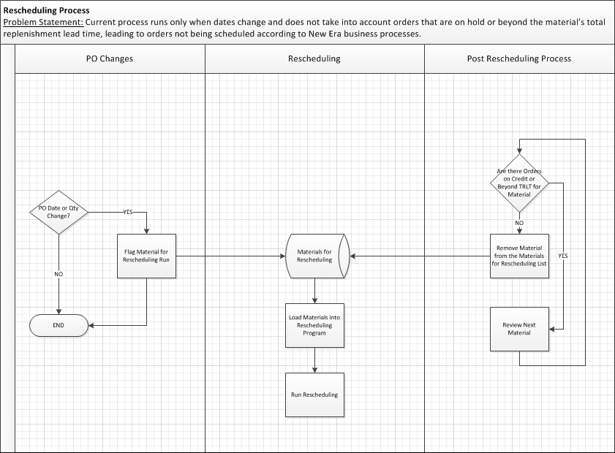

Assumptions:
- Rescheduling will continue to be run each weekend

Known Issues:
None

Technical Specification:
Technical Object | Type | Description

Source Control:
Change Object | Application | Developer | Description

TDMS Requirements:
Is a new TDMS client required? No

Test Scenarios: User-exit update
No. | Test Scenario | Expected Results | Actual Results | Application / Environment | Tester | Creation  Date | P/F | Panaya
1 | Date is changed on purchase order item | Material/plant are written to TVARVC |  | NECNEQ-600 |  |  |  | ☐
2 | Quantity is changed on purchase order item | Material/plant are written to TVARVC |  | NECNEQ-600 |  |  |  | ☐
3 | Date and quantity are changed on a purchase order item | Material/plant are written to TVARVC |  | NECNEQ-600 |  |  |  | ☐
4 | On a purchase order with more than one item, date is changed on a single item | Only the updated material/plant is written to TVARVC |  | NECNEQ-600 |  |  |  | ☐
5 | On a purchase order with more than one item, quantity is changed on a single item | Only the updated material/plant is written to TVARC |  | NECNEQ-600 |  |  |  | ☐
6 | On a purchase order with more than one item, date is changed on more than one item | All items updated have material/plant written to TVARVC |  | NECNEQ-600 |  |  |  | ☐
7 | On a purchase order with more than one item, quantity is changed on more than one item | All items updated have material/plant written to TVARVC |  | NECNEQ-600 |  |  |  | ☐

Test Scenarios:Post-processing Program
No. | Test Scenario | Expected Results | Actual Results | Application / Environment | Tester | Creation  Date | P/F | Panaya
1 | Material is evaluated for which no orders are on credit-hold or with a date beyond TRL | Material is removed from TVARVC |  | NECNEQ-600 |  |  |  | ☐
2 | Material is evaluated for which orders are on credit-hold | Material is left in TVARVC |  | NECNEQ-600 |  |  |  | ☐
3 | Material is evaluated for which orders have a date beyond TRL | Material is left in TVARVC |  | NECNEQ-600 |  |  |  | ☐

Panaya Scripts:
No. | Panaya Script | Test No. | Tester | Description

uPerform / Camtasia:
No. | uPerform Script | Creation Date | Language | Description

