

February 7, 2013
Version 1.0

Functional Specification Document
Title: Picking Slip – WMS Hong Kong
Identifier: FSDF0011
Workstream: Sales & Distribution
Complexity: Medium

Table of Contents

1 Description 3
2 Overview and Scope 3
3 Business Purpose 3
4 Design 3
4.1 Object Type 3
4.1.1 Form 3
4.1.1.2 Form Layout 4
5 Development Notes 4
6 Technical Test Conditions 5
7 Business Test Conditions 5

1 Description
SAP WMS will be installed in the Menlo Hong Kong distribution center. As such, some of the processes and documentation will require updates. A new “picking list” output form must be created which will be triggered following the creation of the picking transfer order (see attached process flow).

2 Overview and Scope
An SAP output form will be created which captures the details of an SAP delivery and the associated locations and quantities of stock within the warehouse. The form will be printed in English-only, and will print onto A4 paper.

The form should automatically trigger and print to the warehouse once a picking transfer order is generated via transaction VL06O. Additionally, it should be able to be reprinted through standard transactions such as LT31.

3 Business Purpose
The picking list output will be used in the Menlo Hong Kong warehouse as a tool during the picking process. The picking list will display the details of which materials/sizes (UPCs) must be picked, along with the location of the stock within the facility. This will allow for efficient picking of the product, so that it can be shipped to our customers on-time.

4 Design

4.1 Object Type
Report
Interface
Conversion
Enhancement
Form
Workflow

4.1.1 Form
4.1.1.1 Form Data
ID | Name | Req? | Comments
1 | Delivery Number | Y
2 | Ship Via | Y
3 | Freight Terms | Y
4 | Customer PO # | Y
5 | Order Date | Y
6 | Scheduled Date | Y
7 | Sales Order | Y
8 | Cancel Date | Y
9 | 3rd Party Acct # | Y
10 | Bill-to Party | Y
11 | Ship-to Party | N
12 | Line | N
13 | Material | Y | Label
14 | Description/Size | Y
15 | Batch ID | Y
16 | Location | Y
17 | Order Qty | Y
18 | Ship Qty | Y
19 | Unit of Measure | Y
20 | Quantity (EA) | Y
21 | Packing Codes | Y
22 | Label Codes | Y
23 | Service Codes | Y
24 | Handling Units | Y
25 | Total Quantity | Y
26 | Page | Y | Label, dynamic
27 | Barcode | Y

4.1.1.2 Form Layout
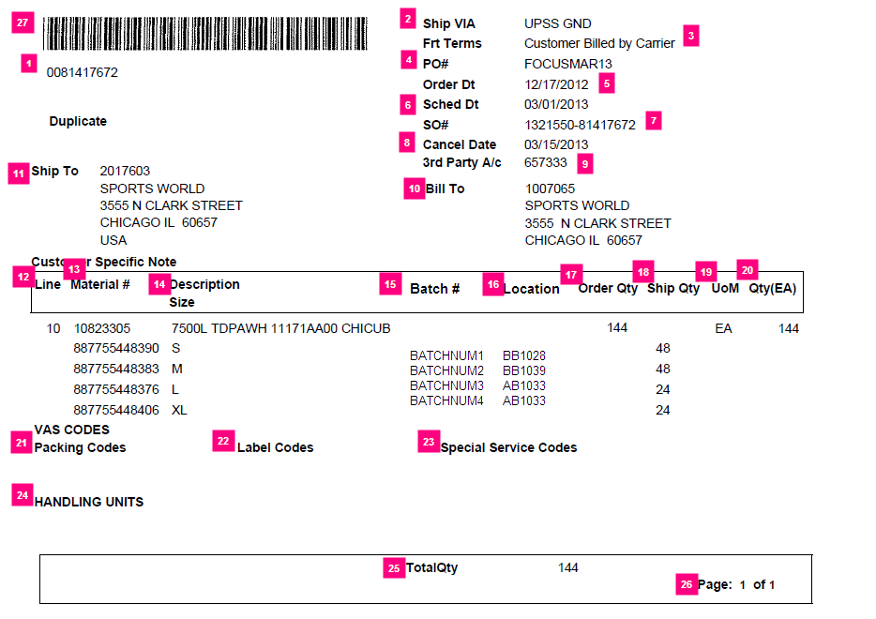

5 Development Notes
- The output will be printed on A4 paper in Hong Kong.
- The form will only need to display in English, no translations are needed.
- Only those materials included in the transfer order will be displayed on the picking list (multiple transfer orders could be created for a single delivery).
- The barcode should display with the same encoded data as the barcode on the ZLD4 output, and will be used for scanning data into Chainlink

6 Technical Test Conditions

Test | Expected Result | Actual Result
T1 | Form should be generated after picking transfer order is saved | Form is printed.
T2 | Form should be generated when run through reprinting transactions | Form is printed.
T3 | If transfer order fails, form should not print | Form is not printed.
T4 | Barcode should be able to be scanned and data transferred to Chainlink | Delivery data is populated into Chainlink.
T5 | When multiple transfer orders are created against a delivery, the output should only show the materials/quantities linked to the specific transfer order, not the whole delivery | Form is printed with only the appropriate materials/quantities displayed.

7 Business Test Conditions

Test | Expected Result | Actual Result
B1 | After creating a picking transfer order, the form should print and contain enough data to physically pick | Physical picking occurs without issue.

