**FABRIC PLANNING**

**Examples:**

FG Materials: 10016565 & 10016566

Fabrics (Component) : 90000621 & 90001444

Created the BOM for Finished products and maintained the fabric as a component.

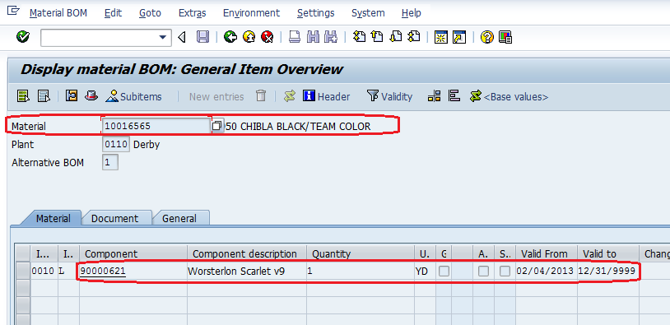

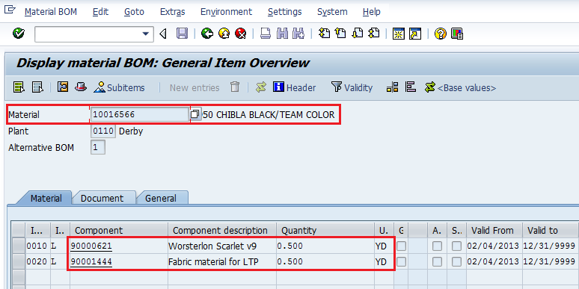

Maintain the planned independent requirements for the finished products at material level. Since we are maintaining PIRs in inactive status these will not participate in regular MRP.

Transaction code is J3A1

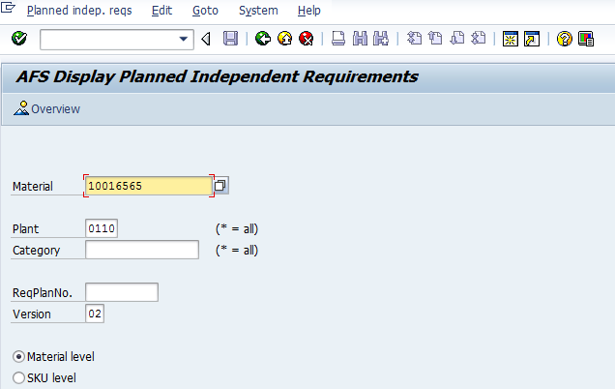

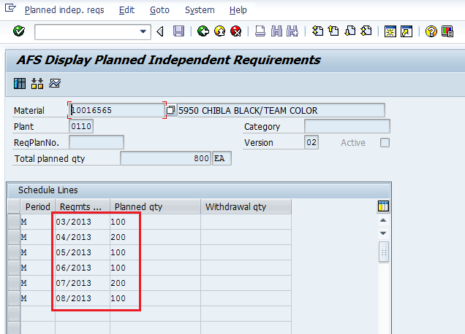

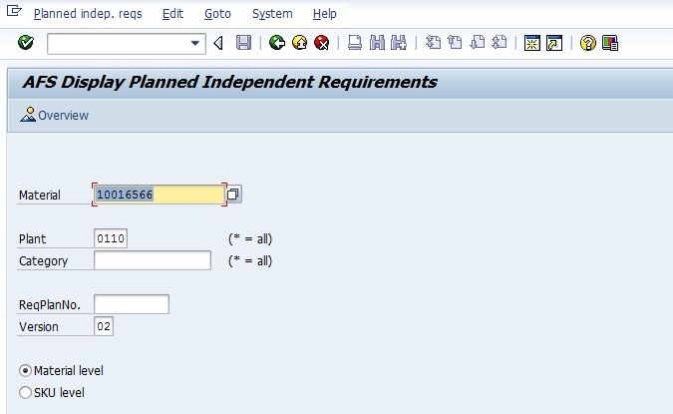

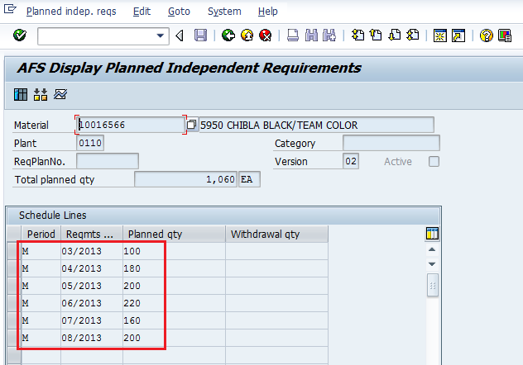

Execute the query Z_FABRIC_PLAN and input the plant and material numbers as shown below.

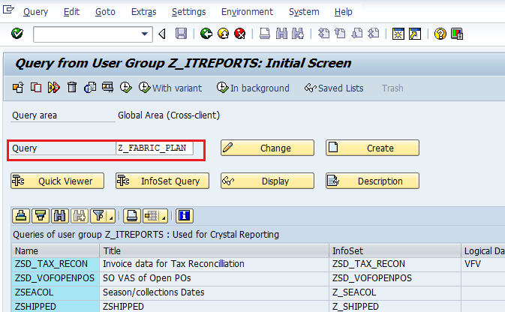

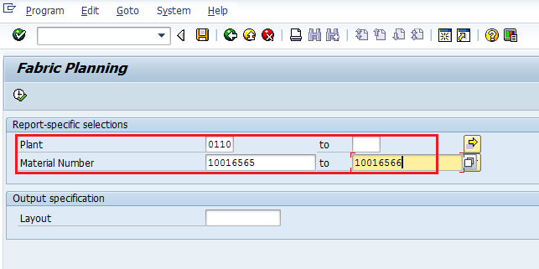

Then we can get the report for requirement of fabric as shown below.

