**Vendor Compliance**

1. Receiving Compliance Report

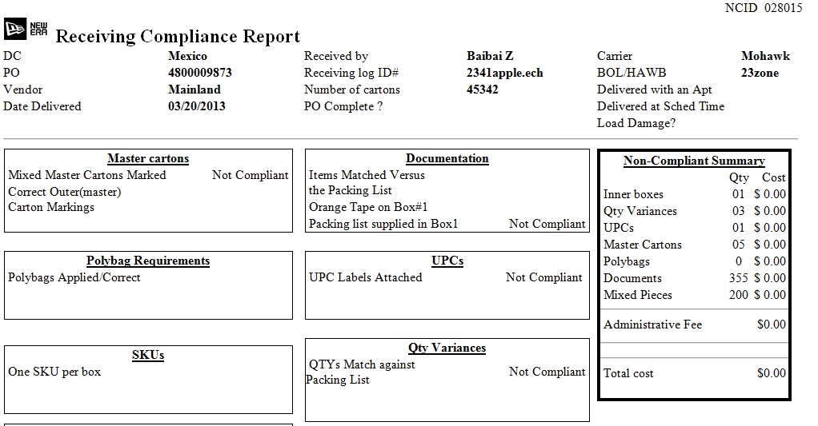

Remove leading zeros in quantity. This is in production as well. **This is Existing functionality in production environment, it can be changed as requested and will be tested.**

**Change it and test it.**

1. I was trying to check “Chargeback invoice issue entry closed” checkbox then clicked Save in step #3.

Then nothing saved but received the tiny error message on top:

“SqlDateTime overflow. Must be between 1/1/1753 12:00:00 AM and 12/31/9999 11:59:59 PM.”

I don’t understand this error message.

**Error message should specify which field is having issues and what the valid format should be.**

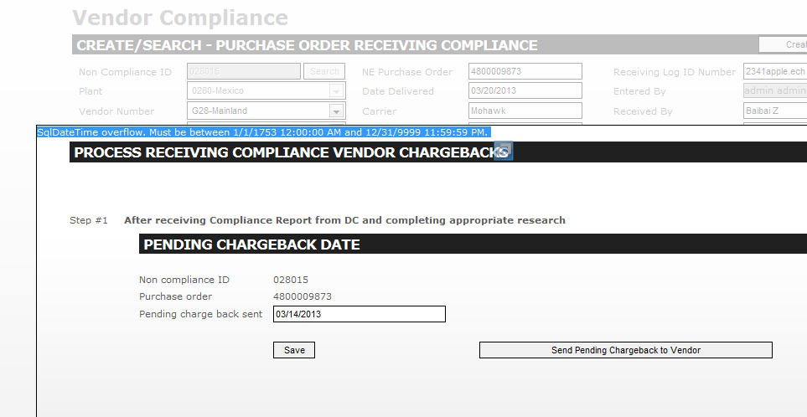

1. Once date fields are entered without even saved, it cannot be removed. User should be able to remove the date value and save tickets in case issue #2 happens.

**Can you please explain me the scenario of the above in GOTO.**

**All the date fields, once entered, cannot be removed. Users should be able to remove date values from non-mandatory fields.**

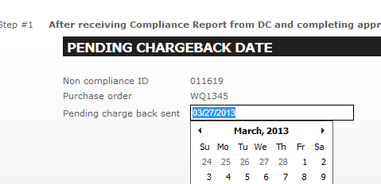

1. DC user cannot edit ticket created by Admin user. **All the users SHOULD be able to edit tickets as long as they have access to that page.**

**Based on the document shared to me, it was not mentioned anywhere that DC User cannot edit ticket created by Admin User. Please share the document regarding the functionality**

**Security is only limiting the pages that the user can access. Whether a user can see a certain ticket, depends on if the plant of the ticket is assigned to that user or not. If not, error message “**No records found.**” should be displayed like the ticket doesn’t exist.**

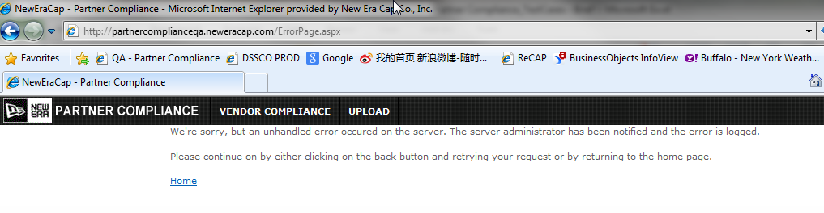

1. Created test ticket using Logistics user

Checked Damage on Load, but it is not reflected in the email.

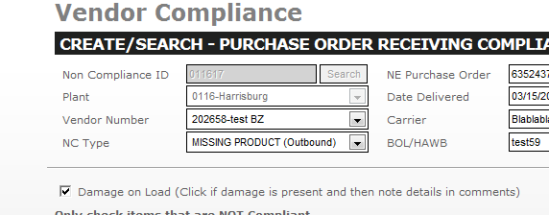

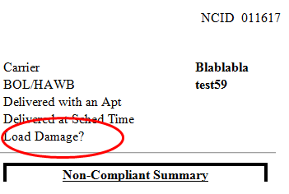

**Will check this and let you known.**

**Fix it and test it.**

1. **Sort plant dropdown alphabetically by plant description. Keep same display (number - description)**

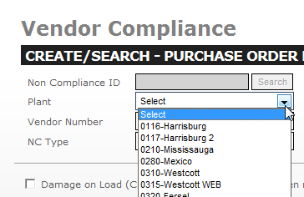

1. **Sort vendor dropdown alphabetically by vendor description. Keep same display (number - description)**

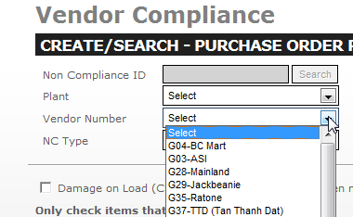

1. **Sort NC Type dropdown alphabetically by NC Type description.**

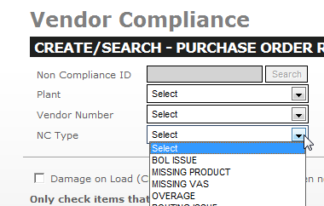

1. Besides carton numbers, any fields that user can manually enter numbers, should not allow commas. But thousand separators should still be displayed, not saved.

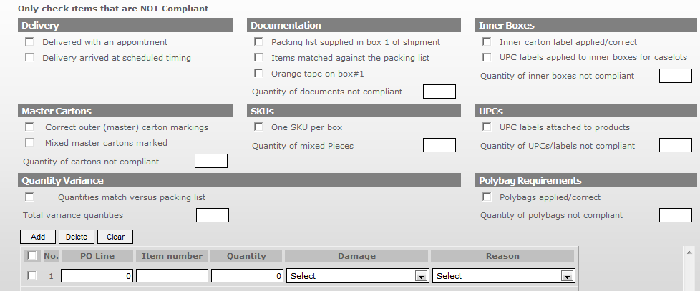

And admin fee field.

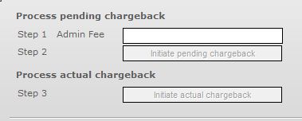

**DC Compliance**

1. **Sort vendor dropdown alphabetically by vendor description. Keep same display (number - description)**

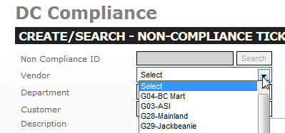

1. **Sort department dropdown alphabetically by department description.**

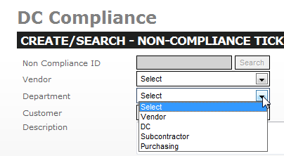

1. **Sort customer dropdown alphabetically by customer description. Keep same display (number - description)**

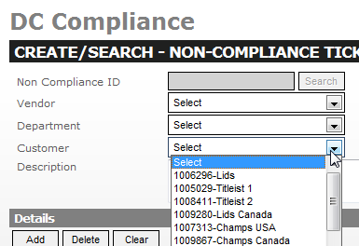

1. **Quantity field should not allow commas. Thousand separators should still be displayed, not saved.** 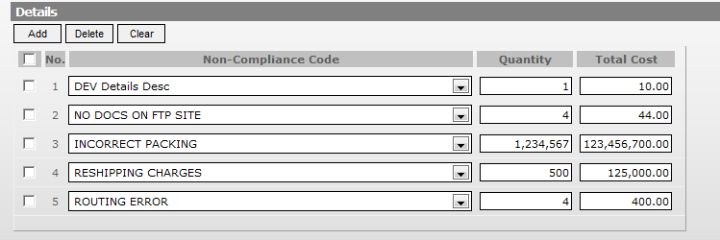

**The comma in quantity 1,234,567 will stop the ticket from saving changes although there will be a pop up saying it is saved.**

1. **User should be able to remove date value from the following fields.**

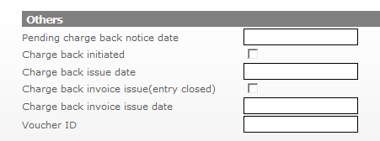

1. **When the user enters a PO line detail with zero quantity or total cost, this should save too. Eg. Line 3.**

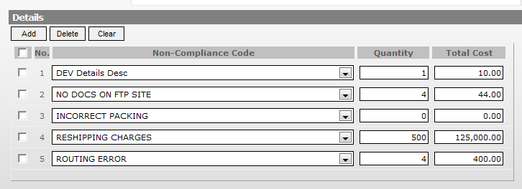

**Admin Page**

1. Cannot save when editing existing users.

**This can be updated or edited when both ADID and User ID modified. Can you please suggest on this.**

**In production, admin can edit any field alone and save it. ADID is the unique identifier. Anything can be changed.**

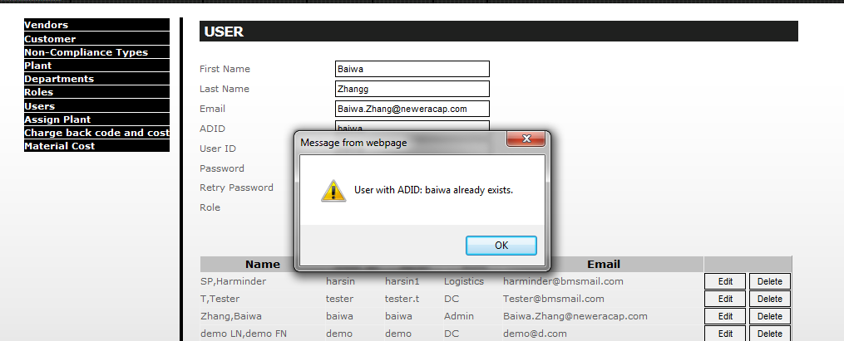

1. None of the delete option has alert. Once accidentally clicked, the record is gone.

(This is not standard, but we don’t need to fix this now.)

**As per the existing functionality ‘After clicking ‘delete’ button the user get a prompt of message like “Deleted Successfully.” With “OK” button, if user click on Ok then data should deleted else not deleted.**

**In QA, after users click “Delete”, the record is deleted no matter user click “OK” or not. Plus that’s the only button user can click except for closing the window. Either way the record is deleted. The alert should say “Delete selected record?”, and deletion will happen upon “Yes.” while the other option is “Cancel”.**

1. Charge back code and cost: once failed to save due to existing record, data is removed from the grid. Change this and keep the data.

**This is an existing functionality and is available in production environment too, it can be changed and tested.**

**Please suggest.**

**Change it and test it.**

1. Charge back code and cost: once inserted, change alert to “Charge back code and cost saved successfully.” And change the edit confirmation to “Charge back code and cost saved successfully.” upon successfully operation.

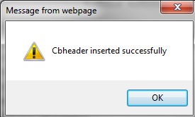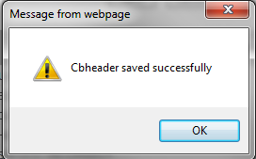

**This is an existing functionality and is available in production environment too, it can be changed and tested.**

**Please suggest.**

**Change it and test it.**

1. Cannot delete material cost for newly created records.

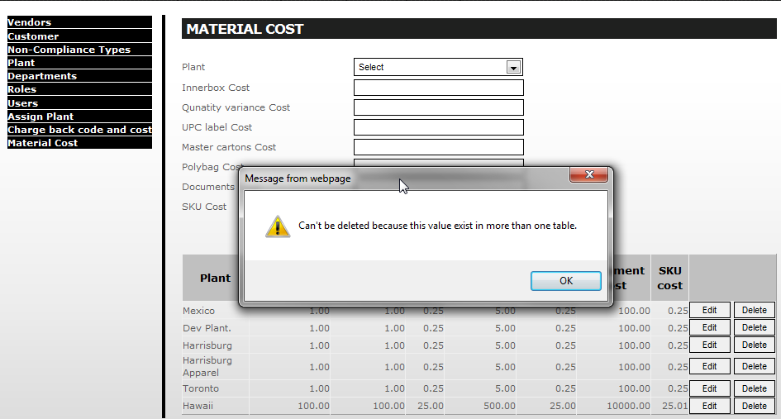

**This is an existing functionality and is available in production environment too,**

**If the record is using in other tables then user get a prompt message of “can’t be deleted because this value exist in more than one table” with ‘OK’ button.**

**How can a new record I just created be used in other tables already?**

**Bug Fix**

1. After the ticket is created, by user A, if user B edits the ticket later, the “Entered By” field will display user B who last edited it.

This field should always display original creator of the ticket. Because normally the ticket creator will not be the one who sends out chargebacks and invoices.

For example, I created P00116 using baiwa user.

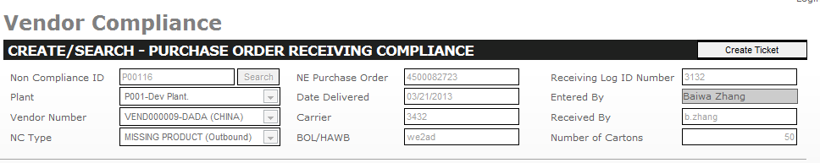

Then I edited it with “admin” user, entered by changed to admin.

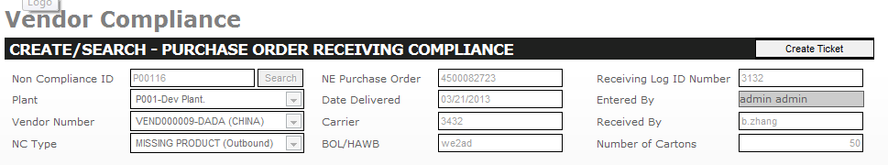

1. “Entered by” should only record the initial creator of the ticket. It shouldn’t change after each edit if by a different user. Same bug as in Vendor Compliance.

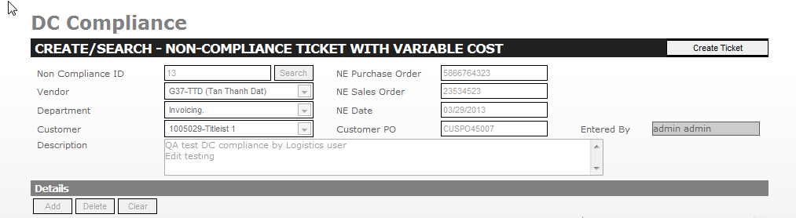

As this was not explained in the provided document to me, Please share the spec documents regarding the correct functionality. It can be changes as requested and tested.

**Currently, this field will change every time the user saves the ticket. If A created the ticket and B changed it, then the entered by will show B. It SHOULD show the ticket creator, which is A.**

1. **Cannot edit existing material costs by highlight and rewrite.**

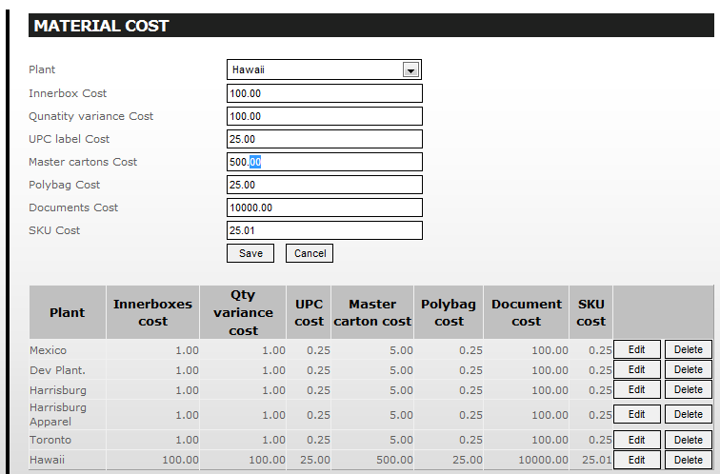

1. **Cannot edit CB code and cost by highlight and rewrite** 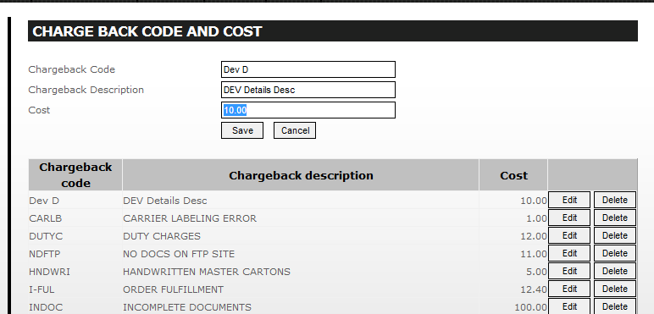

**Failed Test Cases**

|  |  |  |  |  |
| --- | --- | --- | --- | --- |
| **Requirement** | **User Access** | **Test Case ID #** | **Page Name** | **Comments** |
| Clear button functionality in Vendor compliance record. | Admin User | PC_ TC_013 | Vendor Compliance Page. | Clear works but after clicking save, it only adds a cleared line while keeping the original line that was supposed to be cleared. |
| Enter the existing user details in 'user' page | Admin User | PC_ TC_068 | Admin Page | **Mentioned before.** |
| Clear button functionality in DC compliance record. | DC User | PC_ TC_117 | Vendor Compliance Page. | Clear does not work. It clears quantity and total cost but when save as it is, zero quantity and zero cost, it won't save the changed values. |

**Enhancements**

1. **Change access to Logistics users. Give Logistics user access to vendor compliance page.**

|  |  |  |  |  |
| --- | --- | --- | --- | --- |
| **Project Name: Partner Compliance** | | | | |
| **Role Based Security User Checklist** | | | | |
| **S.No** | **Page Name** | **Users** | | |
| **Admin User** | **Logistic User** | **DC User** |
| 1 | Vendor Compliance | **✓** | **✓** | **✓** |
| 2 | DC Compliance | **✓** | **✓** | **X** |
| 3 | Reports | **✓** | **✓** | **X** |
| 4 | Upload | **✓** | **✓** | **✓** |
| 5 | Admin | **✓** | **X** | **X** |