Create a Purchase Order: 4600007721 and Inbound Delivery is created 180001579.

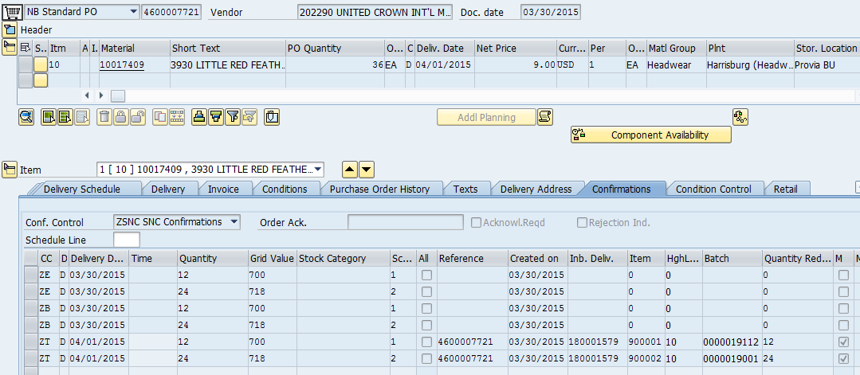

The Quantity reduction field is updated now.

MIGO is done by the IDOC # 358252, Basic Type: /AFS/WMMBID02, Message Type: WMMBXY.

When we try to cancel the MIGO/ GR

Transaction: MIGO

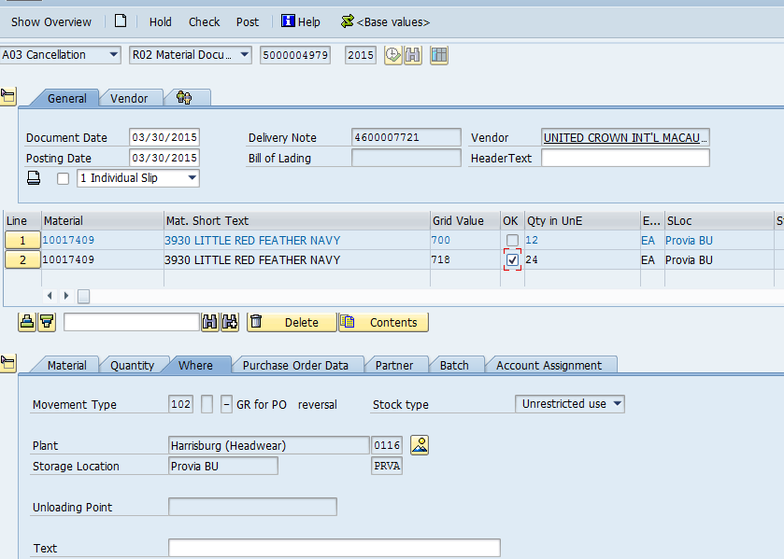

When we try to cancel the Document we get the Dump:

