Issue: Could not able to cancel GR material document:
Error: Below is the error when trying to cancel the material document

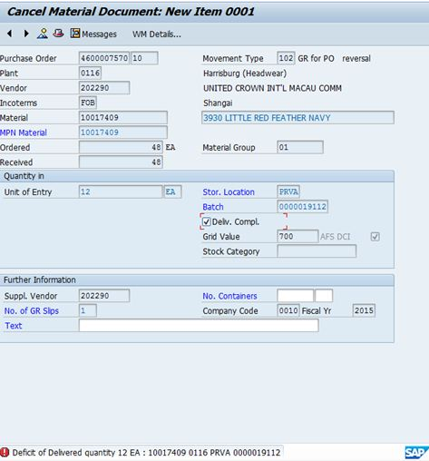

Solution Provided by SAP:

Use customer function 'EXIT_SAPLLMDE_002' to specify and fill field MSEG-ETENS before MB_CREATE_GOODS_MOVEMENT is called.
The issue occurred since the field MSEG-ETENS is not filled before calling MB_CREATE_GOODS_MOVEMENT
Background: At present, you cannot assign the sequence number for the purchase order confirmation (EKES-ETENS) to the IDOC at item level in the interface.
This is the same for customers who are using the message type WMMBXY (L_IDOC_INPUT_WMMBXY).
As we can't determine the confirmation the customer has to fill this in the idoc input function on his own. This means: for customers who are using WMMBXY: they have to user customer function 'EXIT_SAPLLMDE_002' to specify and fill field MSEG-ETENS before MB_CREATE_GOODS_MOVEMENT is called.
The Solution is implemented suggested by SAP.

Testing after the Changes:

Created a NB PO # 4600007597.

Po Confirmations are updated and inbound delivery is created.

Posting Goods Movement using IDOC:

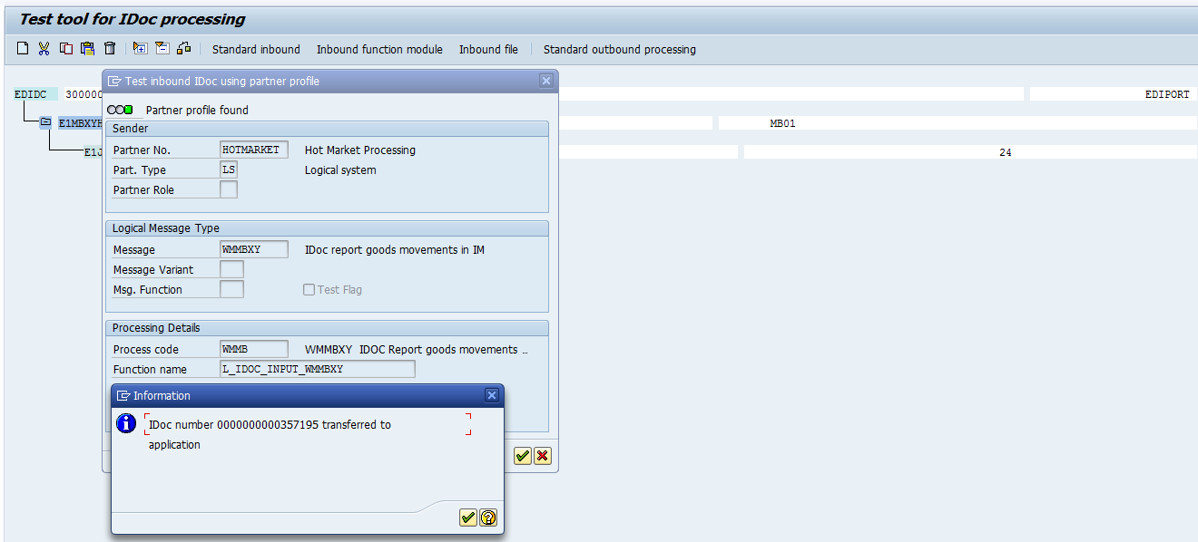

MIGO is carried out using IDOC.

It is observed that the Quantity Reduction field is updated correctly in the PO.

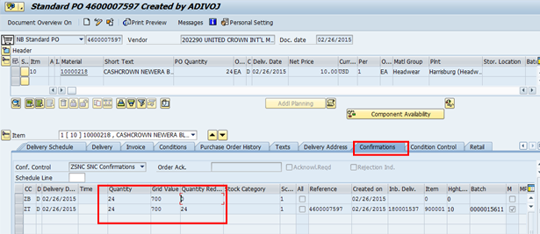
Goods Movement Cancellation :( MBST)

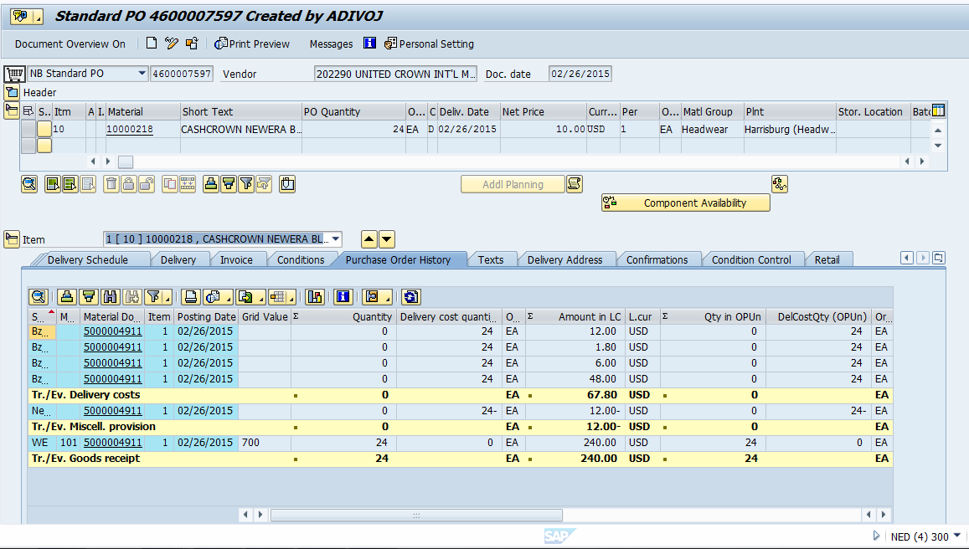

Cancel Document:
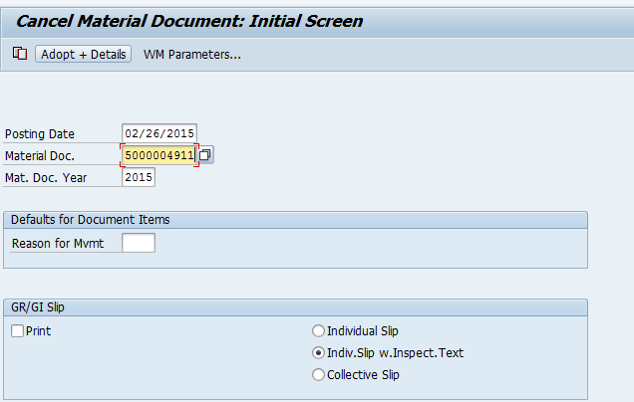

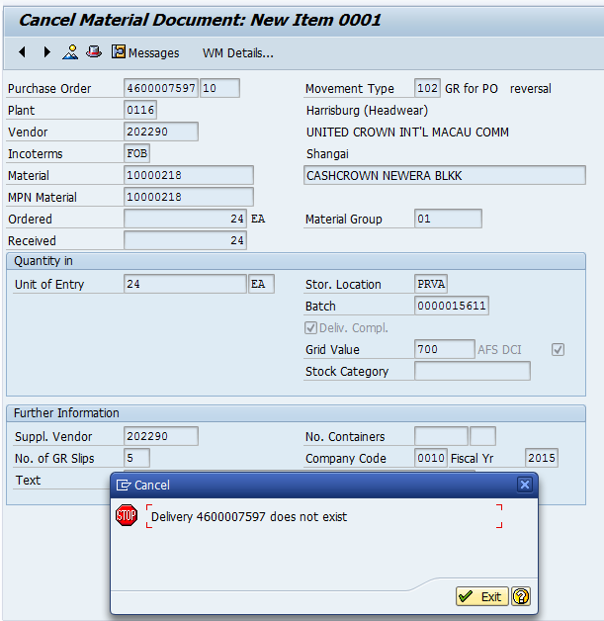

Now the error has been different the PO number is considered as the Delivery.
But when the same is done manually this error is not occurred.

Conclusion:
DABMG field is updated in the Purchase Order confirmations,
Now there is a new error as shown above Delivery PONUMBER does not exist.

