**Issue:** GR Document is not getting cancelled.

**Analysis:**

Whenever confirmation cat ZN is updated in an NB PO, An inbound delivery is created using a custom program and ZT confirmation is updated in the confirmations with the Inbound Delivery number.

In configuration MRP Relevant, GR Relevant and GR Assignment Check boxes are flagged for ZT Confirmation category, which means that to do GR it is mandatory for ZT Confirmation to be updated in the PO confirmations.

 Inbound Deliveries are not PGRed instead GR is done against the PO.

* When GR is done manually against PO by using the transaction code MB01/MIGO, the Quantity reduction field (DABMG) is updated with the GR quantity in the confirmations tab.

***Material Document generated can be deleted (Ex: PO 4600007524 in DEV 300)***

* When GR is done using IDOC the quantity reduction field (DABMG) is not updated which is causing the Issue.

***Material Document generated can be deleted (Ex: Po 4600007523 in DEV 300)***

**IDOC Details which is used to GR the PO.**

Basic type: /AFS/WMMBID02

Message type: WMMBXY

When GR is done using IDOC the quantity reduction field (DABMG) is not updated,

**For Example**: If the PO quantity is 10 EA and if we have done GR for 10 EA using IDOC and quantity reduction did not happen, when we try to cancel the GR it gives an error as shown below

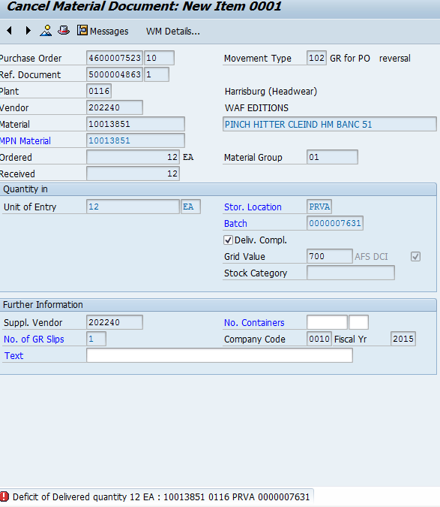

**Suggestions and Test Results:**

As per the suggestion (refer KBA: 2044484) Correction report ZCORREKESGRRTV is added.

When the Report is Ran for the Purchase Order

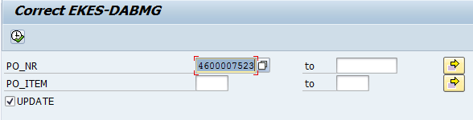

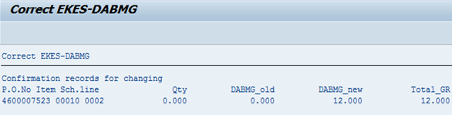

But when GR Document is been cancelled we get the error as shown:

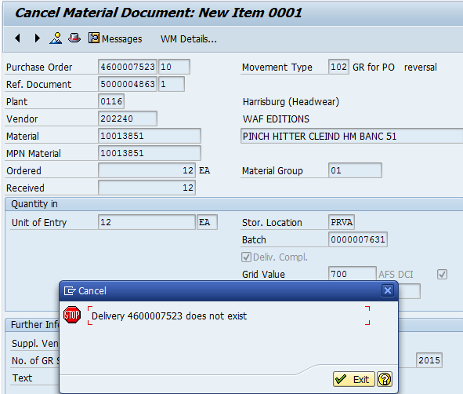

The Purchase Order in the above screen shot is considered as Inb Delivery Number.

We have also tried to implement the following Notes however these notes were not helpful to solve the issue:

|  |  |  |
| --- | --- | --- |
| **Note** | **Status** | **Suggested by** |
| 1919406 | Completely Implemented |  |
| 1983313 | Completely Implemented |  |
| 1561928 | Cannot be implemented |  |
| 2044484 (KBA) |  | SAP |
| 1877198 | Completely Implemented | SAP |
| Pre-requisite Notes for 1877198 |  |
| 1522186 | Cannot be implemented |
| 1668559 | Cannot be implemented |
| 1827920 | Completely Implemented | SAP |
| Pre-requisite Notes for 1827920 |  |
| 1734577 | Completely implemented |
| 1946960 | Completely Implemented | SAP |
| Pre-requisite Notes for 1946960 |  |
| 1554198 | Cannot be implemented |
| 1814532 | Completely implemented |

The above notes did not helped in solving the Issue, for few Notes the status is it cannot be implemented

**Cause:**

Quantity Reduction (DABMG) field which is not updated when the GR is posted with the IDOC.

**Examples in DEV 300:**

Here are couple of Purchase orders in which GR is done using IDOC:

* 4600007525
* 4600007526