Germany not posting Profit Center and Cost Center in ICO for GL 51000 Company code 0040

2012 (using T-code S_ALR_87100205)

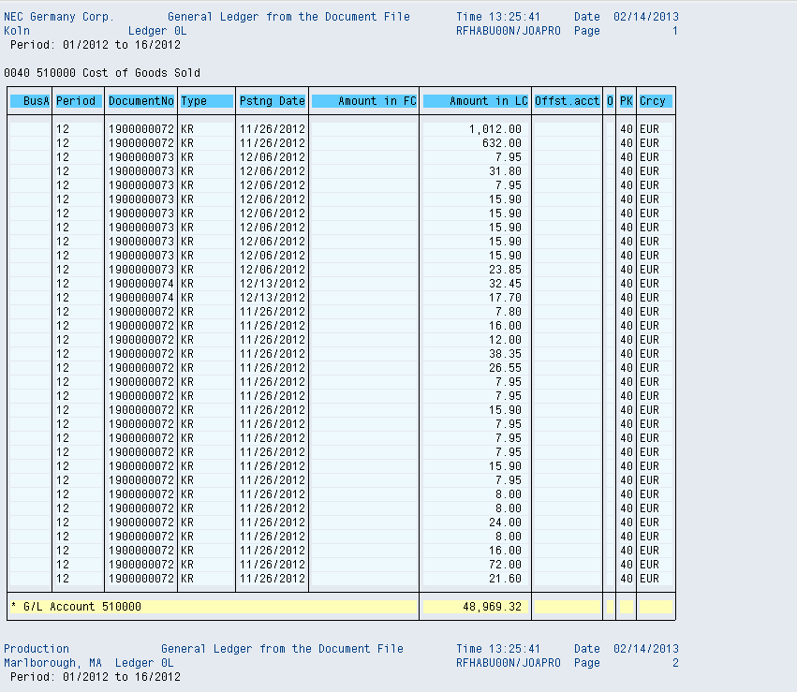

2013 so far

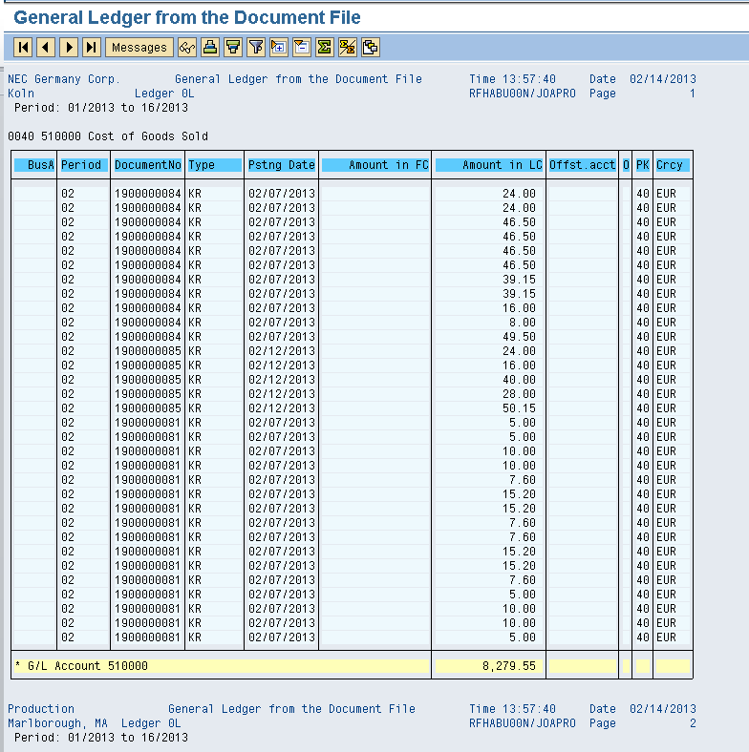

Cost center and Profit center missing - these are done automatically –double click on document 1900000081

