AP postings Between 5th and Sales Org 10000
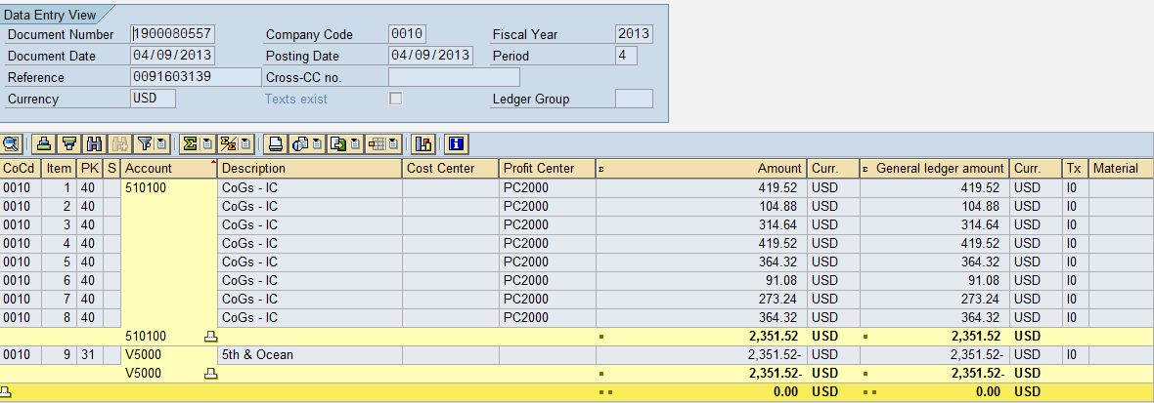
AP postings Between 5th and Sales Org:
It is blocked because of the Vendor being blocked in the IDOC.
