**Inbound process flow (Encashment):-**

1. For conversion of the encashment file received from bank.

|  |  |
| --- | --- |
| Transaction code | SE38/SA38 |
| **Program** | ZFI_PPPUPLOAD_ENCASH |

1. Enter the following data/path on the screen

|  |  |
| --- | --- |
| Upload file from App.Server | /usr/sap/NED/BANK/POSITIVEPAY/IN/ |
| **Download to App.Server** | /usr/sap/NED/BANK/POSITIVEPAY/IN/ |

Note: - Enter the received bank encashment file name for Upload file from App Server and also enter the name for Download to App.Server to convert the file as per the SAP standard.

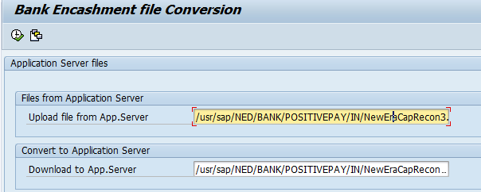

Bank encashment file before conversion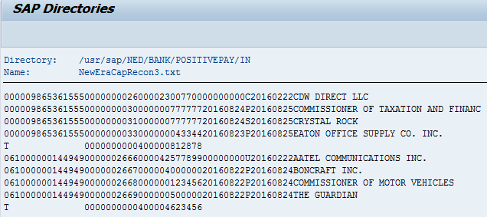

Bank encashment file after conversion as per SAP standard.

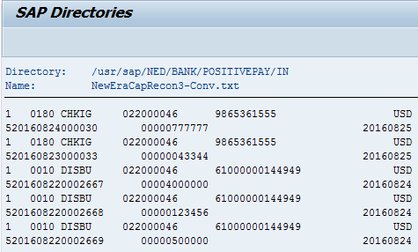

Job log shows all the other check info except the paid checks when the conversion file run

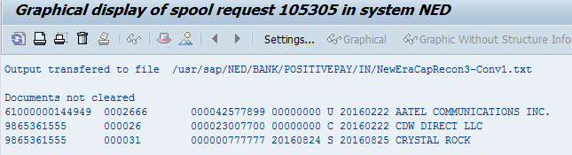

**Encashment process:-**

1. Encashment of checks received from bank.

|  |  |
| --- | --- |
| Transaction code | SE38/SA38 |
| **Program** | ZRFEBCK00 |

1. Enter the following data/path on the screen

|  |  |
| --- | --- |
| Check file with file path | /usr/sap/NED/BANK/POSITIVEPAY/IN/ |
| **Prenumbered Checks** | X |
| **Post immediately** | X |
| **Session name** | User specific |
| **Posting date** | Current date |
| **Document date** | Current date |
| **Document type** | SA |
| **Print file** | X |
| **Detailed log** | X |
| **Print posting log** | X |

Execute in background

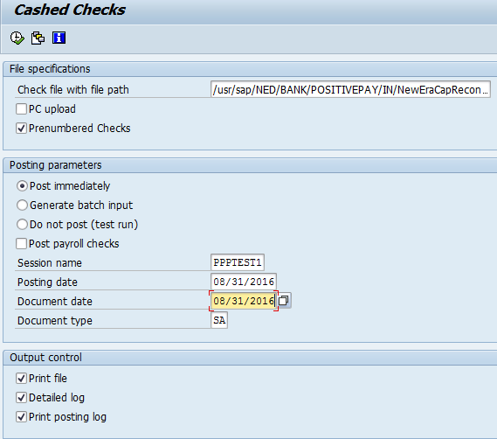

Job log will show for the program ZRFEBCK00.