Incorrect condition value at GR for partial deliveries

Value for only one condition ZOA8 is posting incorrectly in accounting from the time of second GR for the same item in PO.

* While posting the second GR there is a value difference and sometimes wrongly posting to credit instead of debit, where as the first GR is posting correctly.

Condition value at the PO calculated correctly, where as condition ZOA8 is 100% value of condition ZOA9.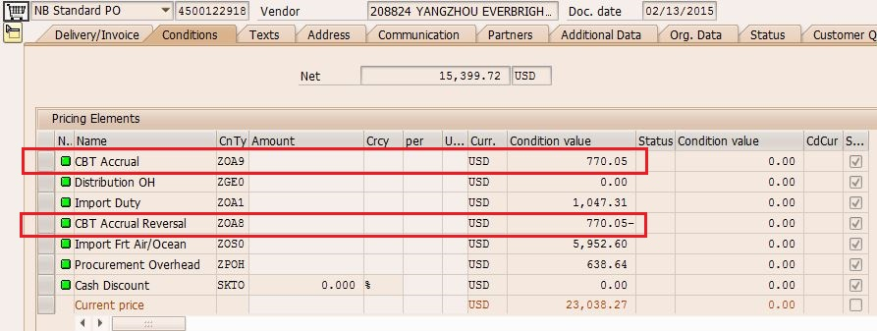

First GR for an item in PO posted correctly.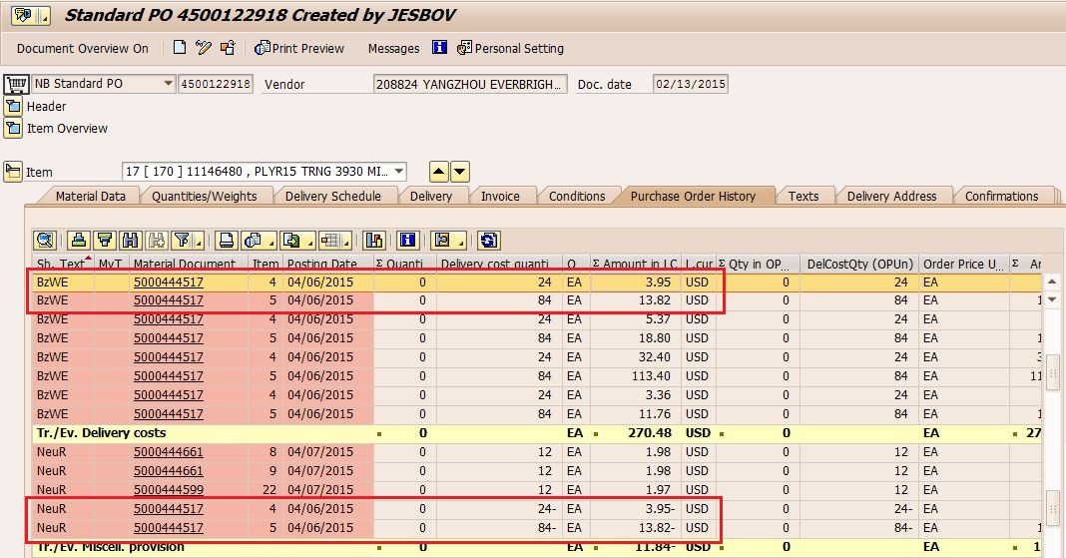

2nd and 3rd GR for the same item posted wrongly.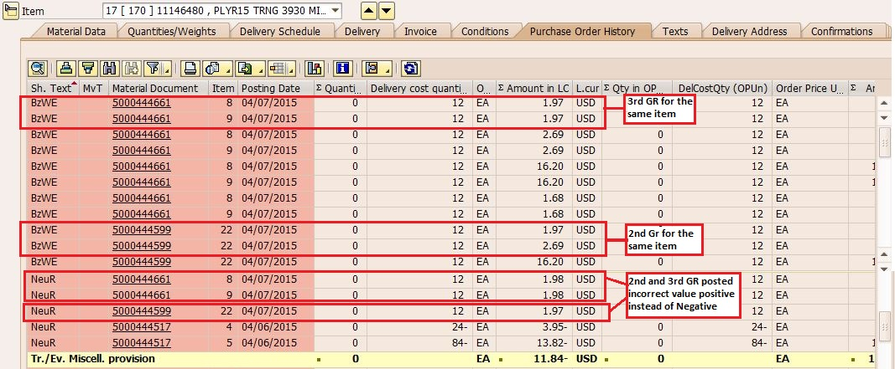

Accounting entry is posted wrongly to credit instead of debit (line item 9 value 19.72).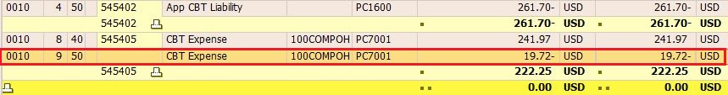

Other item in the same PO with value difference for 2nd GR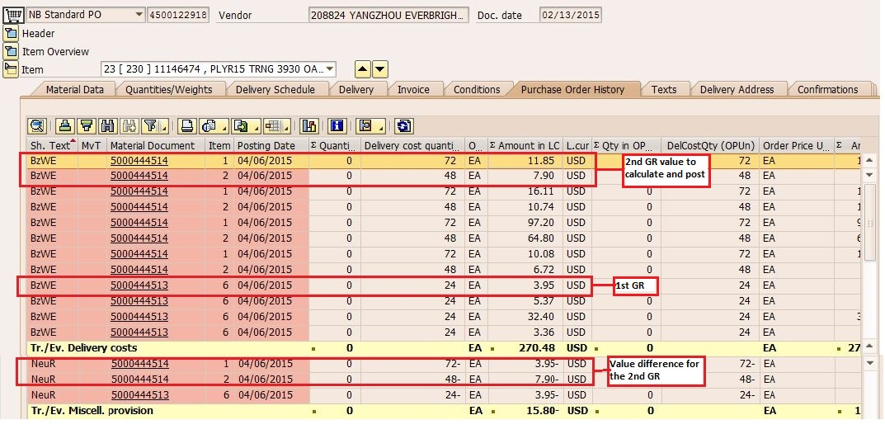

Accounting Entry with value difference