Problem: Inventory and G/L acc val 135100(raw materials), 135110(Finished products) does not match.
Execute the report RM07MBST:
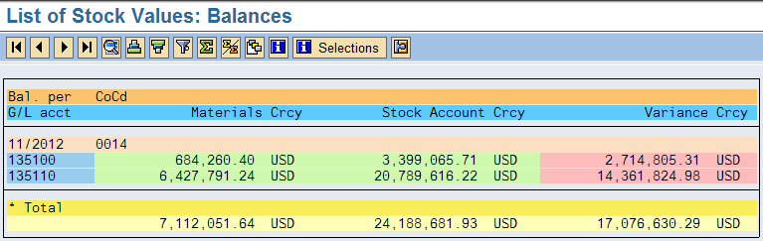Raw materials: Stock value for raw materials 684,260.40
Screen 1
Screen 2
Screen 3
Screen 1:
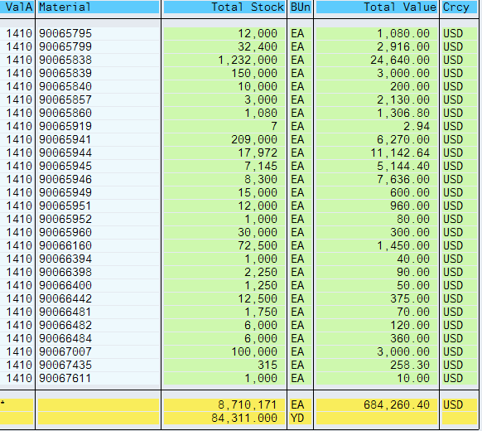
Screen 2: Execute FBl3N with 135100 for Co.code 0014 for the G/L raw material account postings.

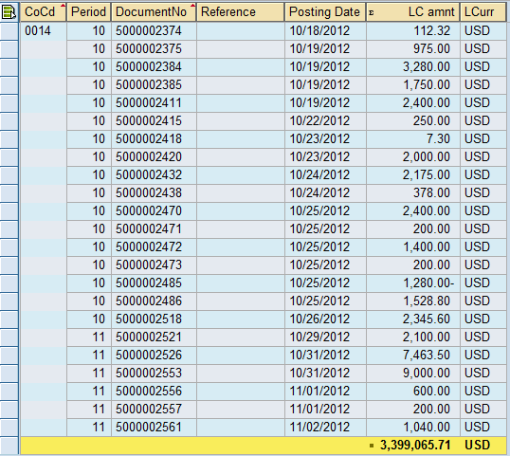
Screen 3: Execute FBL3N account 135100 for Co.code 0014, document type SA
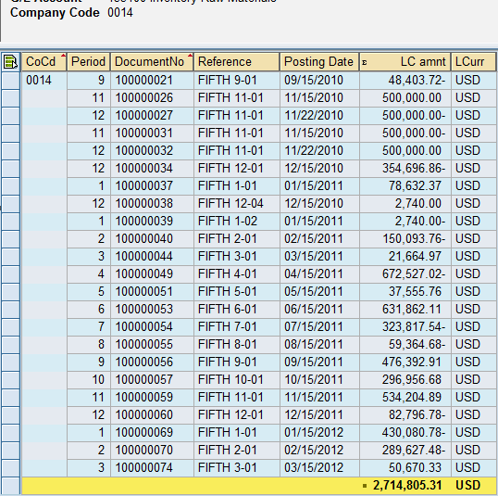

Finished products Inventory balances:

Screen A
Screen B
Screen C

Screen A:
Inventory of Finished products:
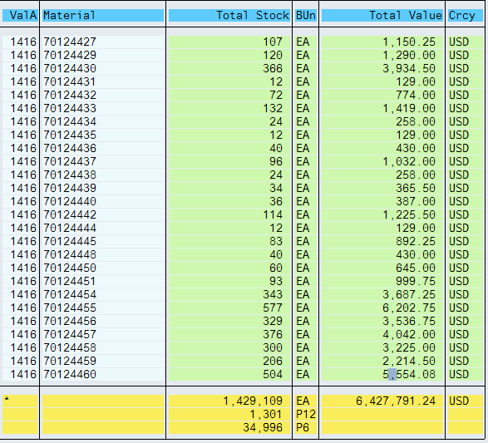

Screen B: Run FBl3N with 135110 for co.code 0014
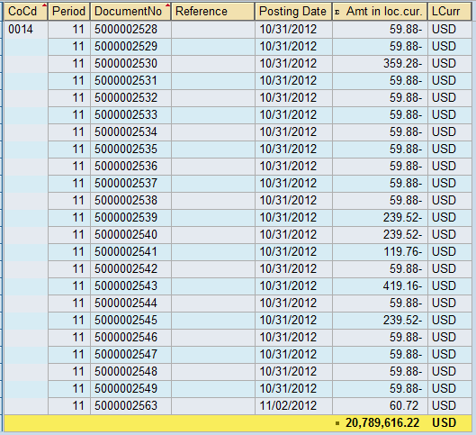

Screen C: Run FBl3N with 135110 for Co.code 0014, document type is SA.
