1. Plant 0110 and Material 90000516 with and without storage location:

Inventory Infocube:

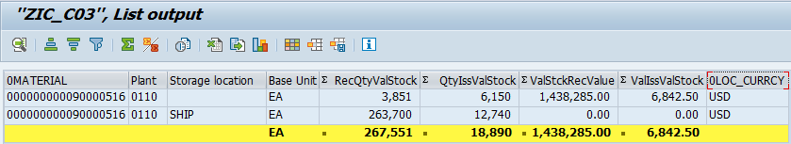

Stock = 267551-18890=248661 EA

Value=1438285-6842.50=1431442.5 USD

Inventory BEx Query:

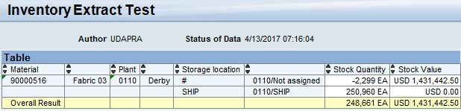

Explorer Space:

C:\Users\uday.p\AppData\Local\Microsoft\Windows\INetCache\Content.Outlook\HOMFFMBH\90000516.JPG

1. For Year 2017, cumulative stock value for all Material for all plants:

Inventory BEx Query:

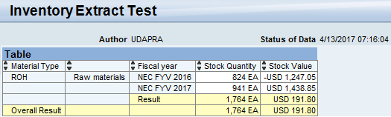

Explorer Space:

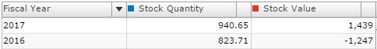

1. For Plant 0110, cumulative stock value for all Materials:

Inventory BEx Query:

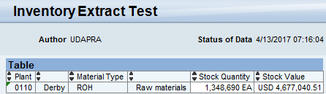

Explorer Space:

C:\Users\uday.p\AppData\Local\Microsoft\Windows\INetCache\Content.Outlook\HOMFFMBH\plant.JPG

1. For Plant 0110, cumulative stock value for all Materials by storage location:

Inventory BEx Query:

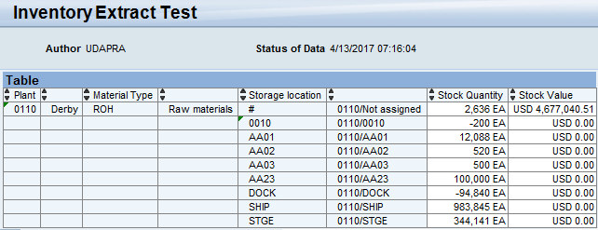

Explorer Space:

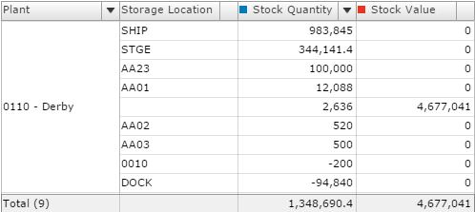

1. For Material 90000426, cumulative stock value for all Plants by storage location:

Inventory BEx Query:

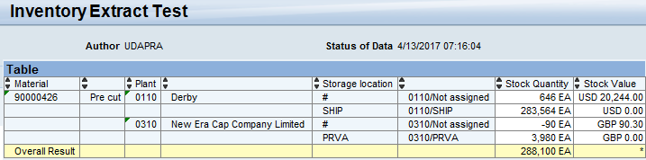

Explorer Space:

