**Japan Remittance Email Confirmations**

Date# 01/23/2018

We are facing the alignment and data missing issues in the form, so it is better to copy ZREMIT_ADV_US to ZREMIT_ADV_JP for Japan remittance form. Please see the below screenshots for reference.

US Remittance form Invoice details missing

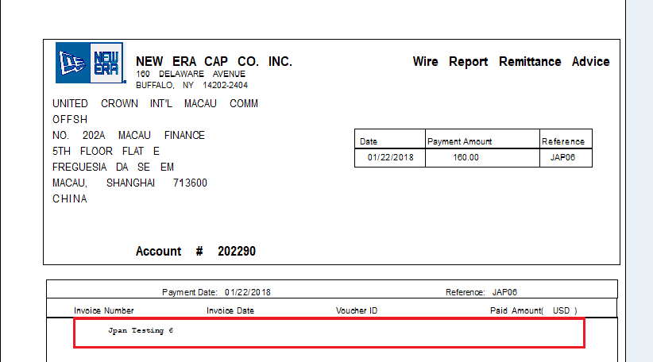

Japan Remittance Form.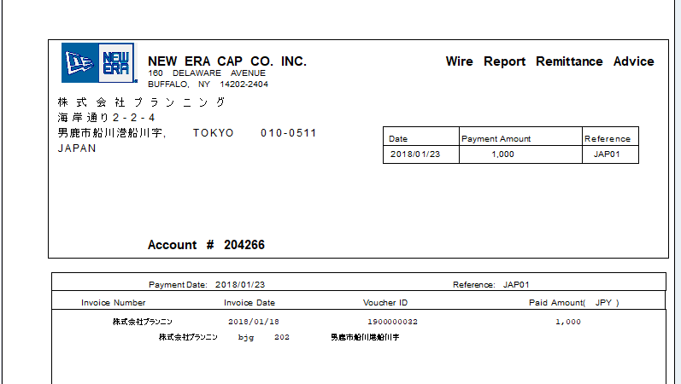

Date# 01/26/2018 - Confirmation from Baiwa

Yes please go ahead and make a separate one for Japan.

Date# 02/03/2018

as we faced the alignment and actual length issues where Japanese font does not fit to remittance file so we made few changes in the form.

1. Increased the form reference and text length.
2. Fields of the invoice date, Voucher ID and Paid amount is moved to bit right from the actual positions

Please see the below remittance form, for reference the spool nos. for Japan 116349 and US 116348 in NED300.

