***NewEraCap***

**Japan Summary Invoice Extract**

Author: Matthew Bolles

**Contents**

***NewEraCap*** 1

**Contents** 2

**Documentation History** 3

Document Location 3

Revision History 3

Quality Review 3

Approval 3

**1.0 - Overview** 3

1.1 - Overview & Scope 4

1.2 - Purpose 4

1.3 - Source System (Details & Direction) 4

1.4 - Target System (Details & Direction) 4

1.5 - Initiating Process 4

1.6 - Complexity (High, Medium, Low) 4

1.7 - Transaction Volume 4

1.8 - Frequency & Timing 4

1.9 - Assumptions 4

1.10 - Risks 4

1.11 – Constraints 4

1.12 - Dependencies 4

**2.0 - Detailed Requirements** 5

2.1 - Interface Flow Diagram 5

2.2 - Detailed Design Description 5

2.2.1 – Data Mapping 7

2.3 – Proposed Transfer Method / Program 7

2.4 – Performance Considerations 8

2.5 – Security Requirements 8

2.6 – Reporting 8

2.7 – Error Handling 8

2.8 – Reconciliation Procedures and Audit Requirements 8

**3.0 - Testing Requirements** 8

**3.1 – Key Business Test Conditions** 8

**3.2 - Results Verification** 8

**4.0 - Outstanding Issues (SIRs)** 8

**Documentation History**

Document Location

The electronic source of the document can be found on:

Revision History

| Version | Revision date | Summary of Changes | Section | Page |
| --- | --- | --- | --- | --- |
| 1.0 | 4/20/2018 | Initial Creation |  |  |
|  |  |  |  |  |

Quality Review

The following have been nominated as quality reviewers for this Product:

| Name | Title | Date of Issue | Versions |
| --- | --- | --- | --- |
|  |  |  |  |
|  |  |  |  |

Approval

This document requires approval from the following individuals:

(Signed approval forms are filed in the quality section of the project files)

| Name | Role | Date | Signature |
| --- | --- | --- | --- |
|  |  |  |  |
|  |  |  |  |

**1.0 - Overview**

1.1 - Overview & Scope

The Japan finance team would like to leverage a widely used SaaS offering ([Infomart](https://www.infomart.co.jp/e/business/index.asp)) to deliver invoices to their customer's electronically.   This will allow our customers in Japan to have 24/7 access to their invoices, including the Summary Invoice. An ABAP program is required which will extract data from the following areas / tables:

* Summary Invoice (ISJPINVSUMHD, ISJPINVSUMIT)
* Billing (VBRK, VBRP)
* Delivery (LIKP, LIPS)
* Sales Order (VBAK, VBAP)

This extract will be in CSV format, and must download to the user's machine.   Once downloaded, the user will populate additional data in the required fields, save, and manually upload to the portal.

1.2 - Purpose

The Japan finance team will save 16 hours per month by providing the invoice to the customer via a self-service portal.  Additionally, the immediate availability of invoices is expected to drive faster payment, increasing cash flow.

1.3 - Source System (Details & Direction)

*SAP ECC*

1.4 - Target System (Details & Direction)

*SAP ECC*

1.5 - Initiating Process

*[Please describe the triggering process for this interface, which could be a fixed time schedule or a specific event / action (batch, manual)]*

1.6 - Complexity (High, Medium, Low)

Low.

1.7 - Transaction Volume

*[Please provide an indication of the expected number of records that will need to be transferred using this interface]*

Each file may contain 10,000+ records.

1.8 - Frequency & Timing

Export will be run five times per month (10th, 15th, 20th, 25th, and month-end, which align with the cutoff dates)..

1.9 - Assumptions

*[Please describe any assumptions that have been made in the process of completing this design]*

1.10 - Risks

*N/A*

1.11 – Constraints

1.12 - Dependencies

*[Please indicate any dependencies that may impact development, in terms of requirements from internal or external applications or teams]*

*Also, please specify any interface or batch jobs that must be run prior to execution and dependent jobs/ operations.]*

**2.0 - Detailed Requirements**

2.1 - Interface Flow Diagram

*[Please insert an interface flow diagram showing source and target systems with directions]*

No automated interface will exist.  The file generated by the program will download to the user's desktop.   Following modification, the user will manually upload the file to the portal.

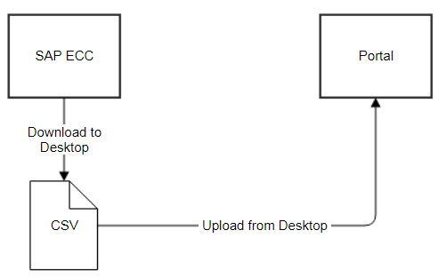

2.2 - Detailed Design Description

*{Please provide additional details for custom development requirements (Process flow diagram, detailed description of data manipulations, transactions required, screen flows) where appropriate}*

*See documents below for examples containing a list of all the fields that need to be included. Some notes:*

*- Fields marked in Grey should be left blank in the output (will be populated by the New Era team manually)*

*- Any field containing a currency value must be output surrounded by quotation marks*

*- File will be output as a CSV, and will include the Japanese header row*

** **

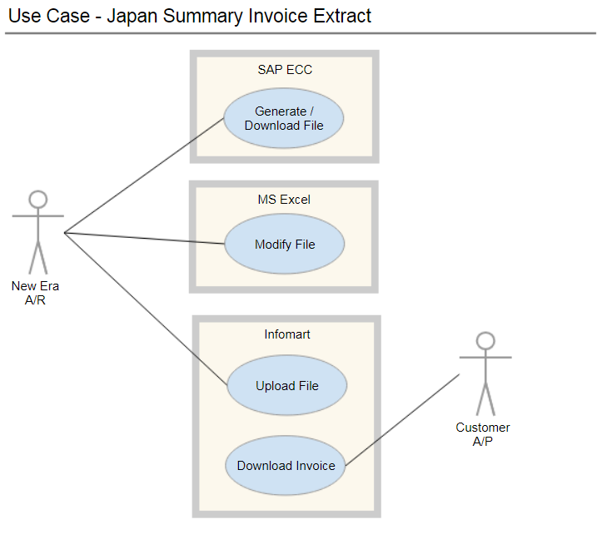

2.2.1 – Data Mapping



2.3 – Proposed Transfer Method / Program

[Please specify the proposed load method (e.g. IDOC, batch transaction processing), and the proposed transfer program name and the inbound/outbound file format (e.g. .txt, .xls)]

*N/A*

2.4 – Performance Considerations

*N/A*

2.5 – Security Requirements

SAP transaction should only be available to Japan Finance resources (specifically A/R)

2.6 – Reporting

*[Please describe any reporting that is expected to be provided in support of this interface]*

2.7 – Error Handling

*N/A*

2.8 – Reconciliation Procedures and Audit Requirements

**3.0 - Testing Requirements**

**3.1 – Key Business Test Conditions**

*[Please indicate the business level test conditions that should be used to verify successful operations of the interface]*

**3.2 - Results Verification**

*[Please provide method of results verification e.g. transactions, reports, text files, etc.]*

# 

**4.0 - Outstanding Issues (SIRs)**

*[Please list any outstanding issues which may impact ongoing development]*

N/A