ANALYSIS: For material 10697987

From the below screen shot we can understand that against delivery 0084021154 negative stock is posted.

Against physical inventory document 6000000085 difference quantity is 1. For which we have tried to write off in Li21. But this is not happened we got error due to deficit of stock.

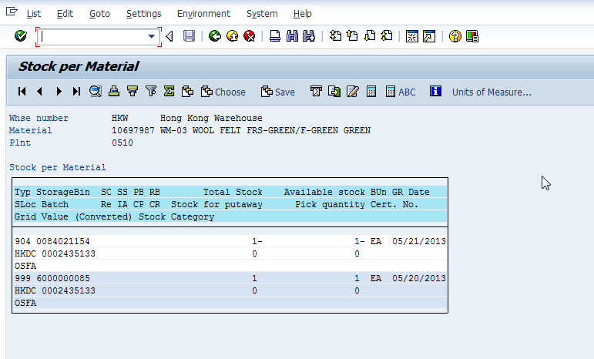

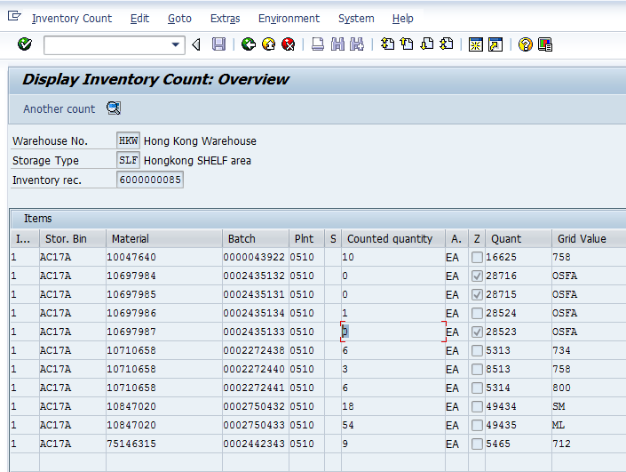

From the above inventory document we can understand that counted quantity is ZERO. Available book quantity is ‘1’. Since material is physically not available specified the counted as zero.
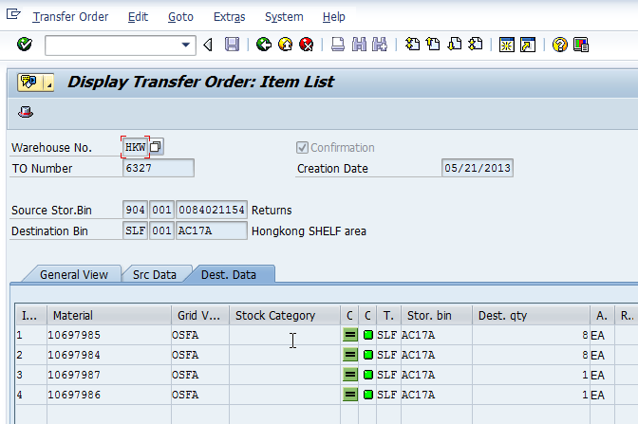

Form the above transfer order we can understand that this TO is created against return delivery 0084021154. This transfer order is created on 05/21/2013 and from below we can conclude that transfer order is confirmed on 07/21/2013.

In between one more transfer order 7151 is created and consumed this stock directly before confirmation of above. Due to this negative stock is posted. This transfer order is created and confirmed on 07/05/2013.
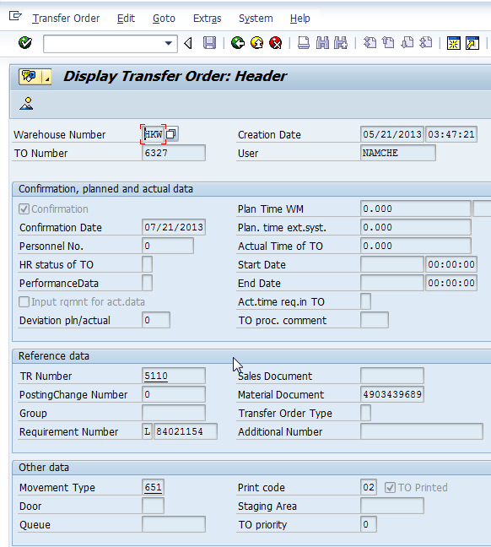

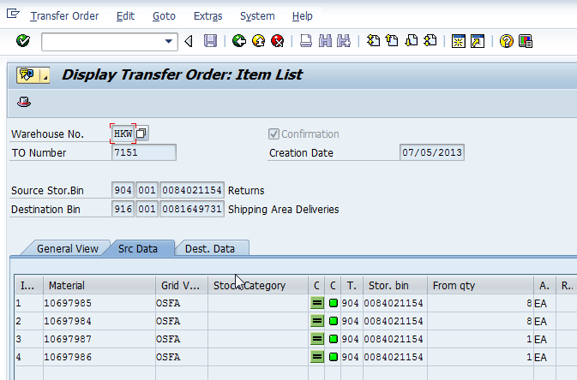

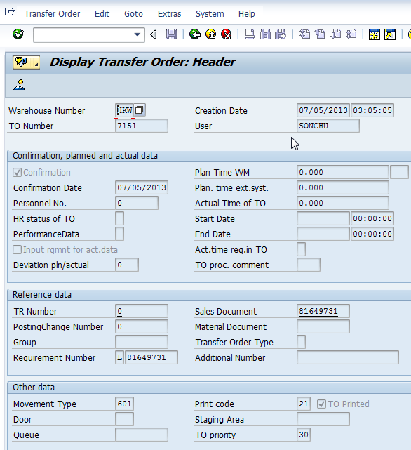

Corrective action: To correct this we have manually created a transfer order as shown below.
We have moved the stock from storage bin 6000000085 (Phy inventory) to storage bin 0084021154 (Delivery for which deficit is there).

