Issues: We have observed below given issues in the subcontract stock monitoring.
1. Unrestricted Stock is not shown in the ME2O screen
2. System does not propose the Quantities and dates when a delivery is created for the first time.
Above given issues we have observed that after implementing the OSS Note 1342514 to resolve the dump issue during creation of delivery to issue the components to subcontractor (Please refer message 317716/2014 escalated to SAP)
Step1: Created Purchase orders 4600006870 & 4600006871 using below given data with item category as L (Subcontract).
Material - 10016953
Vendor - 204235
Company code - 0055
Plant - 0550
SYSTEM - NECNED300

Step2: Run transaction ME2O for the vendor mentioned above.
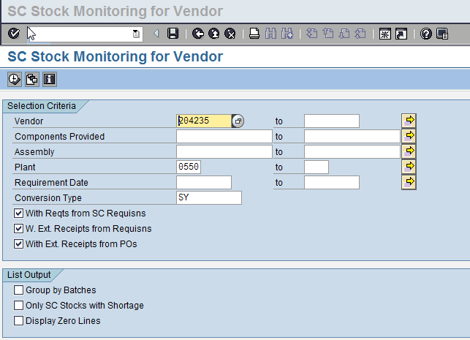
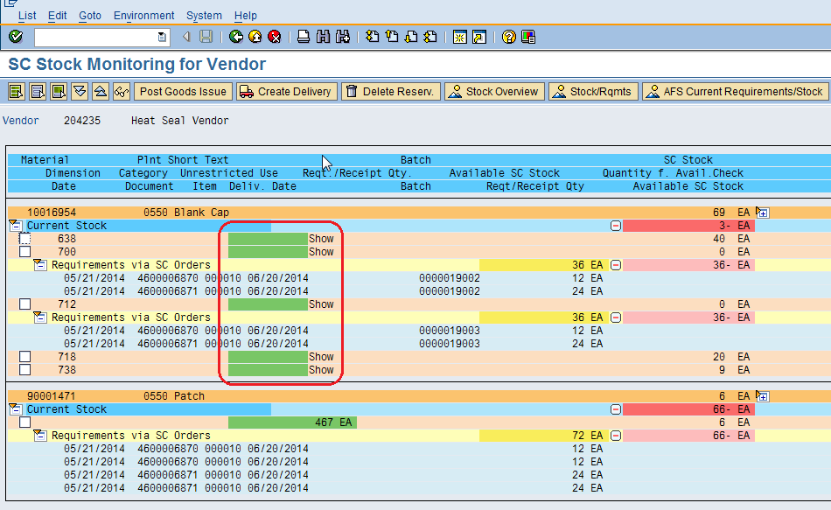
From the above we can understand that unrestricted stock is not showing.

Step3: Create the delivery by selecting the components.
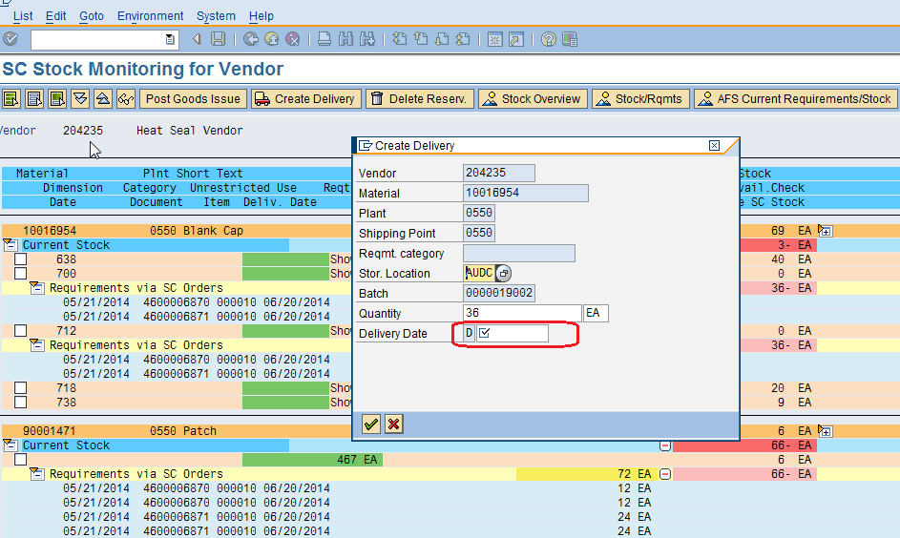
From the above can understand that Delivery date is not populated by default. Observed that, this happens when delivery created first time.
However when we create the delivery by giving the delivery date manually the delivery is created, if we delete the delivery and again try to create Storage location, Quantity and Delivery Date are proposed.

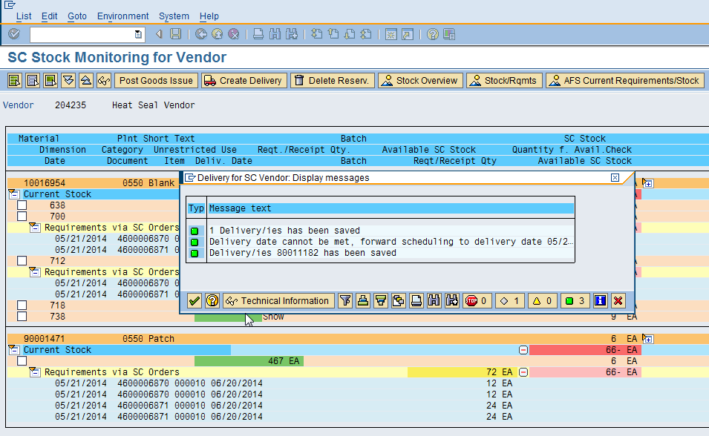

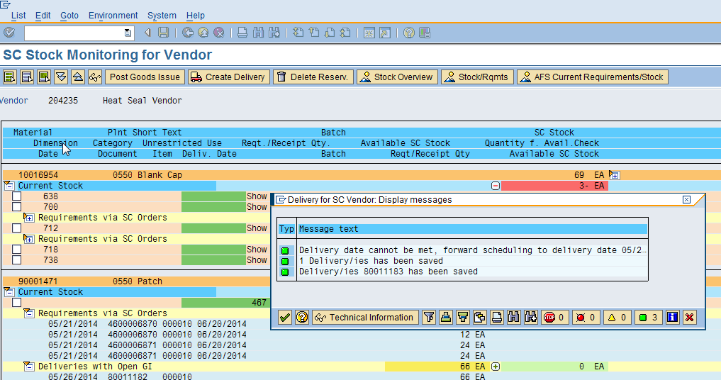

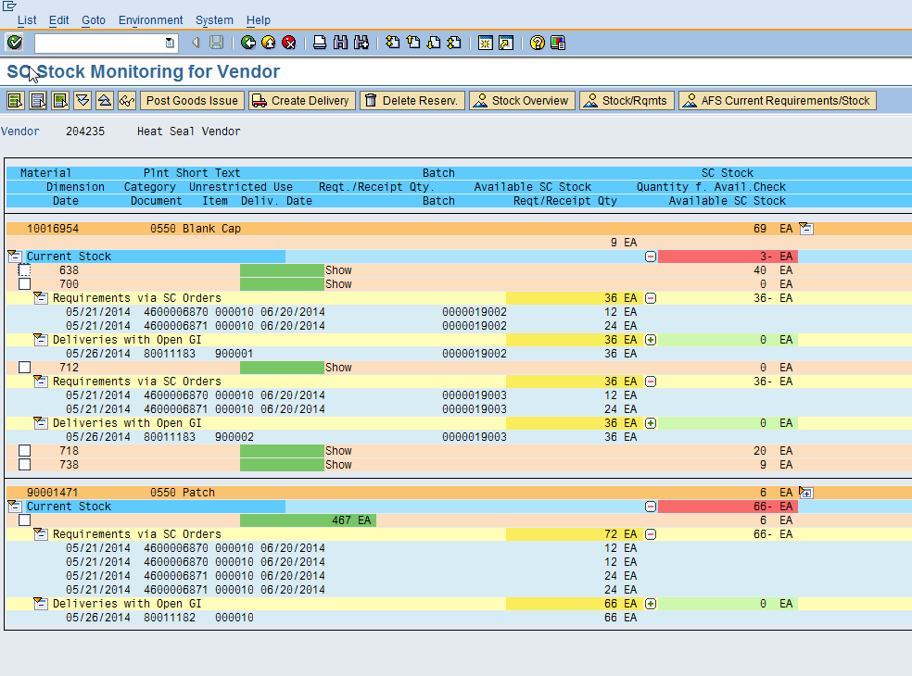
We have observed that some times after creation of delivery able to see the unrestricted stock. One more observation is for AFS materials only we are not able to see the unrestricted quantity. For standard materials there is no issue.

***THE END***

