Requesting Department | Mexico/Korea
Customer Service | N/A

Functional Overview
Business Requirement
Inventory (Master data) file extract for retail pro to create two files one with sbs_no as 1 and sbs_no as 2
Scope:
Program: ZIMM_XML_INVENTORY_OUTPUT

Functional Design
Table fields: MVKE- VKORG
MVKE- VKORG = 1500 then two files to be generated, one with sbs_no as 1 and other with sbs_no as 2.
Note: No changes to XML file format and naming convention can be MXSBS1INVENTORY_DATETIMESTAMP and MXSBS2INVENTORY_DATETIMESTAMP
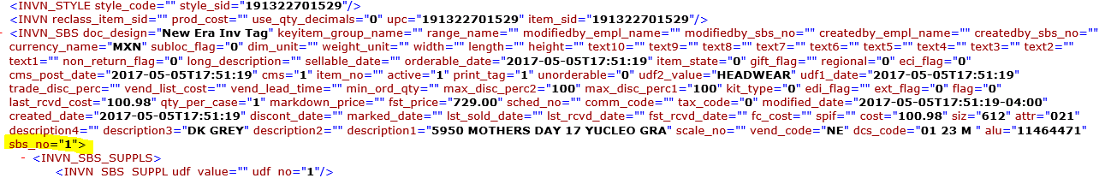

Technical Details
System(s)
NED100
NED300
NEQ600
NEP100

Does this design require.... | (mark applicable with green checkmark)
Configuration | Development/retail master data extract | Mexico retail
Data Conversion | Enhancement | None
Workflow | Network Update | None

Technical Overview
<Populate technical overview>

Test Details
Technical Test Scenarios
ID | Scenario | Expected Results | Actual Results
T-1 | Mexico retail master data extract | Make sure materials created in plant 0282 with sales org 1500 extract data with correct format and sbs_no as 1 | sbs_no as 1
T-2 | Canada retail master data extract | Make sure materials created in plant 0280 with sales org 1500 extract data with correct format and sbs_no as 2 | sbs_no as 2

Business Test Scenarios
ID | Scenario | Expected Results | Actual Results
B-1 | Mexico retail master data extract | Make sure materials created in plant 0280 with sales org 1500 extract data with correct format and sbs_no as 1 | sbs_no as 1
B-2 | Canada retail master data extract | Make sure materials created in plant 0280 with sales org 1500 extract data with correct format and sbs_no as 2 | sbs_no as 2

