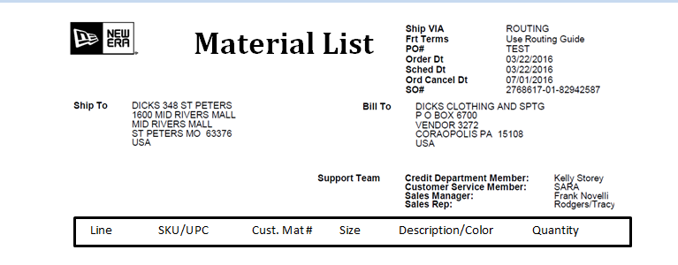

**Material List**

10552911 638 JR THE LEAGUE DETTIG HM   
 10 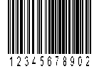    
 10552911 658 JR THE LEAGUE DETTIG HM   
     
 10552911 718 JR THE LEAGUE DETTIG HM   
     
 10552911 634 JR THE LEAGUE DETTIG HM   
 20     
 10897418 718 JR THE LEAGUE DETTIG HM   
     
 10897418 712 JR THE LEAGUE DETTIG HM   
  

Blue

Blue

Blue

10

7

6

9

Black

8

Black

Black

5

Box 1 of 1 Page 1 of 2



Line SKU/UPC Cust. Mat # Size Description/Color Quantity

10685496 638 THE LEAGUE DETTIG HM   
 30     
  
 10685496 658 THE LEAGUE DETTIG HM

Yellow

Yellow

11

 

9

10685496 734 THE LEAGUE DETTIG HM

Yellow

 

8

  
Box 1 of 1 Page 2 of 2

Total Quantity: 72