The following is the procedure that New Era will be using to implement improved SAP ECC security.
- Communicate with the department managers.
  - Explain the reason for the new security changes.
  - Responsibility: New Era IT
- Identify the new role name and role description along with all of the users that will be assigned to it.
  - Responsibility: New Era IT
- Creation of the new roles in NED100.
  - Perform an audit in NEP100 of all the transactions that all of the users identified in step 2 have run in the past three months. Run transaction ST03 to perform the audit.
  - Responsibility: BMS
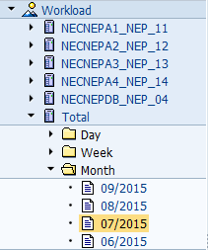
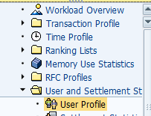
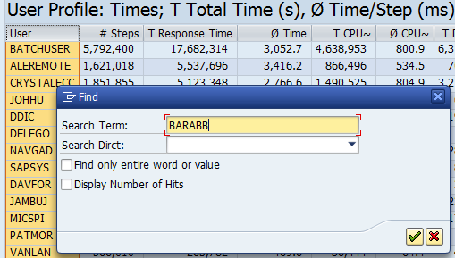
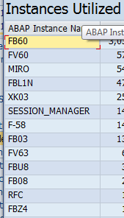
For each of the three months, save the transactions to a file. Sort the transactions and remove all duplicates. These will be the transactions that will be used to create the new role.
Make sure that the transactions are in alphabetical order, both when creating the roles and when adding transactions going forward.
  - Create the new role in NED100 using the role name assigned by New Era IT.
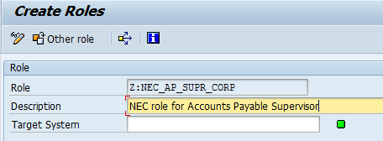
Assign the necessary transactions using the sorted transaction file in step 3.a
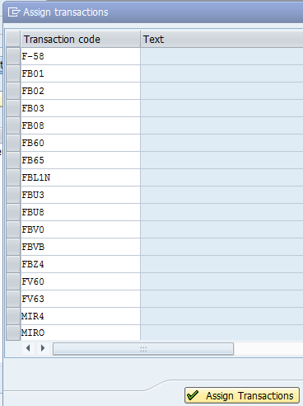
Note: Transactions such as LSMW, SE16, SM30, MASS and others have roles exclusive to them and should not be included in any new roles. I will review all new roles before rolling them out in production and delete any transactions that do not belong in the new roles and transport the changes to all clients.
Edit the Authorizations
Define the Organizational Levels first. For corporate roles, grant Full Authorization to these levels. When defining regional roles (i.e. EMEA, APAC, and Miami), the company code will be identified and send to BMS. Levels other than company code should get full access.
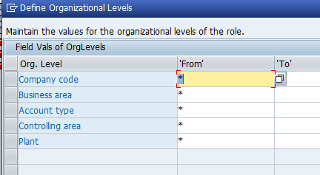
Edit the non-Organization Level authorizations
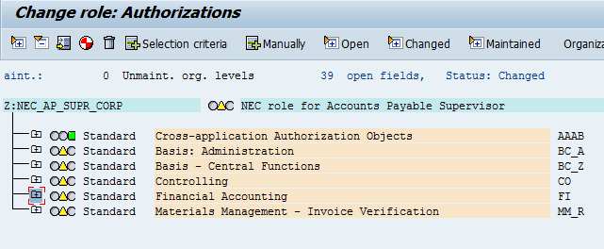
As a rule, I have been assigning all activities except for Delete for the initial creation of the role. This may change during the pilot testing phase. For objects that do not define the Activity, assign Full Authorization.
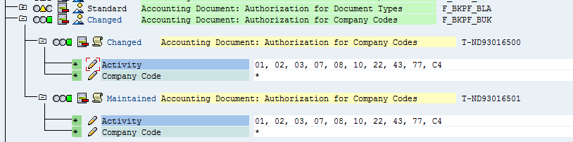
Transport the role to all NED, NEQ, and NEP clients.

Make sure to specify a description in the transport:
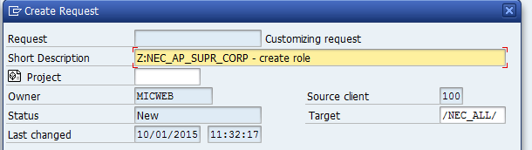

- Assignment of new role and deletion of unnecessary roles from users.
  - Responsibility: New Era IT
- Monitor new roles after the cut-overt and make any changes necessary.
  - Responsibility: New Era IT

Special Instructions:
There have been four departments that have been converted to new SAP security roles. Any changes to security by people assigned to these roles and roles that we will be creating in the future must be made to the role in NED100 and then transported to all clients in NED, NEQ, and NEP.
The following page has a list of the departments that have been converted as 11/6/2015.
Location | Department | New Role
Corp | Customer Service | Z:NEC_CS_REP_NA
Corp | Customer Service | Z:NEC_CS_MANAGER_NA
Corp | Customer Service | Z:NEC_CS_DIRECTOR_CORP
Corp | Ops- Materials Management | Z:NEC_MAINT_TECHNICIAN_CORP
Corp | Ops- Materials Management | Z:NEC_GLOBAL_CAP_PLANNER_CORP
Corp | Ops- Materials Management | Z:NEC_GLOBAL_INV_MGR_CORP
Corp | Ops- Materials Management | Z:NEC_GLOBAL_PLANNING_MGR_CORP
Corp | Ops- Materials Management | Z:NEC_GLOBAL_SUPPLY_PLANNER_CORP
Corp | Ops- Materials Management | Z:NEC_INV_COORDINATOR_CORP
Corp | Ops- Materials Management | Z:NEC_MASTER_DATA_COORDINATOR_CORP
Corp | Ops- Materials Management | Z:NEC_SCHEDULER_CORP
Corp | Ops- Materials Management | Z:NEC_SR_GLOBAL_CAP_PLANNER_CORP
Corp | Ops- Technical Services | Z:NEC_DESIGN_APPROVAL_CORP
Corp | Ops- Technical Services | Z:NEC_DIGITIZER_CORP
Corp | Ops- Technical Services | Z:NEC_PRODUCT_ENGINEERING_CORP
Corp | Ops- Technical Services | Z:NEC_PRODUCT_ENG_MGR_CORP
Corp | Ops- Technical Services | Z:NEC_SAMPLER_CORP
Corp | Ops- Technical Services | Z:NEC_DESIGN_SUPPORT_CORP
Corp | Ops- Technical Services | Z:NEC_TECH_SERVICES_MGR_CORP
Roles for Corp HR (Corp)
Z:NEC_COMM_SPEC_CORP
Z:NEC_DIR_COMP_BEN_CORP
Z:NEC_TALENT_DIR_CORP
Z:NEC_SAFETY_MGR_CORP
Z:NEC_HR_COORDINATOR_CORP
Z:NEC_HR_MGR_CORP
Z:NEC_HR_SR_MGR_CORP
Z:NEC_TALENT_ACQ_MGR_CORP
Z:NEC_TALENT_DEV_SPEC_CORP
Z:NEC_BENEFITS_MGR_CORP
Z:NEC_BENEFITS_ANALYST_CORP
Z:NEC_HR_VP_GLOBAL

